Public Sector Equality Duty

Annual Report

Date: January 2024

Contents

Introduction | 4
Executive summary | 5
Equality and human rights | 6
Equality governance | 9
NHS EDI Improvement Plan | 11
Equality strategy and action plans | 12
Anti-racism | 14
About Bridgewater | 15
Trust strategy | 17
Staff voice | 20
Community engagement | 22
Tackling health inequalities | 23
Due regard in employment | 24
Workforce data | 30
Recruitment data | 32
Leaver data | 34
Employee relations | 36
NHS staff survey | 37
Equality accreditations | 38
Due regard in service delivery | 41
Governors | 51
Local demographics | 52
Population data Halton | 54
Population data Warrington | 56
Patient feedback | 58
Borough plans | 60
Appendix 1: EDS 2023 | 62
Appendix 2: Gender Pay Gap 2023 | 64
Appendix 3: Workforce Disability Equality Standard 2023 | 65
Appendix 4: Workforce Race Equality Standard 2023 | 67
Appendix 5: Language interpretation 2023 | 69

Glossary of acronyms

BOOST | Building On Our Strengths Together (Programme)
BSL | British Sign Language
EDI | Equality, Diversity, and Inclusion
EDS | Equality Delivery System
GP | General Practice
HR | Human Resources
LGBTQIA+ | Lesbian, Gay, Bisexual, Transgender, Questioning, Intersex, Agender/Asexual. + denotes other gender and sexual identities
NICE | National Institute of Clinical Excellence
NHS | National Health Service
PDSA | Plan, Do, Study, Act
POD | People Operational Delivery
WDES | Workforce Disability Equality Standard
WRES | Workforce Race Equality Standard

Introduction

Welcome to our Public Sector Equality Duty Annual Report for 2024.
The past year has been a busy one for equality, diversity, and inclusion in the NHS and in Bridgewater with the publication of the NHS Long Term Workforce Plan; Equality, Diversity, and Inclusion (EDI) Improvement Plan; a refreshed North West Anti-Racist Framework; NHS Sexual Safety Charter; Patient Safety Incident Reporting Framework; and Anchor Institute commitments and actions.
Equality, diversity, and inclusion remains a priority area of focus for Bridgewater, running throughout updated People, and Communities Matter Strategies, strategic equality objectives, borough action plans, and becoming ever more embedded across all areas of business, and a core part of every employee’s role.
Dedicated resource and support for improving equality, diversity, and inclusion is a strong commitment of the Trust, as is ensuring that the actions we take are rooted in co-design and the voice of minoritised groups. It is not enough to tick a box, the Trust wants to take meaningful steps, in partnership with our workforce, patients, and the communities we serve, so that true and lasting positive outcomes are achieved/ Anything less is not acceptable.
This report provides further information on the equality, diversity, and inclusion commitments and work of Bridgewater.
If you have any questions or queries regarding the information in this report, or if you require the information in another language or format, please do not hesitate to contact us using the contact details below.
Thank you.
Paula Woods (Director of People and Organisational Development).
Ruth Besford (Equality & Inclusion Manager).

Contact Details:
Ruth Besford
ruth.besford@nhs.net
07919 898475 (mobile)
1st Floor Spencer House, 81 Dewhurst Road, Birchwood, Warrington. WA3 7PG

Executive Summary

This report provides information that supports the Trust’s legal duties to demonstrate due regard to equality, diversity, and inclusion (EDI) in all areas of business; duties that are set out in the Equality Act 2010, and Human Rights Act 1998 and are briefly detailed in the following section.
Specific information is provided on prioritisation of EDI in the Trust through governance, strategy, and action planning, along with the alignment to national programmes and plans including the NHS People Plan, Our NHS People Promise, and the EDI Improvement Plan.
Anti-discrimination, and zero acceptance of discrimination, harassment, and bullying of minoritised groups is at the core of the Trust’s work, and detail is provided on Trust implementation plans for meeting the commitments of the refreshed North West Anti-Racist Framework.
Information is provided on how the Trust is engaging with its workforce, patients, and communities to develop action plans with regards to the delivery of co-created actions that effect sustained positive improvements on equality in employment, in services, in community access to health care services, and on community health inequalities.
More detail on day-to-day processes, policies, and actions that support equality, diversity, and inclusion in the workforce and in service delivery are provided through bullet point lists.
Data is provided where available and where this is personal identifiable information it will not be disclosed. The Trust recognises that patient data has limitations currently, and a small group is working to address the gaps in equality data that exists in patient records.
Accreditations including Disability Confident, Navajo, and Veteran Aware are detailed. These accreditations are important to the Trust as they drive us forward to continually make improvements for the equality of those groups. Progress is reviewed externally and impartially.
Finally, the appendices to the report refer to language interpretation usage, and results for Workforce Disability and Race Equality Standards 2023, Equality Delivery System 2023, and Gender Pay Gap 2023.
It is intended that the information provided is comprehensive and provides assurance that due regard to equality and inclusion is embedded throughout Trust business.

Equality and human rights

The Equality Act came into force in England in 2010. The Act brought together 116 separate pieces of equality legislation into one simplified and streamlined act that brought protection from discrimination for nine protected characteristic groups:
- Age.
- Disability. This includes:
  - Physical, mental, sensory, learning, and hidden disabilities.
  - Neurodivergent differences such as for example autism, dyslexia, and dyspraxia.
  - Some people with long term conditions, where their impact is significant on day to day living.
- Gender Reassignment (Transgender).
- Marriage & Civil Partnership (including same sex marriage).
- Pregnancy and Maternity.
- Race (Ethnicity).
- Religion or Belief (including no belief).
- Sex (we recognise and value the diversity of gender identity and expression beyond the male/female binary).
- Sexual Orientation (we recognise and value all sexual orientations and identities, recognising that this is a wide and not static spectrum of individuality).
Bridgewater also recognises other often disadvantaged and vulnerable groups. These include:
- Carers.
- Military veterans and the armed forces community.
- Asylum seekers and refugees.
- Other complex needs that include drug or alcohol addition/dependency, sex workers, and homelessness and vulnerably housed.
- People living in areas of high social deprivation.
For organisations providing public services the Equality Act introduced a Public Sector Equality Duty (Section 149 of the Act). The Public Sector Equality Duty has two duties:
- The General Equality Duty.
- The Specific Duties. There are three parts to the Specific Duties:
- To publish at least annually evidence of compliance with the General Equality Duty
- To publish at least every four years measurable and achievable equality objectives
- To publish annually by 30th March data and action plan for gender pay gap.
This report is our 2024 compliance with the first of these Specific Duties.
Our annual equality objectives, the second of the two Specific Duties, are on our website at https://bridgewater.nhs.uk/aboutus/equalitydiversity/ .
The Trust’s gender pay gap reports can be found at https://bridgewater.nhs.uk/aboutus/equalitydiversity/equalityact2010/ and a summary on page 64.

The General Equality Duty

The General Equality Duty requires public sector organisations to have due regard to three aims in all they do:
- To eliminate discrimination, harassment, victimisation, and other conduct prohibited by the Act.
- To advance equality of opportunity between people who share a protected characteristic and people who do not, the Act states that this includes:
  - Removing or minimising disadvantages suffered by people due to their protected characteristics.
  - Taking steps to meet the needs of people from protected groups where these are different from the needs of other people.
  - Encouraging people from protected groups to participate in public life or in other activities where the participation is disproportionately low.
- To foster good relations between people who share a protected characteristic and people who do not, which includes promoting understanding of and between different groups and tackling prejudice, racism, homophobia, transphobia, religious hatred and disability harassment and hatred.
Due regard means thinking about these three aims in all Trust business. This consideration should be robust, timely, conscious, and carried out with an open mind as to the outcomes.

Human rights

The Human Rights Act 1998 sets out the fundamental rights and freedoms that everyone in the UK is entitled to.
The Act sets out a series of articles, the basic rights based on the values of FREDA:
- Fairness
- Respect
- Equality
- Dignity
- Autonomy

There are three fundamental types of rights:
- Absolute rights can never be limited or restricted in any way. The right to freedom from torture and inhuman or degrading treatment is an example.
- Limited rights can be breached in certain circumstances, but breaches must be measured and proportionate. A good example in health care is the right to liberty and security, where a person may be detained under the Mental Health Act to protect their safety and that of others if there is a cause for concern.
- Qualified rights form the majority of human rights and provide the freedoms for example of thought and expression, and religion and belief. A public authority can breach these rights to protect the rights of others, but any steps taken must be proportionate and no more than necessary.

As a public authority the Trust has a legal obligation to ensure the human rights of its workforce, patients and communities are protected within the discharge of its business.
The Trust has policy, procedure, and governance in place to monitor equality and human rights impacts to ensure legal duties are met.

Equality governance

Day to day responsibility sits with the Equality & Inclusion Manager, with executive responsibility in the portfolio of the Director of People & Organisational Development.
Governance is in place that provides challenge around the equality work of the Trust and provides assurance to Board. This is as follows:
- Working Groups, including a newly established EDI Working Group, and Recruitment and Retention Working Group, all report into the People Operational Delivery Council. EDI representation is included on all groups and/or consultation takes place in delivery of new projects such as current staff competencies development.
- The People Operational Delivery (POD) Council; reporting to the People Committee the Council provides the operational management for delivery of all work related to staffing and the delivery of the Trust’s People Strategy. EDI representation is a core Council member and a standing agenda item.
- People Committee. Provides assurance to Board and has delegated authority for approval from Board for decisions related to staffing. There is EDI representation on the Committee, and mandated equality reports are escalated to Board via a Chair’s report from the People Committee.
- Joint Negotiating and Consultation Committee (JNCC); provides a partnership forum for workforce matters with both Management and Staff-side colleagues. An EDI update is a regular agenda item and there is EDI representation on the Committee.
- HR Policy Group; the Trust’s EDI Lead is a core member of the group. All policies must undergo an equality impact assessment and are reviewed by the EDI Lead as part of policy consultation before submitting to the Group.
- Corporate and Clinical Policy Group; EqIA is a mandated element of policy development and review, and the Trust’s EDI Lead is part of the standard consultation for all policies going through this Group.
- Quality Impact Assessment Panels; include equality impact risk assessments of all service changes, cost improvement plans (developed by CIP Council), and borough operational delivery plans where service pathways etc are to be redesigned.
- The Trust Board has EDI on its business reporting cycle, and through sponsorship of Staff Networks the Board are kept informed of diverse staff voice.
- Bridgewater Engagement Group. Recently re-established, the Group includes EDI representation and is providing Trust leadership on patient and community engagement, but also includes a review of staff engagement.
The Trust also reports to Halton and Warrington commissioners through quarterly assurance meetings – equality has a distinct section within the NHS Standard Contract on which compliance and progress must be reported on quarterly.
The Trust is accountable to Government Equalities Office and NHS England for progress on equality specifically in relation to:
- Workforce Race Equality Standard (WRES)
- Workforce Disability Equality Standard (WDES)
- Gender Pay Gap
- Equality Delivery System

NHS EDI Improvement Plan

The NHS EDI Improvement Plan was published in June 2023 and mandates deliverables under six high impact action areas:
- Chief Executives, Chairs, and Board Members must have specific and measurable EDI objectives to which they will be individually and collectively accountable.
- To embed fair and inclusive recruitment processes and talent management strategies that target under-representation and lack of diversity.
- To develop and implement an improvement plan to eliminate pay gaps.
- To develop and implement an improvement plan to address health inequalities within the workforce,
- To implement a comprehensive induction, onboarding, and development plan for internationally recruited staff.
- To create an environment that eliminates the conditions in which bullying, discrimination, harassment, and physical violence at work occur.
In addition to the high impact areas there are a series of deliverables against each protected characteristic group.
Mapping has been undertaken against existing Trust action plans and objectives, including those for Disability Confident, the North West Anti-Racist Framework, WRES, and WDES. The EDI Improvement Plan is now informing refresh of the Trust’s EDI Strategy.
Work is being undertaken and overseen by the new EDI Working Group, with assurance and oversight through Trust governance to Board.
More information on the NHS EDI Improvement Plan can be found at https://www.england.nhs.uk/publication/nhs-edi-improvement-plan/

Equality Strategy and Action Plans

Our current Equality, Diversity, & Inclusion Strategy 2020 - 2023, is built on the conversations we held with our Staff Networks and is aligned to national actions such as the NHS People Plan.
The Strategy, signed off with the full commitment and active support of our Executive and Non-Executive Directors, recognises that every member of staff is a key stakeholder in the delivery of the Strategic Equality Objective and action plans for Bridgewater. The aim is to ensure that equality is fully embedded across the Trust, and integral to the everyday narrative of all our staff.
The Strategy’s vision, aims and principles promote a workplace and services that are compassionate, inclusive, representative, respectful, value diversity, and embed respect and support for individual contributions, needs and aspirations.
Our Strategy will be reviewed in 2024 in consultation with our staff and Staff Networks, whereby we ensure equality is an integral part of every strategy across the Trust, with its own clear narrative and commitments within each.
The current strategy can be found on our website at https://bridgewater.nhs.uk/aboutus/equalitydiversity/ .
The Trust sets annual equality objectives underpinned by action plans for delivery of these objectives. These equality objectives are the practical steps that support the Trust in achieving its overarching strategic equality objective and health equity objective. In 2023 – 2024 the equality objectives are to:
- Embed the NHS EDI Improvement Plan in Working Groups and Trust governance. Completed.
- Develop an action plan and governance for the North West Anti-Racist Framework. 31st January 2024.
- Review Equality Act 2010 compliance. 31st March 2024.
- Continue the delivery of the Accessible Information Standard action plan for patient records through national records updates. 31st March 2024.
- Provision of new language interpretation contracts for spoken/written language and signed languages. Completed.
- Draft and agree a community engagement calendar and oversight plan. Completed.
- Prepare a mid-point assessment and action plan for Veteran Aware accreditation. 31st January 2024.
- Prepare an application and action plan for silver Defence Employers Recognition Scheme. 31st March 2024.
- Draft and launch an ESR how to self-report equality guide. 31st December 2023.
- Develop and publish a Gender Diversity in the Workplace Policy and Toolkit. 31st March 2024.
- Develop and publish a Reservist Policy and Toolkit. 31st March 2024.
- Develop and publish a Reasonable Adjustments for Staff Policy and Toolkit. 31st March 2024.
- Establish a calendar for menopause café events. Completed.
- Develop governance for the Trust’s Staff Networks. 31st March 2024.

Anti-Racism

Bridgewater is committed to improving race equality for our staff and our communities, and to being actively anti-racist.
We are committed to improving awareness and understanding, from an individual to a Trust level, of the ways in which many of us have benefitted from privilege and systemic racial discrimination throughout our lives.
We will as a Trust demonstrate honestly and transparency; we will admit where we have gaps in knowledge, understanding, data, representation; we will be open and honest about where we believe we can do better; and we will actively facilitate and listen to the voices of our diverse workforce and communities, recognising that Black, Asian and minority ethnic groups are not a collective whole any more than ‘White British’ is a group with identical views, needs, aspirations and inequalities.
We will work in true partnership with our Staff Networks and with our wider communities to develop and deliver real and sustainable plans that address racism, discrimination, and inequality.
The above statement was published by the Trust Board in 2020 and remains a positive statement of intent regarding the creation and embedding of an anti-racist culture in Bridgewater. This intent is reiterated in the Board’s commitment to the regional NHS North West Black, Asian, and Minority Ethnic Assembly Anti-Racist Framework, which outlines a set of priorities and deliverables to support the development of an anti-racist culture and practice in employment and service delivery.
The Framework has been revised in 2023 to include bronze to gold attainment levels. Alongside colleagues across the North West, and with the support of the Assembly members, the Trust’s Equality, Diversity, and Inclusion (EDI) Working Group is developing an action plan for submission of an application to bronze level with longer term actions to support progression through the scheme to gold level eventually.
The Trust is committed to a real collaborative journey with staff and communities with lived experience of racial inequality and racism. There are deliverables within the bronze level of the Framework that could be evidenced now, however data tells us that inequality still exists in our workforce for ethnically diverse staff, and conversations with community groups raises the barriers to access faced by diverse groups in the areas we serve. We want to dig deeper into the inequalities, undertake supportive conversations with staff and communities, so that we can gain greater understanding and through that co-design actions that have real and lasting positive impact for those affected.

About Bridgewater

As part of the Cheshire & Merseyside Integrated Care System (ICS), PLACE-based Partnerships, and Provider Collaboratives, the Trust is a key partner in the delivery of joined up approaches to improve health and care outcomes in the region.
Bridgewater provides community services in Halton (Runcorn and Widnes), and Warrington. These services include 0 – 19 services; district nursing and community matrons; therapy services including physiotherapy and speech and language therapy; and specialist services such as palliative care and mental wellbeing.
The Trust also has a number of services who deliver in St Helens and Knowsley, and our Drive Ability North West Service delivers across the North West of England.
The Trust’s specialist dental services are provided across a larger area within Cheshire, Merseyside, and Greater Manchester for patients who because of differing needs and vulnerabilities are unable to access high street dental services.
Figure 1: Bridgewater Map of Services
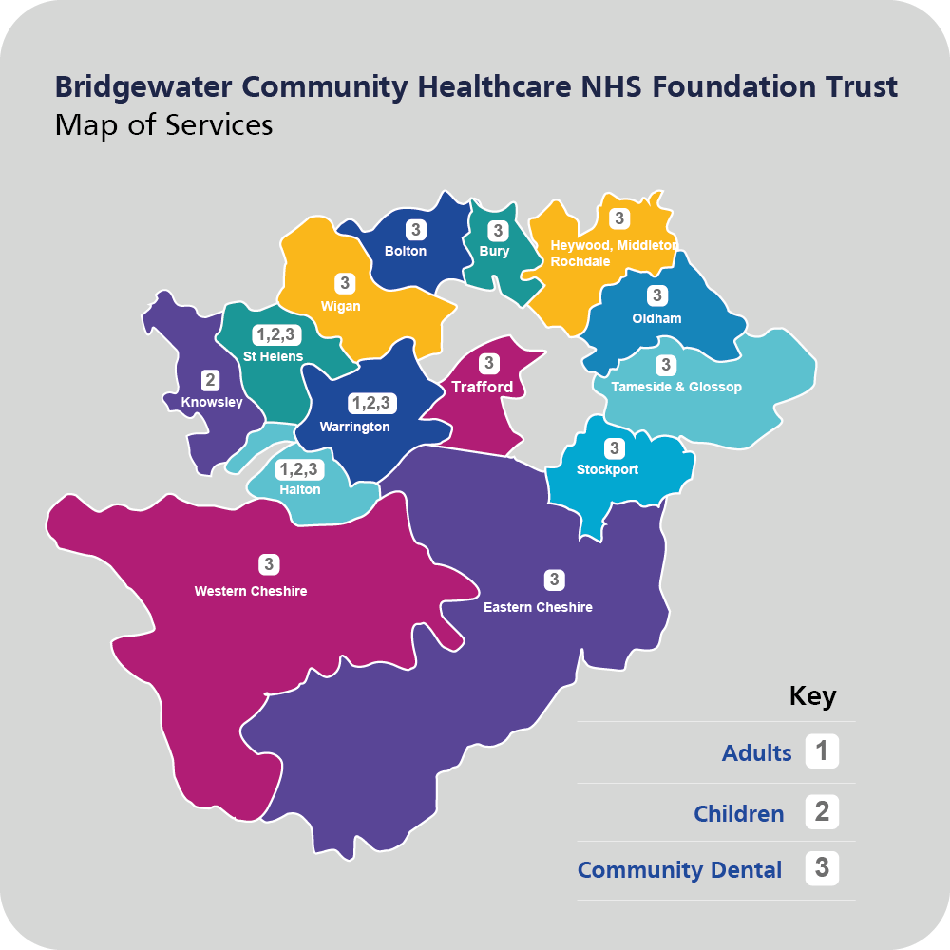

The Trust’s mission is to ‘improve health, health equity, wellbeing, and prosperity across local communities by providing person centred care in collaboration with our partners’.
This mission is delivered within the framework of PEOPLE values:
- Person centred.
- Empowered.
- Open and honest.
- Professional.
- Local.
- Efficient.
Figure 2: Bridgewater People Values image
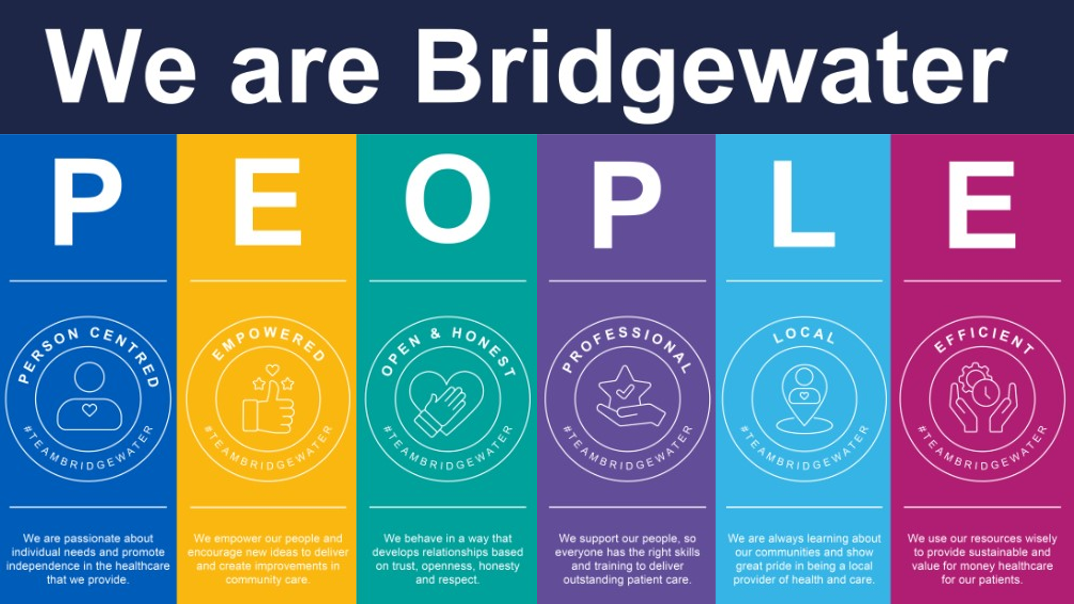

Trust Strategy

In 2023 the Trust published a refreshed People Strategy and new Communities Matter Strategy.
The People Strategy is aligned to the national NHS People Plan and Our NHS People Promise and sets out a vision of a modern employment culture where staff want to work, and where they are equipped with the skills and flexibility to deliver innovative models of care.
Strategic priority 3 in the People Strategy is equality and diversity. They are to:
Pledge: We will attract and recruit a diverse workforce who aspire to work within an innovative community healthcare integrated organisation and our recruitment will select those who align to our inclusive culture and our future plans for community services (collaboration and integration)
The People Strategy commits to actions for equality and inclusion:
- Review recruitment and promotion practices to ensure staffing reflects the diversity of the communities that we serve.
- Reduce any ethnicity gaps in formal disciplinary and grievances processes.
- Become an ‘Employer of Choice’ across all staff groups by offering a modern employment culture, harnessing a bespoke approach to local, regional, national, and international labour markets.
- Develop a unique and flexible employment package to attract the best talent.
- Identify our ‘difficult to recruit’ posts and create bespoke recruitment campaigns to address these.
- Review best practice and ensure our ‘offer’ is reflective and responsive to the organisation’s needs.
- Maximise our workforce intelligence to fully understand our workforce profile to inform workforce planning, utilising Population Centric Workforce Planning approaches.
- Tackle health inequalities within our communities and strive to improve the quality of their lives and access to employment and services.
- Develop our on-boarding approach so that we appeal to staff with protected characteristics because we have adopted an inclusive approach to our recruitment, and we enhance the induction and preceptorship and support to all new staff.
- Complete Quality Impact Assessments (QIA) for any fundamental changes made to our workforce and service delivery, ensuring the quality of care we deliver is not adversely affected.
- Embed equality, inclusion and diversity as fundamental principles in all activities affecting current and future workforce.
The new Communities Matter 2023 – 2026 strategy builds on the previous Quality and Place Strategy developed in partnership with communities in 2018.
At its heart, the new Strategy has collaboration and partnerships, including with other NHS and care providers, voluntary sector partners, staff, patients, and the diverse communities in our regions. Aligned to the place-based priorities identified by the ICS, the Strategy commits to collectively addressing the demands and acuity of need, as well as taking positive steps to address where possible the inequity in the social determinants of health evidenced between the least and most deprived areas we serve.
The Communities Matter Strategy details the six strategic objectives of the Trust:
- Quality - We will deliver high quality services in a safe, inclusive environment where our patients, families, carers and staff work together to continually improve how they are delivered.
- Health equity - We will collaborate with partners and communities to improve equity in health outcomes and focus on the needs of those who are vulnerable and at-risk.
- Staff - We will ensure the Trust is a great place to work by creating an environment for our staff to develop, grow and thrive.
- Resources - We will ensure that we use our resources in a sustainable and effective way.
- Equality, diversity, and inclusion - We will ensure that equality, diversity, and inclusion are at the heart of what we do, and we will create compassionate and inclusive conditions for patients and staff.
- Partnerships - We will work in close collaboration with partners and their staff in place, and across the system to deliver the best possible care and positive impact in local communities.
Further information on the Communities Matter Strategy 2023 – 2026, including context and deliverables for the six strategic objectives can be found at https://bridgewater.nhs.uk/communities-matter/ .
The Trust’s Equality, Diversity, and Inclusion Strategy 2020 – 2023 is due for review and refresh in 2023, a project that is taking place in partnership with Staff Networks and community partners at the time of writing. The refresh was held while the Trust awaited the publication of the NHS Equality, Diversity, and Inclusion Improvement Plan to ensure effective alignment with this national mandate. More information on the national plan can be found by following the link below:
https://www.england.nhs.uk/publication/nhs-edi-improvement-plan/

Staff voice

The annual NHS Staff Survey has a number of equality and inclusion related questions and provides all staff with an opportunity to anonymously feed back to us their views based on their own experiences of the workplace.
The Trust has seen a steady increase in the number of respondents every year, with more than half of all staff now completing the survey. We have observed an increasing number of responses from staff within diverse groups, notably those from ethnically diverse heritages, and staff with disabilities and long-term conditions. This is encouraging as it is critical to our aims of really understanding the lived experience of our minority groups.
Since 2020 we have been building our Staff Networks to provide a safe space for the voice of diverse groups of staff. The Staff Networks, and their Executive sponsors are as follows:
- Carers Support Network – Chief Nurse/Deputy Chief Executive
- Enabled Network – Director of Finance
- LGBTQIA+ Staff Network – Chief Operating Officer, and Trust Secretary
- Menopause Support Network – Trust Secretary
- Paths to Parenthood – new network in development
- Race Inclusion Network – Director of People and Organisational Development (Chair), Chief Executive, and Trust Chair
The Networks are also supported by the Trust’s Freedom To Speak Up Guardian, ensuring that staff who raise issues can be supported to further highlight those concerns where appropriate.
The Networks will also be key partners in the new EDI Working Group, providing voice and challenge for co-design and delivery of actions plans for equity in the workplace and in services.
Other opportunities for staff to speak direct to Board include the regular Time to Shine meetings (a chance to highlight learning and good practice, and open to all staff); Time to Talk (a planned series of service/staff visits with Executive and Non-executive Directors); and Leader In Me (quarterly events open to all staff focusing on specific topics each time).

Figure 3: Staff networks logo
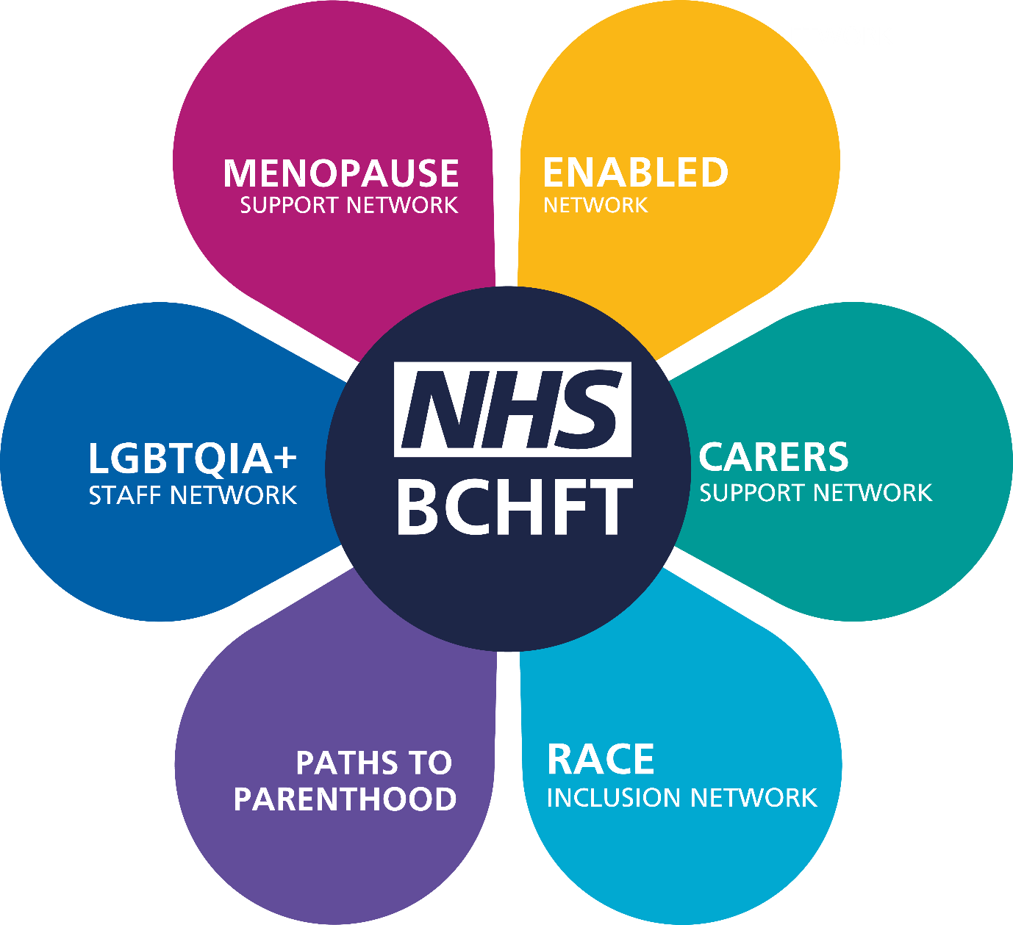

Community engagement

The Trust has a well-established Patient Experience Team who provide a key source of information and support for all patients accessing Trust services.
As the subject matter experts for patient experience the Team manage the Talk To Us survey of patients; support Trust services undertaking additional patient experience engagement; run the nationally recognised Patient Partners Programme; and are the managers of informal and formal concerns and complaints raised with the Trust.
They also collate the patient stories that are presented to Board. These are important stories that tell both of best practice and where things have gone wrong. These stories delivered direct to Trust leaders allow best practice to be shared, lessons to be learned, and resources or actions identified as needed. Patient stories can be viewed on the Patient Experience Team website at https://bridgewater.nhs.uk/patient-information/patient-stories/ .
In 2023 the Bridgewater Engagement Group has been re-established with an increased focus on engagement with communities, building on existing engagement with patients, and including staff engagement within its membership for the first time.
Engagement has started with representative groups in Trust communities, including Warrington Disability Partnership, Irish Community Care, Trinity Safe Space, and Warrington Deaf Club. The actions from each meeting are logged and then managed through the Transformation Team, in this way they are included within delivery of borough operational delivery plans.
A priority is continued engagement; not just talking once to a group but going back to provide updates on actions and to continue the conversations so that changing needs can be understood, effectiveness of actions monitored, and actions updated as necessary to ensure they achieve the outcome planned.
A calendar of engagement events for 2024 is in development, including the commitment to continue talking to the groups already met, and the calendar is seeking to ensure representation of the diversity of communities in the region.

Tackling health inequalities

As an NHS community provider, the Trust is committed to reducing health inequalities through the adoption of the Prevention Pledge and developing the role of an anchor institution.
The Prevention Pledge consists of a set of commitments whereby the Trust pledges support to achieve action on improving population health with a specific focus on prevention measures, for the benefit of staff, patients, and the wider community.
The strategic core commitments have been considered in line with commitments in the NHS Long-Term Plan, sub-regional prevention priorities, and in particular the Cheshire and Merseyside Population Health Framework. These are key to influencing multi-agency action to address social determinants of health; to ensure that as an employer, a purchaser and a local ‘anchor institution’ the Trust can help moderate inequalities and ensure that we tackle the relative disparities in access to services, patient experience and healthcare outcomes.
Working alongside the National Healthcare Inequalities Improvement Team and guided by Marmot principles, the Trust has developed approaches to prevention, working with partners ‘at place’, to address inequalities and deliver local priorities and prevention ambitions set out within the NHS Long Term Plan and in COVID-19 recovery plans.
More information on the Cheshire and Merseyside Prevention Pledge can be found at https://www.cheshireandmerseyside.nhs.uk/about/sustainability/nhs-prevention-pledge/

Due regard in employment

Due regard in employment requires us to consider the three aims of the Equality Duty in all workforce related issues, including for those potentially joining our Trust, and those who support our work through their invaluable volunteering contributions.
Data regarding our staff can be seen on pages 29 to 35, but here are the fundamental functions we carry out which support due regard in our employment actions and decisions.
- The Trust’s People Strategy aligns with the national NHS People Plan and the Our NHS People Promise, both of which have equality and inclusion throughout. Priority three of the People Strategy is specific to equality, but equality and inclusion are woven throughout the priorities set out in the document. Equality and the creation of compassionate and inclusive environments for staff and patients is one of the strategic objectives within the Communities Matter Strategy.
- All Trust workforce policies undergo scrutiny for equality impact at design or review. Sign off is not given until such time as any identified potential negative impact is addressed through minimisation or elimination.
- Policy governance is overseen through the Joint Negotiating and Consultation Committee (JNCC) and People Committee, the latter providing assurance to Board. Day to day policy design and review is managed through the HR Policy Group, where the Trust’s EDI Lead is a management member.
- Staff-side colleagues work closely with corporate and clinical/medical leads through the Joint Negotiating and Consultation Committee and Local Negotiating Committee (LNC). Their insight and challenge on staff issues ensures the Trust considers impact, including equality impact, of workforce policy, strategy, and plans.
- As a Disability Confident Leader, and Defence Employer Recognition Scheme Trust, we offer a guaranteed interview to any candidates who identify as disabled, or an armed forces community member on their application, and who meet the essential criteria of the role.
- All Agenda for Change job descriptions (bands 2 to 9), undergo thorough scrutiny and are evaluated through the Agenda for Change Job Evaluation Scheme. This is a process which has membership support from HR and Staff-side colleagues.
- All staff, except those in very senior leadership roles, are recruited on nationally agreed terms and conditions, either Agenda for Change or Medical and Dental.
- The Trust is increasingly utilising apprenticeship programmes as a way of offering on-the-job training and development opportunities to individuals who are new to the sector or looking to progress within their current role. The apprenticeships are proving to be powerful for promoting equality, diversity, and inclusion within the workforce and community. Increased apprenticeship opportunities are being provided for those who may have no prior experience in the sector but who have the potential to succeed and make valuable contributions to our workforce. This approach helps to break down barriers to entry and create more inclusive workplaces that reflect the diversity of our wider community.
- In addition to providing external apprenticeship opportunities, our programmes also provide existing staff with opportunities to develop and progress. This helps to ensure that all members of our staff can achieve their full potential, regardless of their background or previous experience.
- The Trust regularly engages with local partners including schools, colleges, youth organisations, and local Job Centres, to support members of our community to access our vacancies. By offering job application and interview advice and guidance, we are helping to break down barriers to entry and ensure everyone has an equal opportunity to succeed. This approach also helps to build stronger connections between our organisation and the wider community, promoting a more inclusive and collaborative working environment.
- We recognise that everyone learns differently and that some individuals may require additional support to complete their apprenticeship successfully. That is why we are committed to supporting all apprentice learners who have dyslexia or other learning needs to access and complete our programmes. By providing additional support, including access to diagnosis and workplace assessment, we are ensuring that everyone has an equal opportunity to succeed and contribute to our workforce.
- We offer our staff the opportunity to gain Maths and English qualifications, enabling them to apply for higher level apprenticeship opportunities. This approach is particularly important for promoting diversity and inclusion as it helps to ensure that everyone has an equal opportunity to progress and achieve their full potential, regardless of their previous education or qualifications.
- All staff can access occupational health services, who provide support and advice on health and wellbeing, including advice and support for staff with disabilities requiring reasonable adjustments.
- Occupational health services include counselling services available 24/7, along with trauma support services. Cognitive behavioural therapy is also available and has been utilised by staff members to manage peri-menopause symptoms.
- There are a range of other health and wellbeing support offers available, managed by the Trust’s Health & Wellbeing Lead. This includes Able Futures, (the Department for Work and Pensions Mental Health Service), and Rugby League Cares sessions for individuals and teams.
- The Health and Wellbeing Organisational Development Lead and Health & Wellbeing Co-ordinator proactively work with managers and teams, engaging with colleagues around the Bridgewater Health & Wellbeing offer for support, advice, guidance and tools.
- The Trust’s annual Health and Wellbeing Fortnight in 2023 featured face to face and virtual sessions that included a market stall for health and wellbeing offers, a menopause café, exercise opportunities, a Rugby League Cares session, and flu and Covid 19 vaccine clinics.
- The Trust is in the process of embedding a new annual staff review cycle which will formalise health and wellbeing conversations as part of annual staff conversations with their managers. This is in addition to informal and ad hoc conversations as need arises, and is aligned to the soon to be launched Wellbeing Policy. The new policy has been developed regionally in partnership with Trade Union Bodies. As an early adopter the Trust has supported the development of a robust policy that will provide a more holistic and person centred approach to wellbeing and sickness absence, including wellbeing passports (in addition or instead of the existing staff passport), disability leave, and the removal of absence triggers except where absence gives a cause for concern.
- In 2023 the Trust’s approach to conducting stress risk assessments has undergone an audit, with actions to be taken to improve completion of individual and team assessments. Pregnancy and maternity risk assessments are well established in the Trust to support any staff member who is pregnant, or infant feeding as they return to work.
- Sickness absence is monitored through Trust governance, and includes monitoring of any trends in relation to protected characteristic groups.
- Bespoke health and wellbeing offers, for example for Black, Asian, and minority ethnic staff, are flagged to staff through Staff Network mailing lists and through the Bridgewater Bulletin. Signposting is provided to individual staff as need arises, for example Galop UK for LGBT+ phobic related incidents, and a signposting document to internal and external support is provided on the MyBridgewater extranet and communicated regularly in the Bridgewater Bulletin.
- Flexible working is open to all staff, taking into consideration the needs of the service, and more than half of our staff work flexibly. Retire and return is also an option that many staff eligible to retire, have taken up in recent years. Other options for staff include special leave options to support family emergencies, career break options, and maternity, paternity, and shared parental leave.
- The Special Leave policy, at the time of writing, is about to be signed off. This refreshed policy includes additional paid leave for unpaid carers in the workforce, and additional leave for annual camp for reservists and cadet force adult volunteers.
- All HR policies, as part of design or planned review, are moving to a new more user friendly and person-centred format that includes toolkits to support managers and raise staff awareness to accessible advise and support as relevant to each policy.
- New policies in 2023 have included a Reservists Policy and Toolkit, and Gender Diversity in the Workplace Policy and Toolkit.
- We make reasonable adjustments for staff with disabilities, or unpaid caring responsibilities, and these can be recorded and held by the staff member in the Trust’s Employee Adjustment Passport.
- A number of staff in the past year have been supported to undertake diagnosis assessments for neurodivergence. A diagnosis is not a prerequisite for support being provided in the workplace, but feedback from those staff tells us that a diagnosis can be a ‘weight lifted’ ‘finally understanding myself’.
- In April 2021, the costs for making reasonable adjustments for staff with disabilities was centralised in line with best practice set out by the NHS Workforce Disability Equality Standard Team.
- The principles of our Just and Learning Culture programme are being continually assimilated and embedded into routine practice. In essence a Just and Learning Culture is fundamental and integral to the culture of the Trust, underpinned by an emphasis on the values and behaviours of civility and respect, kindness, and compassion. The Trust has made significant progress in reviewing and revising its human resources, employee relations policies and procedures to ensure that justice and inclusion are cornerstones of practice.
- Promotion of our Just and Learning Culture has expanded with routine delivery of training to new employees and learners in addition to the established workforce.
- Equality and inclusion, anti-racism, Freedom To Speak Up, Just Culture, health and wellbeing, and civility and respect are all elements of the mandated corporate induction attended or accessed by all new starters. In addition, training has been provided to first line managers, students, and operational managers in 2023, combining equality, Just Culture, and civility and respect into one training package.
- The Staff Networks provide an opportunity for staff to meet in a safe space to share experiences and ideas, and to provide challenge to the Trust on equality activities planned or underway. Conversations with the Race Inclusion Network for example in 2023 have supported the development of project proposals for diversity and equity representatives in recruitment, and international staff support. Both are important projects to support compliance with the NHS EDI Improvement Plan and for improvements in the Workforce Race Equality Standard.
- A lot of work has been undertaken to embed support for unpaid carers within Bridgewater. This has included the establishment of the Carers Support Network, and the drafting of a Carers Support Policy. Work has been led by the Trust’s Health & Wellbeing Co-ordinator and is aligned to similar work being undertaken in relation to carers accessing Trust services or support patients who are.
- Work has continued on the development of a menopause friendly culture in the Trust with a Working Group and staff support network meeting regularly. Two face to face cafes have been held in late 2023, a new addition to the existing virtual support options; these featured speakers on understanding menopause, and menopause and mental health. The Menopause Support Policy has been in effect since 2022 and is awaiting the release of the anticipated national NHS policy for review and action as needed.
- Employment, and health and safety laws also underpin our employment practice, including providing protection and reporting processes for staff from discrimination, violence, bullying and harassment.
- Staff can report incidents through a number of channels including Ulysses (for incidents related to patients/families), through online and anonymous reporting for staff incidents, directly to HR and Staff-side colleagues, and to the Trust’s Freedom To Speak Up Guardian and Champions.
- In 2023 a second Freedom To Speak Up Guardian was appointed. They sit independently from HR, but work closely with the existing Guardian in that team. The Guardians attend the Staff Networks regularly and are supporting the new EDI Working Group. It is the aspiration of the Executive Team to have a Champion in every Trust team and communications, awareness raising, and recruitment has intensified in late 2023 to meet this aim.
- The Trust launched a new Civility and Respect training programme in 2023 based on the national NHS toolkit. This is underpinned by a refreshed Civility and Respect Policy. A Working Group (comprising HR, Staff-side, equality and inclusion, and health and safety) have developed a new communications campaign aimed at staff and those accessing services. This Working Group has aligned work on civility and respect, equality, and Violence Prevention and Aggression Standards.
- Annual data is provided by the NHS Staff Survey and through the Gender Pay Gap, and Workforce Disability and Race Equality Standards. These provide the Trust with a profile of progression across the years, and through engagement with our Staff Networks we are able to identify barriers, gaps, issues, and then agree actions to take to continue the work of eliminating any discriminatory practices, or behaviours witnessed or experienced by our staff.
- We have Quality Impact Assessment Panels that look at service changes and the potential impact on protected groups, including within the workforce, and equality impact and risk is included within this.
- We ensure due regard through robust processes that are reported through our governance structures to Board. These structures ensure that all areas of Trust business are appropriately under scrutiny, and are, most importantly, interlinked with issues arising in our People Committee - for example being brought to the attention of our Audit, Finance and Performance Committees.

Workforce data

Please see in the table below information on the workforce by protected characteristic group as at the snapshot date of 1st November 2023.
Table 1: Showing the equality demographics of all staff as at 1st November 2023
Staff in post equality demographics at 1st November 2023

Age % | Under 21 | <3.00
 | 21 – 30 | 11.02
 | 31 – 40 | 24.36
 | 41 – 50 | 25.70
 | 51 – 60 | 28.20
 | 61 – 70 | 9.38
 | Over 70 | <3.00
Disability % | No | 81.67
 | Yes | 3.90
 | Not Stated | 14.43
Maternity % | Maternity leave as at reporting date | <3.00
Race/Ethnicity | Asian, Asian British (inc Indian, Pakistani, Bangladeshi, Sri Lankan, and other) | 3.65
 | Black British, Black African and Caribbean | <3.00
 | Chinese | <3.00
 | Mixed ethnicity | <3.00
 | Other Ethnicity | <3.00
 | White, (inc. White British, Irish, European, and Other) | 92.20
 | Not Stated | <3.00
Religion/Belief % | Christianity | 44.15
 | Islam, Buddhism, Hinduism, Sikhism | <3.00
 | No Religion | 13.82
 | Other | 4.69
 | Not Stated/ Do Not Wish To Disclose | 34.35
Note: The electronic staff record is limited to male/female/other at this time.
Gender Identity % | Male | 10.14
 | Female | 89.16
Sexual identity % | Heterosexual | 73.93
 | LGB+ | <3.00
 | Not Stated/Do Not Wish To Disclose | 24.36
Marital status % | Married | 57.23
 | Civil partnership | <3.00
 | Single | 29.61
 | Other (inc. divorced, separated, and widowed) | 11.71

To provide some further details:
- Staff group:
  - Additional professional scientific and technical 6.82%.
  - Additional clinical services 16.44%.
  - Administrative and clerical 25.82%.
  - Allied health professionals 11.02%.
  - Estates and ancillary <3.00%.
  - Healthcare scientists <3.00%.
  - Medical and dental 4.87%.
  - Nursing and midwifery 33.98%.
  - Students <3.00%.
- Full time staff 52.68% and part time staff 47.32%.
- 35 countries of birth are represented in addition to the nationals from the UK, the workforce is truly global.
- Pay band:
  - 36.11% in Agenda For Change bands 2 to 4.
  - 39.34% in Agenda For Change bands 5 or 6.
  - 19.00% in Agenda For Change bands 7 to 9.
  - 5.48% in Medical and Dental pay scale.

Recruitment data

Data taken from the electronic staff record for the period 1st April to 1st November 2023 shows that:
- There were 188 new starters in total.
- 66 started part time work, 122 full time work.
- By pay band:
  - 28 were Agenda for Change band 2.
  - 36 were Agenda for Change band 3.
  - 16 were Agenda for Change band 4.
  - 56 were Agenda for Change band 5.
  - 29 were Agenda for Change band 6.
  - 15 were Agenda for Change band 7.
  - Less than 10 were recruited to higher Agenda for Change pay bands or medical and dental roles.
- By staff group:
  - 65 were in nursing and midwifery.
  - 52 were in administrative and clerical.
  - 36 were in additional clinical services.
  - 22 were in allied health professionals.
  - 13 were in other groups including medical and dental, students, estates, and healthcare scientists.
While the Trust does not actively undertake international recruitment programmes as a community organisation, we have applied for an organisational Certificate of Sponsorship to support the recruitment of people on sponsorship visas. We do currently recruit staff who have been born and trained overseas. During this period we recruited more than 10 members of staff from European, African, and South East Asian nations.
The table below shows the equality demographic breakdown of new starters in the period. Pregnancy and maternity is not detailed as during this period there were no new starters on maternity leave.
Table 2: Showing new starter equality demographic data from 1st April to 1st November 2023
New starter demographics 1st April to 1st November 2023
Percentages less than 3% are not disclosed for data protection

Age % | Under 21 | 3.72
 | 21 – 30 | 22.87
 | 31 – 40 | 31.38
 | 41 – 50 | 19.15
 | 51 – 60 | 20.21
 | 61 – 70 | <3.0
 | Over 70 | 0.00
Disability % | No | 62.2
 | Yes | 4.79
 | Not Stated | 32.98
Race/Ethnicity % | Asian, Asian British (inc Indian, Pakistani, Bangladeshi, Sri Lankan, and other) | 3.19
 | Black British, Black African and Caribbean | <3.0
 | Chinese | <3.0
 | Mixed ethnicity | <3.0
 | Other Ethnicity | 0.00
 | White, (inc White British, Irish, European, and Other) | 90.96
 | Not Stated | <3.0
Religion or belief % | Christianity | 20.21
 | Islam, Buddhism, Hinduism, Sikhism | 3.19
 | No Religion | 28.19
 | Other | <3.0
 | Not Stated/ Do Not Wish To Disclose | 46.81
Note: The electronic staff record does not record transgender, instead is limited to male/female/other at this time.
Gender Identity % | Male | 14.89
 | Female | 85.11
Sexual orientation % | Heterosexual | 72.87
 | LGB+ | <3.0
 | Not Stated/Do Not Wish To Disclose | 25.53
Marital status % | Married | 48.86
 | Civil partnership | <3.0
 | Single | 41.48
 | Other (inc. widowed, separated, and divorced) | 7.39

Leaver data

Data from the electronic staff record for the period 1st April to 1st November shows:
- 104 leavers were permanent members of staff; 11 were on fixed term contracts.
- By pay band:
  - 42 were in Agenda for Change bands 2 to 4.
  - 52 were in Agenda for Change bands 5 or 6
  - Less than 10 were Agenda for Change band 7.
  - 14 higher Agenda for Change pay bands 8 and 9, very senior managers, or medical and dental staff.
- By staff group:
  - 38 were in nursing and midwifery.
  - 30 were in administrative and clerical.
  - 20 were in additional clinical services.
  - 11 were medical and dental.
  - 16 were in other groups including allied health professionals, estates, and additional professional and scientific staff.
- 71 members of staff had less than 5 years’ service with the Trust; a further 20 had between 5 and 9 years’ service; 7 had 10 to 14 years’ service; 6 up to 19 years’ service; and 11 had more than 20 years of service.
- Reasons for leaving varied with the largest number leaving for a better reward package, and a significant number leaving to take retirement or flexi retirement. A challenge for the Trust has been not just the numbers leaving for a better reward package (which might include promotion opportunities) but also the number of ‘other’ reasons where nothing has been recorded on the Electronic Staff Record.
- The People Operational Delivery Group are actively addressing these issues, including removal of the ‘other’ option on the system; more robust exit interview processes and reporting with the opportunity to complete exit interviews with members of staff outside of the individual’s line management; scoping exercises with other local providers for benefits and pay offers; enhancing our reward and recognition agenda, and work to support healthy life balances and flexible working choices.
Table 3: Showing the equality demographic data for staff leaving the Trust between 1st April and 1st November 2023
Leaver’s demographics 1st April to 1st November 2023
Percentages less than 3% are not disclosed for data protection

Age % | Under 21 | <3.00
 | 21 – 30 | 16.52
 | 31 – 40 | 28.70
 | 41 – 50 | 17.39
 | 51 – 60 | 21.74
 | 61 – 70 | 15.65
 | Over 70
Disability % | No | 84.35
 | Yes | 5.22
 | Not Stated | 10.43
Race/Ethnicity % | Asian, Asian British (inc. Indian, Pakistani, Bangladeshi, Sri Lankan, and other) | 5.22
 | Black British, Black African and Caribbean | <3.00
 | Chinese | <3.00
 | Mixed ethnicity | <3.00
 | Other Ethnicity | <3.00
 | White, (inc. White British, Irish, European, and Other) | 87.83
 | Not Stated | <3.00
Religion or belief % | Christianity | 42.61
 | Islam, Buddhism, Hinduism, Sikhism | 5.22
 | No Religion | 12.17
 | Other | 5.22
 | Not Stated/ Do Not Wish To Disclose | 34.78
Note: The electronic staff record does not record transgender, instead is limited to male/female/other at this time.
Gender Identity % | Male | 89.47
 | Female | 10.43
Sexual orientation % | Heterosexual | 73.91
 | LGB+ | <3.00
 | Not Stated/Do Not Wish To Disclose | 24.35
Marital status % | Married | 48.18
 | Civil partnership | <3.00
 | Single | 37.27
 | Other (inc. widowed, separated, and divorced) | 14.55

Employee relations

From 1st April 2023 to 20th November 2023 there were 16 new employee relations cases logged by the Human Resources Team. Due to the very low numbers involved in each type of case it is not possible to report here due to information being potentially personally identifiable. The low numbers also preclude the identification of statistical significance in relation to protected characteristic group representation of those involved.
Oversight of employee relations cases sits with the People Committee; this group has delegated responsibility from Board in relation to workforce issues. Regular challenge is offered around protected characteristic representation in employment relations cases, and Committee members exhibit rigour in examination of data and the steps taken to both expedite cases so that all staff are treated with compassion and fairness, and that the health and wellbeing of all staff involved is central to each case.
The Trust committed to a Just and Learning Culture in 2021, as such employee relations cases are now approached through a Just Culture process. This includes informal fact finding, lessons learned, health and wellbeing support, timeliness of actions, and it all means that only cases that truly require formal process being escalated into disciplinary, grievance, civility and respect, or other formal policy process.

NHS Staff survey

The annual NHS Staff Survey provides an important snapshot of staff experience every autumn. With results published in February/March each year the Trust is able to review the experiences of staff against a number of questions and a smaller number of themes, and this includes data available by some protected characteristic groups. This data can be viewed in the 2023 Workforce Disability and Race Equality Standard reports published on the Trust website at https://bridgewater.nhs.uk/aboutus/equalitydiversity/equalityact2010/
The Trust’s Communication and Engagement Team manages the production and delivery of directorate level action plans based on directorate results for the annual survey, with themes aligning to the Our NHS People Promise. This means that directorates have action plans that include targeted actions related to the Compassion and Inclusive theme.
The Communication and Engagement Team also lead on staff engagement with a large network of Staff Engagement Champions across the Trust. While work is underway to refresh the role of the champions following the challenges of the Covid 19 pandemic, the Champions themselves continue to support engagement with their teams including fun activities to build team morale, and awareness raising events such as men’s health week.

Equality accreditations

Disability Confident

The Trust was delighted to be awarded Disability Confident Leader level in March 2022. This was in collaboration with the Shaw Trust who provided leadership, advice, and final verification of evidence of progress in relation to disability equality.
An action plan is being delivered through the EDI Working Group to fill gaps, embed best practice, and further develop our employment and service delivery practices in anticipation of re-assessment in February 2025.
Figure 4: Disability Confident Leader Logo
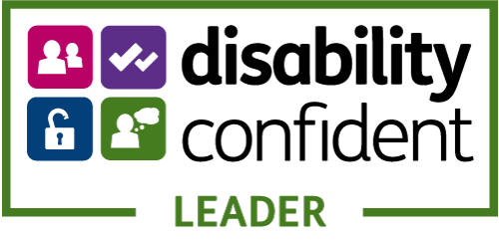

Navajo Charter Mark

In summer 2022 we were proud to be re-accredited with the Navajo Charter Mark for LGBT+ inclusion in employment and service delivery.
Assessed externally by Navajo staff and volunteers the re-accreditation looked at current policy and practice, and progress on the action plan agreed in 2018 when first awarded the Charter Mark.
Work to deliver the action plan is through the EDI Working Group before re-accreditation in 2024.
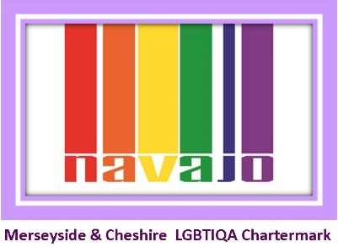
Figure 5: Navajo Charter Mark logo

Armed Forces Friendly

The Armed Forces Act 2021 placed a new due regard duty on organisations in relation to the armed forces community, due regard to the commitments of the Armed Forces Covenant.
Bridgewater has for several years been a signatory of local covenants across our boroughs, Royal Assent of the new Act felt the time was right for the Trust to review and make its own commitments to this community. The Armed Forces Covenant was signed by Board in 2022 and set out the following additional commitments:
- Promoting the Armed Forces: promoting the fact that we are an armed forces-friendly organisation, to our staff, customers, suppliers, contractors and wider public.
- Accessible health and dental services: ensuring our services are accessible and inclusive for the armed forces community, and that there is no disadvantage suffered in accessing our services for members of the community.
- Veterans: supporting the employment of veterans, recognising military skills and qualifications in our recruitment and selection process; and working with the Career Transition Partnership to support the employment of service leavers.
- Service families: supporting the employment of service family members and providing flexibility in granting leave for service family members before, during and after deployment.
- Reserves: supporting our employees who are members of the Reserve Forces; granting additional leave for annual Reserve Forces training; supporting any mobilisations and deployment; and actively encouraging members of staff to become Reservists.
- Cadet Organisations: supporting our employees who are volunteer leaders in military cadet organisations, granting additional leave to attend annual training camps and courses; actively encouraging members of staff to become volunteer leaders in cadet organisations; and recognising the benefits of employing cadets/ex-cadets within the workforce.
- National Events: supporting Armed Forces Day, Reserves Day, the Poppy Appeal Day, and Remembrance activities.
The Trust was awarded Defence Employers Recognition Scheme bronze level in November 2022.
With the support of the Trust’s Veteran Health Care Alliance representative, Bridgewater was delighted to be awarded Veteran Aware accredited status in February 2023. This is a significant recognition of the work undertaken so far to develop and embed armed forces friendly cultures in employment and in service delivery.

Figure 6: Defence Employers Recognition Scheme bronze award logo
Figure 7: Veteran Aware logo
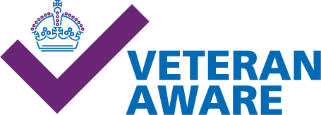

Our next steps are the delivery of an action plan through the EDI Working Group to fill those identified gaps and implement a number of actions, including refresh of communications and literature produced a number of years ago.
The Trust is part of local and regional armed forces networks and is looking to develop further engagement with the armed forces community in the workforce and in the community.

Due regard in service delivery

Due regard to our patients, their families, and carers, and our diverse communities requires us to consider the three aims of the Equality Duty in all service delivery and healthcare related issues. This includes a focus on accessibility, experience, outcomes, and inequalities.
Outlined below are the fundamental functions which support and promote due regard in our employment actions and decisions:
- The Trust’s Communities Matter Strategy, Trust Mission, and PEOPLE Values, all have equality and inclusion embedded. The Communities Matter Strategy details the Trust’s strategic objectives, two of which relate directly to health equity, equality, and inclusion. Valuing diversity and meeting individual needs are at the heart of the Trust’s delivery of community and specialist dental services.
- Equality is a regular feature on Committee agendas reporting up to Board to ensure oversight, challenge, and assurance. See Equality Governance section.
- Trust services are often commissioned quite specifically and may therefore exclude, with justifications, some members of protected characteristic groups, a good example being the differentiation of 0 – 19 Children and Adult Services. Other services require specific criteria set by commissioners, for example GP registration or particular levels/types of need. Others may be clinic based or in people’s homes. In all services staff will work as flexibly as they are able to support patient access. This may include domiciliary visits from a primarily clinic-based service (where equipment etc practicalities allow), or signposting and support to other services to support access. Many services also work closely with partner organisations that may include other NHS Trusts, the local authority, and voluntary sector organisations.
- The Trust’s Quality Impact Assessment Panels include standardised paperwork that includes engagement around service changes, and assessment of equality risk. The Trust’s EDI Lead is a core member of the panel, and using the equality impact assessment risk guidance developed by Midlands & Lancs Commissioning Support Unit supports assessment of equality risk and due regard to the Trusts duties under the General Equality Duty.
- All Trust policies, procedures and guidelines related to patients and services have an equality impact assessment completed by the Trust’s equality lead as part of consultation. Final sign off is given through the governance pathway from the Trust’s Corporate and Clinical Policy Group on to our Quality & Safety Committee and ultimately, to Board.
- All policies are drafted and reviewed by subject matter experts and are reviewed by a large consultation group that includes clinical and corporate staff. Clinical policies are taken from national best practice including NICE guidelines and the Royal Marsden Manual of Clinical and Cancer Nursing Procedures.
- Many policies relate at least in part to equality, but of particular note are the Equal Opportunities Policy, Language Interpretation Policy, Reasonable Adjustments for Patients Policy, and Violence and Aggression Policy. Policies also cover for example consent, Mental Capacity Act, and Safeguarding, which includes child sexual exploitation, female genital mutilation, honour-based violence, and other topics. All undergo equality impact assessment.
- Equality information in patient records is a challenge for the Trust with many fields related to protected characteristic data not mandated at this time. Notes regarding particular needs or concerns are regularly made in patient records, for example language, reasonable adjustments, safeguarding etc, but these aren’t in a format that allows data to be pulled from records for review, and indeed data protection would mean that some of this would never be available for general review.
- As a result, the Trust committed to membership of the Cheshire and Merseyside equality collaborative some years ago. A group led by commissioning colleagues that looked at research and engagement, nationally, regionally, and locally, on barriers to access that impacted on equality for protected characteristic and vulnerable groups and took actions collaboratively to address these. Work has included the development of the quality standard for language interpretation, work on accreditation for support for the armed forces community, and ongoing work to develop a transgender patient support policy. The Trust, and the region, remain committed to collaboration on equality across the region for the benefit of staff, patients, and communities.
- At present the recording of reasonable adjustments is within the notes of patient records. With the updates to the NHS Spine/National Care Record System about to launch the Trust’s ability to record and access existing information about reasonable adjustments should improve, in line with the NHS Accessible Information Standard. A Working Group is looking at developing training, a standard operating procedure, communications, and updates to existing policies in relation to this development.
- Trust records in relation to gender diversity have limitations, so Trust policy and guidance to staff details noting and using affirmed pronouns and names. The Trust is part of the Cheshire and Merseyside equality collaborative that with engagement with local groups is developing a transgender support policy for patients – a complex piece of work due to the many medical factors that are relevant to gender across the organisations. As a Navajo LGBT+ Charter Mark holder the Trust has an action plan to improve LGBT+ equity and inclusion in services, this includes this policy along with engagement, training, and other actions. The Trust committed to NHS Rainbow Badges in 2019 and has a training module for staff to access before making their commitment to the Badges; consideration is being made to the new phase 2 accreditation scheme. Information for staff support considered the Brianna Ghey trial in late 2023 and included signposting to staff and patient support for those impacted by the trial and the publicity surrounding its outcome in December 2023.
- Work has been undertaken in services to improve the recording of marriage and civil partnership, updating legacies within record systems that were not inclusive of the diversity of family units that exist.
- Regular patient feedback from all services is through the standard Talk to Us forms.
- The Trust has a child friendly Talk To Us form in use across services and also uses SMS messaging to receive feedback after an appointment. Work is ongoing in partnership with local groups to develop a Talk To Us form for patients with learning disabilities.
- Where more formal feedback is gathered, for example complaints, the Patient Experience Team work to understand any potential equality factors and work closely with the equality lead on any lessons learned or further understanding that is needed to better address the complaint and make necessary changes as a result.
- The Patient Experience Team works with individual services on bespoke patient engagement exercises. The team also leads on the Trust’s Patient Partners programme, an established programme for involvement of patients at service level in service improvements.
- We understand that patients and carers are often best placed to gauge how services are performing. Patient Partners is an approach that aims to actively encourage patients, their families and carers to work in collaboration with services to identify areas for improvement in quality of care and service delivery. A network of clinical staff meets regularly to discuss and share good practice in involving patients and carers in service improvement activities. The network aims to ensure all services continually listen to the unique insight of patients and carers in order to inform service development and to improve patient care and service quality.
- Individual services undertake engagement with local groups and with patients. For example for the redesign of the neurodevelopment diagnosis pathway in Warrington the children’s service is engaging with WARPAC and with the local authority and schools to gain views and feedback and share information on the proposal.
- Patient experience reports are collated monthly and shared within governance structures, through to Board. Patient stories are a regular Board agenda item, both good news stories, and stories where things may not have gone to plan, and lessons have been learned through governance reviews.
- The Trust also engages at place level with partners in the Integrated Care Board/Integrated Care System, provider collaborative, and equality groups such as local armed forces networks. The Trust also has links with local Healthwatch organisations and is working to better engage with them in a supportive partnership.
- The North West and Cheshire and Merseyside regions are fortunate to have strong and support equality networks for leads, bringing together information, best practice, and issues from across the region, including from engagement with voluntary sector and patient groups.
- Engagement with local voluntary groups representing protected characteristic and vulnerable groups has commenced in 2023 and includes Irish Community Care, Trinity Safe Space, and Warrington Deaf Club (whose members include Halton residents). The information provided in this engagement is noted within public engagement trackers that are held by the transformation team who support services in delivery of borough operation plans, themselves aligned to the Trust’s strategic objectives. There is a commitment in the public engagement work to continue to engage with the same groups, and feedback actions undertaken as a result of conversations held.
- The Trust has a strong focus on the ‘voice of the child’ and has published information and training to support staff in this important area. The webpage introduction states:
  - The voice of the child is a phrase used to describe the real involvement of children and young people. It means more than seeking their views, which could just mean the child saying what they want, rather than being really involved in what happens. Lord Laming said of Victoria Climbié that no-one could describe a day in her life.
  - Children and young people should have the opportunity to describe things from their point of view. They should be continually involved, and have information fed back to them in a way that they can understand.
  - There should always be evidence that their voice has influenced the decisions that professionals have made. Voice of the child can help others gain a sense of a child's life experience.
  - Understanding the life experience can help professionals make the right decisions for children.
- Professional curiosity is a further programme of work, this time led by our Safeguarding Team, that teaches clinicians to look further and explore holistically the factors influencing the health and wellbeing of an individual or family.
- Incident reporting is embedded across the Trust. The NHS Staff Survey asks questions about the reporting of incidents and staff feeling safe to do so. The Trust recognises the difference in responses for some protected characteristic groups, and through the Staff Networks and recent Freedom To Speak Up engagement activities the Trust is working to improve staff confidence and awareness of reporting of any incidents of concern. Differential responses for disabled and ethnically diverse staff for every staff indicator in 2023 was presented to Board in August.
- The Trust’s Leader in me event that took place in December 2023 focused on us each having a voice that counts, and the various ways and means by which staff can raise concerns.
- Incidents are monitored through the quality governance structure of the Trust to Board, with RCAs undertaken, and lessons learned shared with all staff in Bridgewater Bulletins.
- The Trust’s Just Culture programme is a key part of improving patient safety and experience, with its focus on improving staff reporting of incidents and near misses, and the informal initial approach and ongoing wellbeing focus to embed psychological safety for staff. 60 ambassadors were trained as the programme started to be implemented. This includes the EDI Lead, HR Team, service and operational leads, and the Head of Risk. These ambassadors had a role supporting the delivery of action plans to embed a Just Culture across the Trust. Work continues and is now aligned to the Patient Safety Incident Response Framework work plans.
- The Trust is actively working to embed policy and practice to implement the new NHS Patient Safety Incident Reporting Framework which will replace existing serious incident reporting processes in 2023/24. This work is led by the Board with representatives from across the Trust, including engagement with the equality lead.
- The Trust’s approach to transformation and quality improvement is known as the BOOST (Building On Our Strengths Together) programme. The approach features a strong ethos of staff inclusion and engagement, with programmes of work being agreed and developed from the "bottom up” – usually starting with a series of staff workshops that are open to staff at all levels within the organisation, where ideas are gathered to form the basis of directorate and service work streams.
- BOOST’s methodology is based on NHS England’s Change Model, using simple PDSA (Plan, Do, Study, Act) cycles to drive change, and is supported by the Trust’s Transformation Team. Upon creation of a transformation or quality improvement plan, follow up staff workshops are arranged, to ensure that staff engagement remains central to the steering and delivery of the plans.
- Progress with transformation and quality improvement plans are monitored by the Trust’s Transformation Council to ensure appropriate governance is in place, and that plans have high visibility within the organisation.
- All Trust staff must undertake mandatory training, of which some is standard for all and some role specific. This includes equality eLearning every three years that covers legislation and also scenario-based learning.
- Training recommendations are governed through the Education Governance Group, part of the quality and people governance structures, to ensure all training is appropriate and of high quality.
- Additional training may be identified through reviews and incidents, for example a safeguarding review in Halton has identified a training need in relation to Gypsy, Roma, and Traveller communities, training that is being developed for the 0 – 19s services in Halton and Warrington with Irish Community Care.
- Civility and respect and violence prevention are key priorities in the Trust, with work already referenced being undertaken on a refresh of messages, policies, and training. This includes these behaviours towards patients from staff and from other patients/members of the public. While reports of these behaviours towards patients are very low in the Trust we are working hard to ensure through engagement and other work that this is an accurate reflection rather than an unwillingness or barrier to reporting for protected characteristic groups in services.
- https://www.bridgewater.nhs.uk/wp-content/uploads/2018/07/Bridgewater-Patient-charter.pdf
- The Trust has in development new resources regarding civility and respect. At present zero tolerance posters are available for display in services, but these need to align the new civility and respect toolkit and violence prevention and reduction standard. A Working Group that includes HR, EDI, health and safety, and risk have worked together to update and align the policy, develop new communication resources, and develop and start to deliver training.
- The Trust Board has committed to the NHS North West Anti-Racist Framework and is working towards an application for bronze accreditation in the coming months, this is being led by the EDI Working Group. The Trust could potentially apply for accreditation more quickly than this, but we want to fully engage with our staff with regards to lived experience and embed their experiences, ideas, and concerns in actions that will fundamentally address race (in)equity within the structure of the Trust. While predominantly about employment the Framework does have a limited number of service facing deliverables, and of course good employment is one of the Marmot social determinants of health. Through engagement with the Trust’s Race Inclusion Staff Network, with local voluntary groups, and alignment with Anchor Institute/Health Equity leads in the Trust the intent is to deliver actions that will support both workforce and the communities in which they live.
- Regular communications are issued to all staff regarding anti-bullying and harassment, racism, LGBT+phobia etc to raise awareness and provide signposting to support. Freedom To Speak Up is also aligned to EDI to provide additional reporting routes.
- All Trust services can access language interpretation for spoken and signed languages. At present other formats such as Makaton, Easy Read and Braille are sourced ad hoc as the Liverpool Framework for these lots is finalised. In house the Trust has specialist learning disability support in Halton through the Community Matron Team who advise and supports services in relation to access and support for learning disabilities patients in the borough. Work is underway to look at how patients can access Trust services via the interpreter services themselves, becoming more of a two-way source of access support. Please see Appendix 5 for our language interpretation usage in 2023.
- AccessAble have produced access guides to some Trust clinics through Community Health Partnerships, our landlord in some services. These are available on their website, and the Trust is looking to engage with AccessAble about guides for our Trust owned buildings in 2023-2024.
- A Patient Led Assessment of the Care Environment (PLACE) took place at Widnes Urgent Treatment Centre in September 2022. PLACE involves local people (known as patient assessors) going into healthcare settings to assess how the environment supports the provision of clinical care. An action plan based on patient assessors’ recommendations is currently being worked through by the Operational Manager of the Urgent Treatment Centre and the Estates team. The action plan is monitored at the Borough Quality meetings.
- The Trust is a Disability Confident Leader, and while this relates mostly to employment there are indicators relevant to service delivery, and the action plan notes these, including accessible information/reasonable adjustment records, and patient engagement.
- The Trust’s internet has been refreshed in 2022, based on national accessibility guidelines. The website hosts ReachDeck accessibility software that allows patients to tailor their view to best suit their needs, whether this is translation, screen masks, text to speech, or creation of MP4 files.
- The house writing guide for leaflets and patient information was refreshed in 2022 based on national accessibility guidelines. The new templates are created to allow easy access using digital technology, but paper copies, translations and other formats will always still be produced based on patient need.
- All staff can access information and advice about different needs in health care including those related to religion (this includes annual Ramadhan advice through the relevant month of fasting).
- Trust teams undertake regular communications and awareness raising to ensure all staff are aware of diverse need and experience. This includes annual religious and cultural events such as Ramadan, Diwali, and Spring Festival, and also awareness raising such as hate crime awareness, violence against women, and safeguarding children.
- The Trust launched its new Carers Strategy in 2023 and implemented service changes to ensure that carers attending services with loved ones or as patients themselves are identified, recorded, and signposted as appropriate to support services. Staff training has been rolled out to support this development. https://bridgewater.nhs.uk/aboutus/information-for-carers/
- The Trust was awarded Defence Employers Recognition Scheme bronze, and Veteran Aware accreditation in late 2022, action plans are in place to ensure progression/re-accreditation as the Trust works to remove barriers to access for the armed forces community, and to improve equity and inclusion for the community in services and employment. This supports the new legal duty of due regard to the Armed Forces Covenant.
- Trust services work actively with asylum seekers housed throughout the boroughs, and signpost and support registration with services as needed to ensure barriers to accessing NHS services are removed or minimised.
- The Community Health and Wellbeing Worker Programme is a new model of care that provides universal and integrated geography-based outreach in peoples own homes, based on the Brazilian Family Health Strategy model. It is currently running within the Oakwood area of Birchwood, which according to the Index of Multiple Deprivation is ranked in the top 20% of the most deprived areas in the UK. This is a proactive approach, whereby the Community Health and Wellbeing Workers actively seek out engagement in the service at a household level, thereby allowing for the discovery of unmet health needs, with the ultimate aim of reducing inequality. Employment requirements are kept to a minimum to allow for increased diversity in the team of Community Health and Wellbeing Workers, with the aim of employing as locally as possible.
- In autumn 2023 the Trust appointed the first voluntary sector Link Workers following engagement with voluntary sector groups during 2023. Employed by the voluntary sector and working within Bridgewater the role is designed to link Trust services to voluntary sector organisations, providing a link for signposting and linking to opportunities such as social prescribing opportunities in our boroughs.
- Research is important in the Trust with clinical and corporate staff supported to undertake individual and collaborative research, with the updates made in National Institute for Health and Care Research impact on inequalities is embedded in review of research proposals regionally. The Warrington Neurosciences service have in 2023 successfully bid for funding for two projects looking at inequality in Warrington.
- Staff are supported by the internal Library Service who advise on updated NICE guidance, changes to legislation, current news, and who provide an invaluable source of support in developing the patient policies, procedures, and guidelines.
- The Trust’s services are effectively supported by our Safeguarding Teams, with staff and named nurses working collaboratively with outside agencies to ensure the most vulnerable in our communities are identified and supported.
- There is robust health and safety, and risk management in place with policy, training, and governance to ensure the safety and wellbeing of staff and patients accessing services, this includes processes around violence and aggression prevention, reduction, management, and support.
- As a Trust committed to becoming an anchor institute the public health lead for the Trust is leading, with executive support, on action plans in relation to this. This is being aligned to workforce EDI work and to the public engagement taking place.
- In 2023 it was agreed with Cheshire and Merseyside commissioner colleagues that three Trust services would undergo equality review and grading through the Equality Delivery System (EDS). These were Urgent Treatment Centre Widnes (Halton), Podiatry Warrington, and Bath Street Dental Warrington. The domain scores can be seen in appendix 1, and the full evidence report can be viewed at https://bridgewater.nhs.uk/aboutus/equalitydiversity/equalityact2010/ .
- As referenced previously the Trust has refreshed and re-launched its Bridgewater Engagement Group, and work has begun on engaging with representative groups in the community. However, in 2023 this was not aligned to EDS stakeholder review and grading, and as a result we want to thank Healthwatch colleagues in Halton and Warrington for providing the necessary peer review for domain 1.
- As stated earlier in the report the Trust was awarded a number of accreditations in 2022 that recognise equality in service delivery, and action plans are being implemented to continue to improve in these areas.

Governors

As an NHS Foundation Trust we have some devolved decision making authority, with our members and governors supporting and challenging the Trust in our strategy and how we operate and run services.
Our members can be service users, carers, staff, and other local people interested in Bridgewater. They represent the areas in which the Trust delivers services, i.e. Halton, Warrington and those parts of the North West region where we provide community dental services including Bolton, Oldham, Rochdale, Bury, Ellesmere Port, St Helens, Widnes, Warrington and Leigh.
We strive to ensure our members are representative of the communities in which they live. When recruiting members we pay due regard to the diversity of an area and endeavour to encourage people from a diverse range of groups through targeted engagement with local groups.
Our public governors are elected by our members to undertake specific roles, including the appointment of the Trust Chair and non-executive directors, and holding the Board to account on decision making and progress; we make every effort to encourage diversity in applications to public governor roles as they are advertised.
Our staff governors are elected by our staff members. Again, we are seeking to harness the knowledge of our colleagues who are members of our Race Inclusion Network, Enabled Network, and other Staff Networks, by encouraging them to consider standing for election in 2023.
It is important our Council of Governors is reflective of the communities they serve and the staff they represent, and we make every effort to consider the diversity of the towns where we deliver services. We remain cognisant of the need to encourage greater representation of culturally diverse and challenged sectors and shall be working closely with those groups in the months to come.

Local demographics

Based on 2019 ONS income deprivation mapping.
In Halton 18.5% of the population was defined as income deprived in 2019, and the authority is the 31st most income deprived local authority in England:
- 35 of the 70 neighbourhoods in Halton are in the 20% most deprived in England.
- 12 of the 79 neighbourhoods in Halton are in the 20% least deprived in England
Figure 8: Showing a map of socio-economic deprivation in Halton
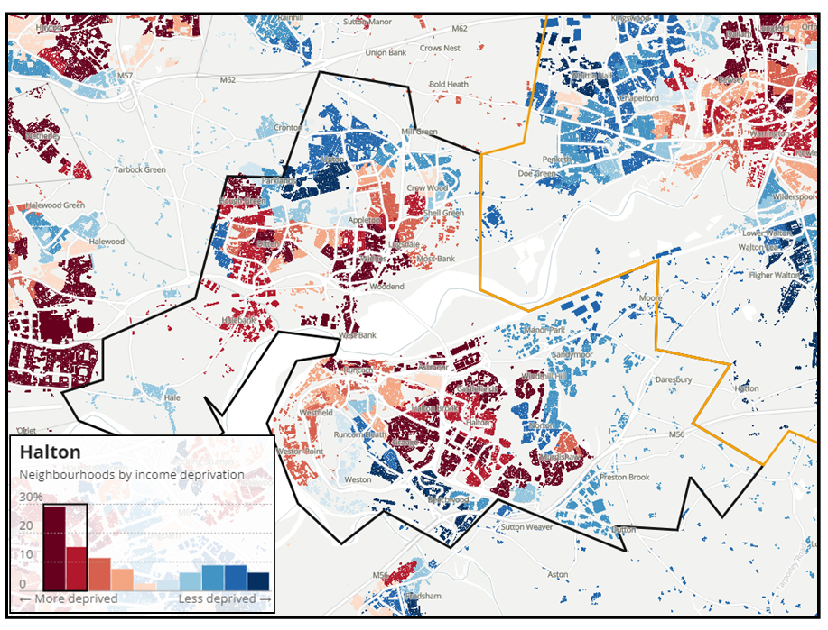

In Warrington 10.9% of the population was defined as income deprived in 2019, and the local authority was ranked 153rd most deprived in England (out of 316 local authorities:
- 22 of the 127 neighbourhoods in Warrington were ranked in the 20% most deprived in England.
- 40 of the 127 neighbourhoods were ranked in the 20% least deprived in England.
Figure 9: Showing a map of socio-economic deprivation in Warrington
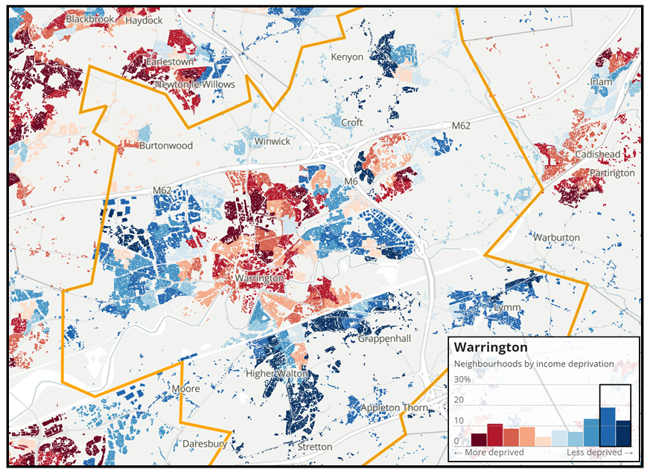

Population Data Halton:

Census 2021 data tells us that:
- The Halton population is 128,478.
- 51% are female, and 49% male.
- 19% of the population were under 16, a further 4.3% under 20, and 19.7% were aged 65 or over.
- 42% were married or in a civil partnership.
- 96.5% were white, and 3.5% from ethnically diverse heritages.
- 3.0% identified with a non-UK national identity solely.
- 58.6% identified as Christian, with 1.6% identifying with other religions.
- 95.2% were UK born, with 1.8% identifying as born outside Europe, the majority in the Middle East or Asia.
- 0.4% of households had no adult residents with English as a first language, and a further 1.7% of households with no residents with English as a first language.
- 55.1% were employed, with 2.7% unemployed, 22.1% retired, 3.8% students, and 14.5% economically inactive due to disability/ill health, caring responsibilities, or other reasons.
- 2.6% identified with diverse sexual identities.
- 208 residents identified as trans, non-binary or another gender identity.
- 10.7% identified as disabled under the legal definition of such, a total of 13,770 residents.
- 6.6% of residents provided 20 or more hours of unpaid care for a loved one.
- 5,000 residents identified as an armed forces veteran or service leaver having served in the regulars and/or reservist forces.

The public health profile for Halton shows inequality in:
- Life expectancy at birth.
- Under 75s mortality rate for cardiovascular disease.
- Emergency emissions for self-harm.
- Hip fractures in the over 65s.
- Alcohol concerns.
- Obesity.
- Teenage conception.
- Smoking during pregnancy.
- Breastfeeding rates.
https://fingertips.phe.org.uk/profile/health-profiles/data#page/1/gid/1938132701/pat/6/par/E12000002/ati/302/are/E06000006/yrr/1/cid/4/tbm/1
The child health profile for Halton shows inequality in:
- School readiness.
- Children in care.
- Obesity.
- Dental decay.
- Teenage conception.
- Alcohol under 18s.
- Substance misuse in 15 to 24 year olds.
- Smoking during pregnancy.
- Breastfeeding.
- Emergency admissions in under 4s (worst in country).
- Other hospital admissions in children and young people.
https://fingertips.phe.org.uk/profile/child-health-profiles/data#page/1/gid/1938133228/pat/6/ati/402/are/E06000006/iid/92196/age/2/sex/4/cat/-1/ctp/-1/yrr/3/cid/4/tbm/1

Population Data Warrington:

Census 2021 data tells us that:
- The Warrington population is 210,974.
- 50.5% are female, and 49.5% male.
- 18.1% of the population were under 16, a further 4.1% under 20, and 19.0% were aged 65 or over.
- 46.9% were married or in a civil partnership.
- 93.5% were white, and 6.5% from ethnically diverse heritages.
- 5.8% identified with a non-UK national identity solely.
- 56.7% identified as Christian, with 3.4% identifying with other religions, the predominant being Muslim.
- 90.6% were UK born, with 3.8% identifying as born outside Europe, the majority in the Middle East or Asia.
- 0.8% of households had no adult residents with English as a first language, and a further 3.7% of households with no residents with English as a first language.
- 58.3% were employed, with 2.3% unemployed, 23.1% retired, 3.6% students, and 10.7% economically inactive due to disability/ill health, caring responsibilities, or other reasons.
- 2.5% identified with diverse sexual identities.
- 402 residents identified as trans, non-binary or another gender identity.
- 7.6% identified as disabled under the legal definition of such, a total of 16,091 residents.
- 3.6% of residents provided 20 or more hours of unpaid care for a loved one.
- 6,875 residents identified as an armed forces veteran or service leaver having served in the regulars and/or reservist forces.

Public health profile for Warrington shows inequality in:
- Life expectancy at birth for some groups.
- Under 75s mortality from cardiovascular disease.
- Emergency admissions for self-harm.
- Hip fractures in the under 65s.
- Alcohol admissions in under 18s.
- Obesity.
- Breastfeeding.
- Violence crime.
https://fingertips.phe.org.uk/profile/health-profiles/data#page/1/gid/1938132701/pat/6/ati/302/are/E06000007/iid/90366/age/1/sex/1/cat/-1/ctp/-1/yrr/3/cid/4/tbm/1
Child health profile for Warrington shows inequality in:
- Homelessness.
- Dental decay.
- Alcohol under 18s.
- Substance misuse in 15 to 24 year olds.
- Breastfeeding.
- Various hospital admissions in children and young people.
https://fingertips.phe.org.uk/profile/child-health-profiles/data#page/1/ati/402/are/E06000007

Patient feedback

The Trust’s Patient Experience Team provide leadership and day to day management of patient feedback; this includes the Talk to Us Form returns, questions, compliments, and formal and informal complaints.
All services are required to seek patient feedback through the Talk to Us forms, which are available as in a paper format, as a text message, and in a child friendly version, and in development is an Easy Read form in co-production with local learning disabilities groups.
The data is collated monthly and shared within governance structures up to Board, where patient stories are also regularly shared – see page https://bridgewater.nhs.uk/patient-information/ .
The team works closely with the EDI Lead to ensure any potential equality factors are identified in questions submitted or complaints raised. There have been no identified equality related complaints in 2023.
Table 4: Showing patient feedback data from 1st January to 30th September 2023
January - March 2023
Percentage of patients who rated their experience good or very good | 95.8%
Compliments received | 4,938
Contacts received – informal concerns, signposting, liaison, and advice/information | 270
Informal concerns Treatment Rooms (5) Health Visiting (3) | 17
Formal complaints Paediatric Community Medical Service (4) | 9
Joint complaints | 1
MP letters Paediatric Community Medical Service, Warrington (2), Dental, Warrington (1) | 3
Complaints referred to the Parliamentary and Health Service Ombudsmen | 0
April – June 2023
Percentage of patients who rated their experience good or very good | 95.7%
Compliments received | 3,532
Contacts received – informal concerns, signposting, liaison, and advice/information | 285
Informal concerns Halton (17) Warrington (28) Dental (7) | 52
Formal complaints Halton (6) Warrington (6) | 12
Joint complaints | 1
MP letters Paediatric speech and language service, Warrington | 1
Complaints referred to the Parliamentary and Health Service Ombudsmen | 0
July - September 2023
Percentage of patients who rated their experience good or very good | 96.0%
Compliments received | 4,997
Contacts received – informal concerns, signposting, liaison, and advice/information | 298
Informal concerns Adult Services: Halton (5), Warrington (5) Children’s Services: Halton (3), Warrington (6) of which seven relate to Children’s Specialist Services: Paediatric Community Medical Services (5): Halton (3), Warrington (2), Children’s Neuro-developmental Service (2) and four relate to Dental Services: ORB (3), Stockport (1). | 23
Formal complaints Halton (3), Warrington (5), Dental (1) | 9
Joint complaints Urgent Treatment Centre Halton (2), Intermediate Care Warrington (1), Health Visiting/Paediatric Speech and Language Therapy/Paediatric Community Medical Service Warrington (1) | 4
MP letters District Nursing/Community Matrons Halton (1), District Nursing Warrington (1) | 2
Complaints referred to the Parliamentary and Health Service Ombudsmen

Borough plans

The borough operational delivery plans have been developed for 2023/24 aligned to the Trust’s six strategic objectives with actions identified based on data, local and national priorities, and staff and patient engagement.
Each Trust directorate has an operational delivery plan:
- Childrens
- Halton Adults
- Warrington Adults
- Dental
The plans include an introduction, current context, achievements in the previous year, and identified priorities. The plans were reviewed by the Trust’s EDI Lead prior to finalising to provide an equality impact assessment of the planned actions.
As the Trust has a strategic objective for health equity, and one for EDI, each plan has deliverables targeted at these areas.
Childrens:
- Warrington Health and Wellbeing Hub
- Halton Health and Education Hub
- Development of a children, young people, parent, and carers participation plan
Halton Adults:
- To explore service-user access to the Widnes Urgent Treatment Centre (UTC). Enabling us to ensure services are targeted at those most in need, to enhance outcomes and improve the health and wellbeing of local population.
- To continue to work with system partners to develop an enhanced Heart Failure Pathway within Halton- improving care and health outcomes for those patients with Heart failure and their carers and families.
- To develop and implement a high quality, safe and effective Enhanced Care Home Support Service Model in Halton which will enhance care home delivery, improve outcomes, and support a reduction in unnecessary hospital admissions.
- We will prioritise all services users including the most vulnerable people that access our services.
- To strive to secure a healthy and diverse workforce.
- We will continue to improve the reach of our organisation and grow our standing in the community through local partnerships.
Warrington Adults:
- Intermediate Care Services – Community. This workstream has several strands and includes the ongoing service improvement between Warrington Borough Council IMC at Home service and the IMC therapy service, further development of the integrated management and governance structures and redesign of the community rehabilitation and falls service within the IMC landscape.
- Neurosciences Service. Functional Electrical Stimulation (FES) Project. The use of electrical stimulation has been recommended in the RCP guidelines for the upper and lower limb (RCP, 2018). There is currently only one clinician trained in this modality and there are long waiting lists.
- Neurosciences Services. Provision of splinting – external funding has supported the development of the service for specialist thermoplastic splinting for upper and lower limb dysfunction.
- Warrington One Front Door (OFD). This is a project led by Warrington Borough Council, we are a key partner and fully signed up to this approach through our collaborative Warrington Together.
- Patient Involvement and Engagement
Dental:
- Implement the place - based Safeguarding/Advocates roles
- Collaborate with HEE, to host a second year of Foundation Dental Therapists: and expand our offer to hosting Foundation Dentists
- Implement a paediatric GA pathway at Oldham General Hospital for Oldham, Rochdale and Bury.
- Ensure a high quality, responsive interpreter service is procured.

Appendix 1 – EDS2023

The Equality Delivery System, or EDS, was refreshed by NHS England in 2022 to provide a simplified, easy to use toolkit for co-delivery with stakeholders from patients, communities, the workforce and Staff-side, and for domain 3 peer support organisations.
In domain 1 the outcomes have remained largely the same, with clearer deliverables now provided to be evidenced against. These look at access, outcome, safety, and experience of diverse patients and communities accessing services.
Domain 2 has been updated to take account of the inequality clearly evidenced in the disproportionate impact of Covid 19 on ethnically diverse communities, and those with underlying health conditions. EDS now supports the outcomes of the WRES and WDES by supporting organisations to make the connections between race and disability inequality and discrimination and health and wellbeing. The other seven protected characteristic groups and other vulnerable groups are of course also included in evidence gathering and review.
Domain 3 remains focused on the inclusive behaviours and messages of Trust leaders and how equality governance and oversight is managed within the Trust.
The 11 outcomes of EDS2023 cover three domains:
- Commissioned and provided services.
- Workforce health and wellbeing.
- Inclusive leadership.
Three services were agreed with Halton and Warrington commissioners for 2023 review in domain 1:
- Urgent Treatment Centre Halton.
- Podiatry Warrington.
- Bath Street Dental Warrington.
Engagement for evidence review and grading was undertaken with stakeholders from Staff-side and Staff Networks for domain 2, and peer review was given by local Healthwatch representatives for domain 1, and Wirral Community Health and Care NHS Foundation Trust equality colleagues for domain 3, with heartfelt thanks to all.
The full EDS20232 report can be viewed on our website at https://bridgewater.nhs.uk/aboutus/equalitydiversity/equalityact2010/ but results are detailed below.
Table 5: Showing the EDS 2023 grading as agreed with stakeholders
EDS2023 Domain and Outcome | Rating
Domain 1: Commissioned or provided services
1A: Patients (service users) have required levels of access to the service | Developing
1B: Individual patients (service users) health needs are met | Developing
1C: When patients (service users) use the service, they are free from harm | Developing
1D: Patients (service users) report positive experiences of the service | Achieving
Domain 2: Workforce health and wellbeing
2A: When at work, staff are provided with support to manage obesity, diabetes, asthma, COPD, and mental health conditions | Achieving
2B: When at work, staff are free from abuse, harassment, bullying and physical violence from any source | Achieving
2C: Staff have access to independent support and advice when suffering stress, abuse, bullying, harassment, and physical violence from any source | Achieving
2D: Staff recommend the organisation as a place to work and receive treatment | Achieving
Domain 3: Inclusive leadership
3A: Board members, system leaders (Band 9 and VSM) and those with line management responsibilities routinely demonstrate their understanding of, and commitment to, equality and health inequalities | Achieving
3A: Board/Committee papers (including minutes) identify equality and health inequalities related impacts and risks and how they will be mitigated and managed | Achieving
3C: Board members and system leaders (Band 9 and VSM) ensure levers are in place to manage performance and monitor progress with staff and patients | Achieving
Overall rating | Developing  (total score of 19)

Appendix 2 - Gender Pay Gap 2023

The full report for Gender Pay Gap at 31st March 2023 can be found on our website, but please see below in brief our 2023 results.
Table 6: Showing Gender Pay Gap results for 31st March 2023
 | March 2019 |  | March 2020 |  | March 2021 |  | March 2022 |  | March 2023
Number of male and female staff in quartiles 1 to 4
 | Female | Male | Female | Male | Female | Male | Female | Male | Female | Male
1 | 660 | 57 | 397 | 44 | 370 | 50 | 371 | 50 | 328 | 44
2 | 621 | 61 | 416 | 24 | 397 | 23 | 391 | 30 | 347 | 24
3 | 626 | 42 | 415 | 25 | 392 | 28 | 395 | 26 | 343 | 29
4 | 707 | 97 | 373 | 67 | 364 | 56 | 367 | 54 | 316 | 55
Mean Gender Pay Gap
Percentage % | 22.38 |  | 25.35 |  | 16.14 |  | 14.45 |  | 15.97
Cost £ | 4.53 |  | 5.56 |  | 3.26 |  | 2.95 |  | 3.48
Median Gender Pay Gap
Percentage % | 1.54 |  | 9.19 |  | 2.37 |  | 0.34 |  | 3.16
Cost £ | 0.23 |  | 1.56 |  | 0.38 |  | 0.06 |  | 0.55
Bonus pay
Percentage % | No bonus pay gap, all clinical excellence awards to female staff in relevant period |  |  |  |  |  |  |  | 0.00

Appendix 3 – Workforce Disability Equality Standard 2023 (WDES)

The full report for WDES 2023 can be found on our website, but please see below in brief our 2023 results.
Table 7: Showing the WDES results for 2023
Metric
- Percentage of staff in each AfC Band 1-9 or Medical and Dental pay grades, compared with the percentage of staff in the workforce overall. Disaggregated by non-clinical staff, clinical staff, and medical and dental staff. Note rounding up of numbers may mean a slightly higher figure than 100% is seen in the below.
 | Non-clinical |  |  |  | Clinical
 | Disabled | Not Disabled | N/S |  | Disabled | Not Disabled | N/S
AfC1 - 4 | 5.5 | 82.2 | 12.3 |  | 1.7 | 78.8 | 19.5
AfC5 - 7 | 2.3 | 79.1 | 18.6 |  | 3.1 | 82.3 | 14.1
AfC8a – 8b | 0.0 | 83.9 | 16.1 |  | 5.1 | 64.4 | 30.5
AfC8c - VSM | 10.0 | 70.0 | 20.0 |  | 2.8 | 80.6 | 16.6
 | Medical and Dental Grades:
Consultants | 0.0 | 80.0 | 20.0
Non-Consultant Career Grade | 1.4 | 78.8 | 19.7
Trainee Grades | 0.0 | 0.0 | 0.0
- Relative likelihood of being appointed from shortlisting across all posts |  |  |  | 1.0 times – equity between disabled and not disabled applicants
- Relative likelihood of entering capability processes |  |  |  | No formal capability procedures related to performance  No formal capability procedures related to ill health for staff with a disability

Metric - continued
- A) Percentage of staff experiencing bullying, harassment, and abuse from patients/relatives/public in last 12 months | 25.4% Disabled  20.8% Not Disabled
Percentage of staff experiencing bullying, harassment, and abuse from managers in last 12 months | 10.4% Disabled  6.6% Not Disabled
Percentage of staff experiencing bullying, harassment, and abuse from staff in last 12 months | 22.1% Disabled  10.7% Not Disabled
- Percentage staff reporting bullying, harassment, and abuse in last 12 months | 48.6% Disabled  51.4% Not Disabled
- Percentage believing the Trust provides equal opportunities for career progression and promotion | 56.2% Disabled  62.0% Not Disabled
- Percentage feeling pressure by manager to attend work even when feeling unwell | 19.0% Disabled  15.8% Not Disabled
- Feeling valued by the Trust | 40.8% Disabled  48.3% Not Disabled
- Satisfaction that reasonable adjustments made to support them in their work | 85.6% Disabled
- A) Staff engagement score (Disabled staff only) | 6.9 Disabled  7.3 Not Disabled
B) Have you taken action to facilitate the voices of Disabled staff | Yes
- Percentage difference between Board membership and overall workforce  Disaggregated by voting and non-voting members | -3.0% Disabled  -23.0% Not Disabled
Trust Overall Workforce:
Disabled: 3.2%
Non-Disabled: 80.5%
Unknown: 16.4%

Appendix 4 – Workforce Race Equality Standard 2023 (WRES)

The full report for WRES 2023 can be found on our website, but please see below in brief our 2023 results.
Indicator
- Percentage of staff in each AfC Band 1-9 or Medical and Dental pay grades, compared with the percentage of staff in the workforce overall. Disaggregated by non-clinical staff, clinical staff, and medical and dental staff
 | Non-clinical |  |  |  | Clinical
 | White | Black, Asian, or minority ethnic | Not stated, or unknown |  | White | Black, Asian, or minority ethnic | Not stated, or unknown
Under AfC Band 1 | 0.39 | 0.06 | 0.00 |  | 0.00 | 0.00 | 0.00
AfC1 | n/a | n/a | n/a |  | n/a | n/a | n/a
AfC2 | 4.54 | 0.06 | 0.00 |  | 2.01 | 0.10 | 0.06
AfC3 | 8.89 | 0.52 | 0.19 |  | 7.92 | 0.13 | 0.13
AfC4 | 2.21 | 0.00 | 0.00 |  | 7.92 | 0.58 | 0.06
AfC5 | 2.27 | 0.26 | 0.19 |  | 15.12 | 0.84 | 0.19
AfC6 | 1.56 | 0.00 | 0.00 |  | 18.04 | 0.71 | 0.26
AfC7 | 1.04 | 0.26 | 0.00 |  | 9.99 | 0.19 | 0.13
AfC8a | 1.30 | 0.06 | 0.00 |  | 3.24 | 0.19 | 0.06
AfC8b | 0.58 | 0.06 | 0.00 |  | 0.26 | 0.00 | 0.00
AfC8c | 0.71 | 0.00 | 0.00 |  | 0.16 | 0.13 | 0.00
AfC8d | 0.13 | 0.00 | 0.00 |  | 0.06 | 0.00 | 0.06
AfC9 | 0.06 | 0.00 | 0.00 |  | 0.00 | 0.00 | 0.00
VSM | 0.19 | 0.06 | 0.13 |  | 0.06 | 0.00 | 0.00
 | Medical and Dental Grades:
Consultants | 0.19 | 0.32 | 0.13
Non-Consultant Grade | 2.92 | 1.56 | 0.13
- Relative likelihood of being appointed from shortlisting across all posts |  |  |  | 1.44 times more likely to be appointed if you are White
- Relative likelihood of entering formal disciplinary processes |  |  |  | 2.46 times more likely to enter formal disciplinary processes if you are Black, Asian, or minority ethnic
- Relative likelihood of accessing non-mandatory training/CPD |  |  |  | 1.79 times more likely to access this training if you are Black, Asian, or minority ethnic
- Percentage of staff experiencing bullying, harassment, and abuse from patients/relatives/public in last 12 months |  |  |  | Black, Asian, or minority ethnic 29.2%  White 21.6%
- Percentage of staff experiencing bullying, harassment, and abuse from staff in last 12 months |  |  |  | Black, Asian, or minority ethnic 25.0%  White 16.9%
- Percentage believing the Trust provides equal opportunities for career progression and promotion |  |  |  | Black, Asian, or minority ethnic 45.8%  White 62.0%
- In the last 12 months personally experiencing discrimination from manager/team leader/other colleagues |  |  |  | Black, Asian, or minority ethnic 10.4%  White 3.8%
- Percentage difference between Board membership and overall workforce  Disaggregated by voting and non-voting members |  |  |  | Black, Asian, or minority ethnic 8.1%  White -20.7%
Trust Overall Workforce:
Black, Asian, and minority ethnic: 99 (5.75%)
White: 1,562 (90.7%)
Not stated: 61 (3.5%)

Appendix 5 – Language Interpretation 2023

The provision of language and communication support for people whose first language isn’t English, or for people with disabilities or impairments with communication support needs, is very important for effective and safe provision of care, and equity of outcome.
As a Trust through the EDS Collaborative we have implemented the use of a language interpretation quality standard for procurement of interpretation services across Cheshire and Merseyside providers.
Up to 20th August 2023 all language interpretation services were provided by a single external provider, from 21st August two new contracts began, one for spoken languages (including translation of spoken languages in written formats), and signed languages.
A small number of contracts are still to be agreed through the procurement exercise referenced above and led by commissioners in Merseyside, this includes Easy Read, and interpretation/translation services for visually impaired and blind patients.
The following tables provide information on:
- Volume and spend on language interpretation from 1st January to 20th August 2023 – table 8.
- Total service requests for spoken language interpretation from 21st August to 30th November 2023 – table 9.
- Volume for British Sign Language (BSL) interpretation requests from 21st August to 30th November 2023 – table 10.
- Volume by language for spoken interpretation requests from 21st August to 30th November 2023 – table 11.
- Service usage for spoken language interpretation from 21st August to 30th November 2023 – table 12.

Table 8: Showing the volume and spend on language interpretation between 1st January and 20th August 2023
 | Bookings | Spend
Face to Face | 1,335 | 42,229.10
Telephone | 564 | 5,385.60
Video | 47 | 4,907.83
Translation | 148 | 4,768.00
Total | 2094 | 57,290.53

Table 9: Showing total service requests for spoken language interpretation since 21st August 2023
Spoken Language | Bookings
Face to Face | 287
Telephone | 217
Video | 148
Translation | 27
Total | 679

Table 10: Showing the volume for BSL interpretation since 21st August 2023
BSL | Bookings
Face to Face | 32

Table 11: Showing the volume by language of spoken language interpretation bookings from 21st August to 30th November 2023
Top 10 Spoken Languages Requested | Volume
Face to face:
Urdu | 114
Bengali | 48
Arabic | 17
Romanian | 13
Kurdish Sorani | 12
Polish | 8
Mandarin Chinese | 8
Cantonese | 7
Portuguese | 7
Russian | 6
Telephone:
Cantonese | 34
Polish | 28
Arabic | 25
Romanian | 22
Kurdish Sorani | 18
Urdu | 13
Turkish | 6
Portuguese | 6
Russian | 5
Slovak | 5
Video:
Polish | 39
Cantonese | 29
Romanian | 12
Arabic | 12
Kurdish Sorani | 12
Turkish | 8
Urdu | 8
Russian | 5
Kurdish Badini | 5
Tamil | 5
Translation:
Kurdish Sorani | 4
Polish | 4
Slovak | 3
Cantonese | 3
Romanian | 2
Tamil | 2
Urdu | 2
Arabic | 2
Turkish | 1
Mandarin Chinese | 1

Table 12: Showing service usage for spoken language interpretation from 21st August to 30th November 2023.
Top 10 Service Usage | Volume
Pennine Dental | 111
Warrington OCATS | 98
Oldham Dental | 48
Warrington Speech and Language | 42
Bury Dental | 35
Halton Urgent Treatment Centre | 35
Ashton Dental | 31
Warrington Dental | 30
Bolton Dental | 27
Warrington Health Visiting South Team | 22

We have been working closely with our spoken language interpretation providers throughout 2023 as we have worked through some particular difficulties sourcing face to face interpretation in some languages.
There are different factors that are influencing this issue including a shortage of trained interpreters in the region, and a culture change to home working. Our language interpretation providers have worked to actively recruit throughout 2023.

