Workforce Race Equality Standard
Including Medical and Bank Workforce Race Equality Standards

Annual Results and Report 2023

Date: Published 7 August 2023

Contents

 | Page
Introduction | 3
Indicator 1 | 4
Indicator 2 | 7
Indicator 3 | 9
Indicator 4 | 11
Indicator 5 | 12
Indicator 6 | 15
Indicator 7 | 18
Indicator 8 | 20
Indicator 9 | 23
Workforce Race Disparity Ratio Results 2023 | 24
Work in 2022 – 2023 | 26
Summary | 28
Appendix 1: Bank Workforce Race Equality Standard 2023 | 33
Appendix 2: Medical Workforce Race Equality Standard 2023 | 36
Appendix 3: Staff Survey Results 2022 – Full | 39

Introduction
The Workforce Race Equality Standard has been mandated for all NHS providers since 2015.
The nine indicators look at difference in workplace experience for ethnically diverse and white staff, from likelihood of being recruited, to career advancement, involvement in disciplinary processes, and experiences of bullying and harassment and discrimination from different sources. Information is taken from various sources and reported anonymously to NHS England.
In this 2023 report, progression detail has been provided for each indicator from 2015 to date, a full summary table of the NHS England data submission is given, brief information of equality work in 2022 – 2023 provided and full NHS Staff Survey results for 2018 to 2022 shown.
Key findings for 2023 in brief are:
- Overall workforce representation of ethnically diverse staff is increasing and the number of ‘not known’ records decreasing.
- There remains disparity of representation in pay bands and staff groups, however caution is used as many groups are very small and statistical significance is therefore difficult to determine.
- The likelihood of ethnically diverse candidates being recruited from shortlisting has deteriorated slightly.
- The likelihood of ethnically diverse staff being involved in formal disciplinary processes has deteriorated slightly.
- The likelihood of ethnically diverse staff completing non-mandatory training and professional development has deteriorated slightly.
- Caution should be used in indicators 3 and 4 because of small numbers involved.
- The percentages of ethnically diverse staff experiencing harassment, bullying, or abuse from the public or colleagues has increased.
- The percentage of ethnically diverse staff who believe the Trust provides equity for career progression and promotion has decreased.
- The percentage of ethnically diverse staff who experienced discrimination at work in the last 12 months has decreased.
- The Board remains over-representative of ethnically diverse staff.

Indicator 1
Indicator 1 asks the percentage of staff in each pay band, split by non-clinical, clinical, and medical and dental roles. The percentage details by pay band submitted to NHS England for 2023 can be found in the summary table on page 28.
The detail in table 1 shows the overall workforce ethnicity percentages from 2015 to 2023.
Table 1: Showing the percentage of the total workforce by ethnicity from 31st March 2015 to 31st March 2022. Also showing total workforce each year in numbers.
 | 2015 | 2016 | 2017 | 2018 | 2019 | 2020 | 2021 | 2022 | 2023
Ethnically diverse staff | 2.5 | 2.4 | 2.6 | 2.8 | 3.0 | 5.7 | 5.4 | 5.8 | 6.2
White staff | 95.6 | 93.5 | 90.8 | 90.6 | 89.9 | 89.1 | 90.5 | 90.7 | 92.0
Not known | 1.9 | 4.1 | 6.6 | 6.6 | 7.2 | 5.1 | 4.2 | 3.5 | 1.8
Total Staff | 3,325 | 3,251 | 3,305 | 3,005 | 3,016 | 2,048 | 1,730 | 1,722 | 1,541

It can be observed that the percentage of staff whose ethnicity is unknown or not stated has decreased since 2019, this is significant progress as it allows the Trust as an employer to better understand equity within the workplace for ethnically diverse staff. This detail is also shown in Figure 1 on the following page.
Improving recording of protected characteristic information is a key priority for the Trust and it is therefore pleasing to see that efforts to improve self-reporting on staff records has had a positive impact. Engagement with the Race Inclusion Network continues to allow understanding of the barriers to both reporting ethnicity, and to career progression. This supports our work in embedding a psychologically safe culture, and a culture that positively supports and promotes equity of opportunity in employment.

Figure 1: Showing the percentage of staff by ethnicity from 2015 to 2023 as part of the workforce total for each year.
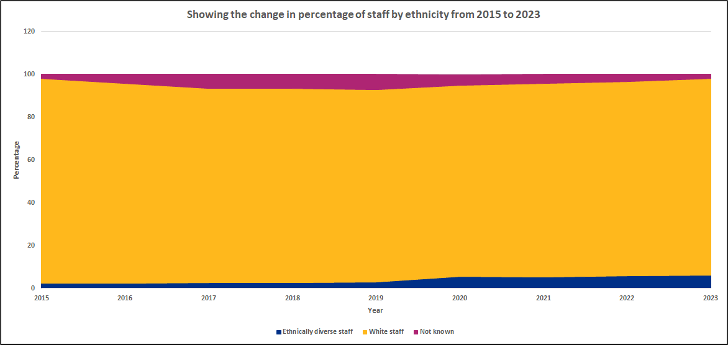

The next table details the percentage of staff by ethnicity in three staff groups:
- Non-clinical – administrative, clerical, and estates
- Clinical – Allied Health Professions, nursing staff, healthcare support workers, additional clinical service staff, additional professional scientific and technical staff, and healthcare scientists
- Medical and Dental
The data in table 2 demonstrates the increased representation of ethnically diverse staff in non-clinical and clinical roles, it can be observed that ethnically diverse staff remain underrepresented in non-clinical roles when compared to the overall workplace ethnically diverse staff percentage representation. In medical and dental roles, as is applicable across most of the NHS, ethnically diverse staff show higher representation than the overall workforce totals.
Table 2: Showing the percentage of staff by ethnicity as a total of each staff group from 2015 to 2023.
 | 2015 | 2016 | 2017 | 2018 | 2019 | 2020 | 2021 | 2022 | 2023
Non-clinical
Ethnically diverse staff | 1.9 | 2.1 | 2.2 | 2.5 | 2.4 | 3.0 | 3.7 | 4.4 | 5.3
White staff | 96.1 | 94.3 | 89.5 | 89.4 | 91.8 | 92.1 | 91.6 | 91.6 | 92.7
Not known | 1.9 | 3.6 | 8.3 | 8.1 | 5.8 | 4.9 | 4.7 | 4.0 | 2.0
Clinical
Ethnically diverse staff | 1.8 | 1.8 | 2.0 | 2.1 | 2.4 | 3.5 | 4.3 | 4.6 | 6.6
White staff | 96.3 | 93.8 | 92.3 | 92.0 | 90.0 | 91.6 | 91.9 | 92.2 | 91.8
Not known | 1.9 | 4.4 | 5.7 | 5.9 | 7.6 | 4.9 | 3.8 | 3.2 | 1.6
Medical and Dental
Ethnically diverse staff | 18.4 | 18.4 | 19.3 | 22.3 | 20.5 | 36.6 | 30.5 | 30.1 | 34.5
White staff | 78.0 | 79.6 | 70.1 | 68.1 | 70.5 | 55.2 | 64.4 | 63.9 | 57.1
Not known | 3.6 | 2.0 | 10.5 | 9.6 | 9.0 | 8.2 | 6.1 | 6.0 | 4.8
Indicator 2
The second indicator asks what the likelihood of being appointed from shortlisting is for ethnically diverse staff compared to white staff. Table 3 provides the results from 2015 to 2023.
Table 3: Showing the likelihood of being recruited from shortlisting for ethnically diverse staff, and white staff. From 2015 to 2023
Recruitment of Ethnically Diverse Staff
2015 - 2023
 | 2015 | 2016 | 2017 | 2018 | 2019 | 2020 | 2021 | 2022 | 2023
Likelihood | 1.85 | 1.72 | 1.30 | 1.24 | 1.28 | 1.39 | 0.61 | 1.17 | 1.44
Total Ethnically Diverse Staff Recruited | 12 | 24 | 31 | 24 | 23 | 13 | 36 | 23 | 23
Total White Staff Recruited | 241 | 532 | 498 | 418 | 395 | 224 | 310 | 276 | 209
Total Not Stated Staff Recruited | * | 160 | 120 | 30 | 10 | 17 | * | * | *

(A figure below 1.0 suggests ethnically diverse candidates are more likely to be appointed than white candidates from shortlisting to appointment).
This data is taken from NHS Jobs and from new starter lists taken from the electronic staff record. It can be seen in the table above that this indicator has fluctuated over the years, and this is portrayed in Figure 2 below which details the yearly likelihood result against the equal representation line at 1.0 times likelihood whereby ethnically diverse and white staff have the same opportunity to be successful in recruitment.

Figure 2: Showing the likelihood of ethnically diverse staff being appointed from shortlisting from 2015 to 2023.
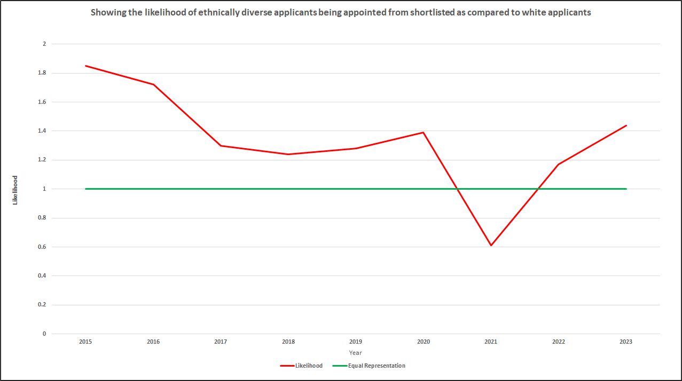

As a Trust that does not hold a tier 2 sponsorship licence we are legally unable to recruit overseas applicants requiring employment sponsorship. This presents challenges for the Trust, but also opportunities to recruit from local communities, and grow our own workforce capabilities, both priority actions for the organisation and seen in campaigns such as healthcare support worker recruitment.

Indicator 3
This indicator looks at the likelihood of ethnically diverse staff being involved in formal disciplinary processes compared to white staff. The table to follow details Trust results from 2015 to 2023.
Table 4: Showing the likelihood of ethnically diverse staff being involved in formal disciplinary processes compared to white staff. From 2015 to 2023.
Ethnically Diverse Staff in Formal Disciplinary
2015 - 2023
 | 2015 | 2016 | 2017 | 2018 | 2019 | 2020 | 2021 | 2022 | 2023
Likelihood | 6.46 | 4.93 | 3.83 | 1.99 | 2.72 | 2.40 | 0.00 | 0.00 | 2.46

(A figure above 1.0 suggests ethnically diverse staff are more likely to be involved in formal disciplinary than white staff).
The results in the table above, and in the figure on the following page, show the fluctuations in this indicator from 2015 to date.
Caution must be used in this indicator as the Trust has a very small number of staff on average who enter formal disciplinary, for example in 2022 – 2023 less than 10 staff in total were included in this data for the year. The small sample size can have a significant impact on results, as can be seen in the results across the years. However the Trust is committed to engagement with staff, and monitoring of cases and outcomes, to ensure that processes are fair and unbiased.
The Trust has since 2021 been rolling out and embedding a Just Culture programme. This focuses on the human factors when something doesn’t go to plan and seeks to ensure everyone involved in a process is actively and continually supported, particularly in relation to health and wellbeing, and communication.
In 2022 the Trust launched the fact-finding process, an informal review after any event that didn’t go as it should, to understand the factors which led to an incident; these may relate to training, equipment, staffing, health, or anything else that can cause pressures on individuals and teams. Only after this process, and communication across the Trust will a decision be made to learn lessons and make effective changes, and/or to progress to a formal disciplinary process.
Figure 3: Showing the likelihood of ethnically diverse staff entering formal disciplinary processes. From 2015 to 2023.
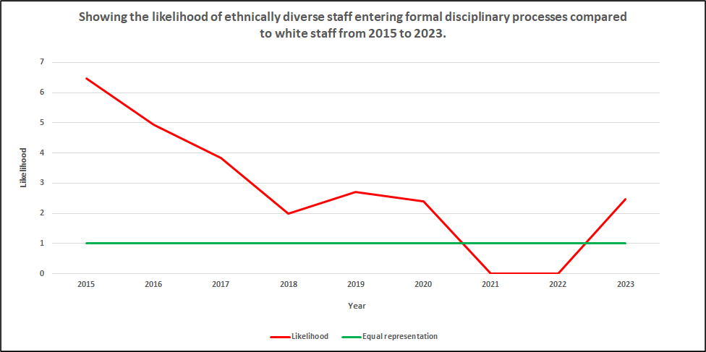

Indicator 4
Indicator 4 looks at the likelihood of staff undertaking non-mandatory training and professional development by ethnicity.
All staff must complete a suite of mandated training on an annual to three yearly cycle, dependant on module. This includes equality, health and safety, and data protection. In addition, there are role specific training modules and levels, for example safeguarding has three levels depending on staff role.
This indicator looks at the other training and development accessed by staff and is a more challenging indicator to report as much development can go unrecorded, for example attendance at training events held externally with no cost. As a result for this indicator we have looked in recent years at staff access to two elements of development – apprenticeships, and core skills (maths and English), and these provide the data we report on for indicator 4.
Table 5: Showing the likelihood of ethnically diverse staff access non-mandatory training and development compared to white staff. From 2015 to 2023.
Ethnically Diverse Staff Undertaking Non-Mandatory Training and Development 2015 - 2020
 | 2015 | 2016 | 2017 | 2018 | 2019 | 2020 | 2021 | 2022 | 2023
Likelihood | 0.0 | 0.55 | 0.90 | 1.10 | 1.74 | 0.60 | 1.09 | 0.57 | 1.79
 | No data available

(A figure below 1.0 suggests ethnically diverse staff are more likely to access non-mandated training and development than white staff).
As this is a challenging indicator to evidence we are working to better embed recording processes so that the diversity of training and development opportunities can be better captured.

Indicator 5
Indicator 5 is the start of the indicators taken from the annual NHS Staff Survey. As the survey runs in autumn with data published early spring the following year the data results always show as a calendar year behind, i.e. in 2023 the Trust reported data is for the staff survey results for autumn 2022. All staff survey indicators show the results for Bridgewater, and also for comparator community Trusts as a benchmark.
The percentage of the workforce submitting the staff survey in 2022 was the highest ever for Bridgewater at 56%, this equates to 828 individual staff members. Data would also suggest that half of all the Trust’s ethnically diverse staff also submitted responses to the survey, caution needs to be used though as some of the 48 respondents may have chosen not to state their ethnicity on the electronic staff record.
Table 6: Showing the percentage of staff who reported experiencing bullying, harassment, or abuse from patients/families/public. From 2015 to 2022.
Bridgewater: | 2015 | 2016 | 2017 | 2018 | 2019 | 2020 | 2021 | 2022
Ethnically diverse staff | 0.0* | 23.0 | 28.6 | 37.5 | 28.0 | 30.3 | 22.2 | 29.2
White staff | 28.0 | 29.0 | 25.8 | 26.0 | 23.1 | 18.2 | 20.1 | 21.6
Benchmark: | 2015 | 2016 | 2017 | 2018 | 2019 | 2020 | 2021 | 2022
Ethnically diverse staff | 25.0 | 24.0 | 26.9 | 26.1 | 23.7 | 23.4 | 24.3 | 24.2
White staff | 26.0 | 24.0 | 23.4 | 25.7 | 25.2 | 21.9 | 20.6 | 21.5

*Note: Figure too low to report for Black, Asian, or minority ethnic staff in 2015
Figure 4: Showing the percentage of ethnically diverse and white staff who experienced bullying, harassment, or abuse from patients/families/public in the last 12 months for Bridgewater and benchmark Trusts. From 2015 to 2022.
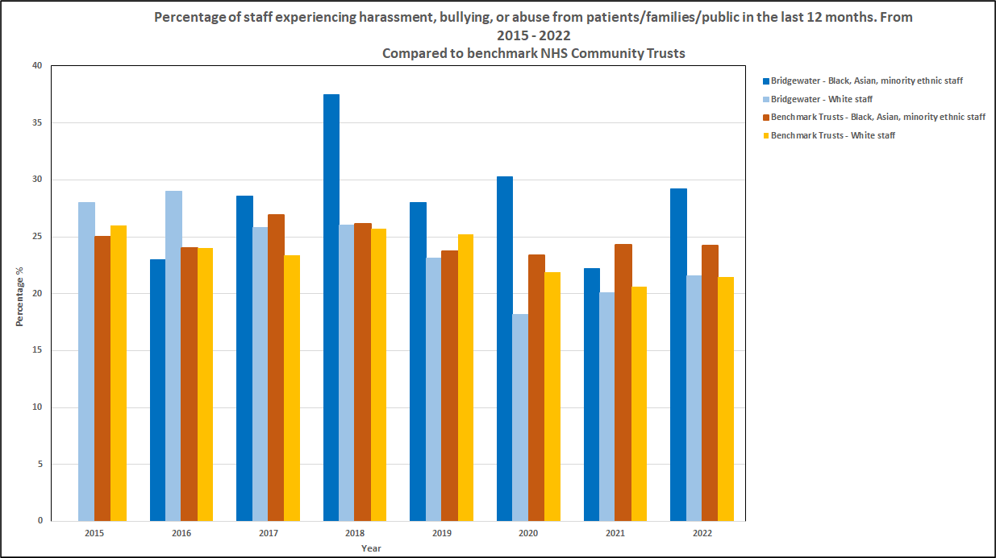

Figure 4 shows the annual changes in results for ethnically diverse and white staff in Bridgewater and in our benchmark comparators. It can be observed that a gap remains in experiences of harassment, bullying, and abuse between ethnically diverse and white staff in both this Trust and in the benchmark Trusts, however the gap is wider between the two groups of staff in Bridgewater in most years.
The final figure for this indicator demonstrates that the fluctuations in Bridgewater across the years are greater than in comparator results. The small size of the organisation, and the small sample size of staff when compared to our benchmark group, is likely to make results more changeable. However, the Trust continues to engage with the staff networks to understand lived experience, to provide support, and to enable staff voice in the programmes to deliver and embed change. The recruitment of a Freedom To Speak Up Champion from the Race Inclusion Network, and the 2023 civility and respect project should both support improvements in workplace experience for ethnically diverse staff.
Figure 5: Showing the percentage of ethnically diverse staff in Bridgewater and in comparator Trusts who experienced bullying, harassment, or abuse from patients, families, or the public in the last 12 months. From 2015 to 2022.
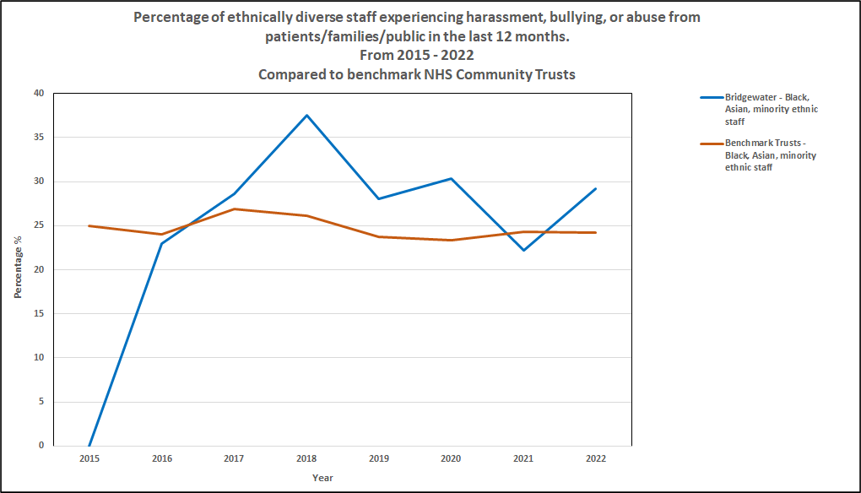
Indicator 6
This next indicator looks at experiences of harassment, bullying, or abuse from other members of staff in the last 12 months. The total number of experiences is not explored, only that if there has been at least one experience this is reported.
It can be seen in table 7 that there has been a large deterioration in this result for Trust ethnically diverse staff, where previously the indicator had seen improvements. As for indicator 5 caution should be used given low sample sizes, however the Trust is committed to creating a compassionate and inclusive environment, to being actively anti-discriminatory, and therefore believes that even one individual experiencing this behaviour is one too many. The Trust is continuing to engage with staff networks to better understand lived experience so that projects such as civility and respect are effectively designed and implemented.

Table 7: Showing the percentage of staff experiencing bullying, harassment, or abuse from other staff in the last 12 months. From 2015 to 2022.
Bridgewater: | 2015 | 2016 | 2017 | 2018 | 2019 | 2020 | 2021 | 2022
Ethnically diverse staff | 0.0* | 26.0 | 21.4 | 16.7 | 20.0 | 15.6 | 13.3 | 25.0
White staff | 23.0 | 24.0 | 20.4 | 17.5 | 20.8 | 17.8 | 16.9 | 16.9
Benchmark: | 2015 | 2016 | 2017 | 2018 | 2019 | 2020 | 2021 | 2022
Ethnically diverse staff | 24.0 | 24.0 | 21.8 | 24.0 | 23.8 | 22.9 | 20.0 | 22.4
White staff | 22.0 | 18.0 | 18.6 | 19.6 | 19.6 | 16.9 | 15.9 | 15.6

*Note: Figure too low to report for Black, Asian, or minority ethnic staff in 2015

Figure 6 below shows clearly the gap between ethnically diverse and white staff in Bridgewater, a gap for the first time in several years that shows a greater experience of these behaviours for ethnically diverse staff compared to their white colleagues.
Figure 6: Showing the percentage of ethnically diverse and white staff who experienced bullying, harassment, or abuse from other staff in the last 12 months for Bridgewater and benchmark Trusts. From 2015 to 2022.
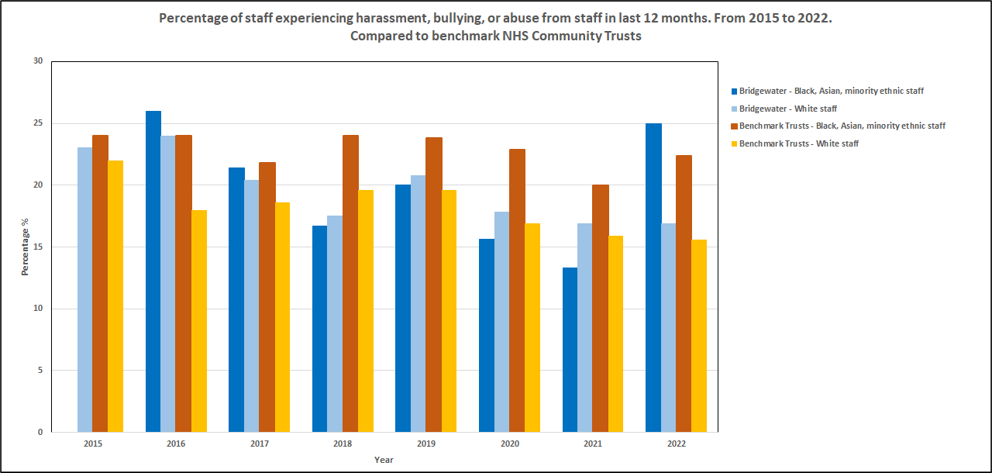

The final figure for this indicator shows the changes in these results for ethnically diverse staff in Bridgewater and comparator Trusts from 2015 to 2022. As stated previously it is likely that the lower sample sizes for a single small Trust have influenced the greater fluctuations over time, but any instance is one too many and must not be dismissed as statistically insignificant or flawed.
Figure 7: Showing the percentage of ethnically diverse staff in Bridgewater and comparator Trusts who stated they had experienced bullying, harassment, or abuse from colleagues in the previous 12 months. From 2015 to 2022.
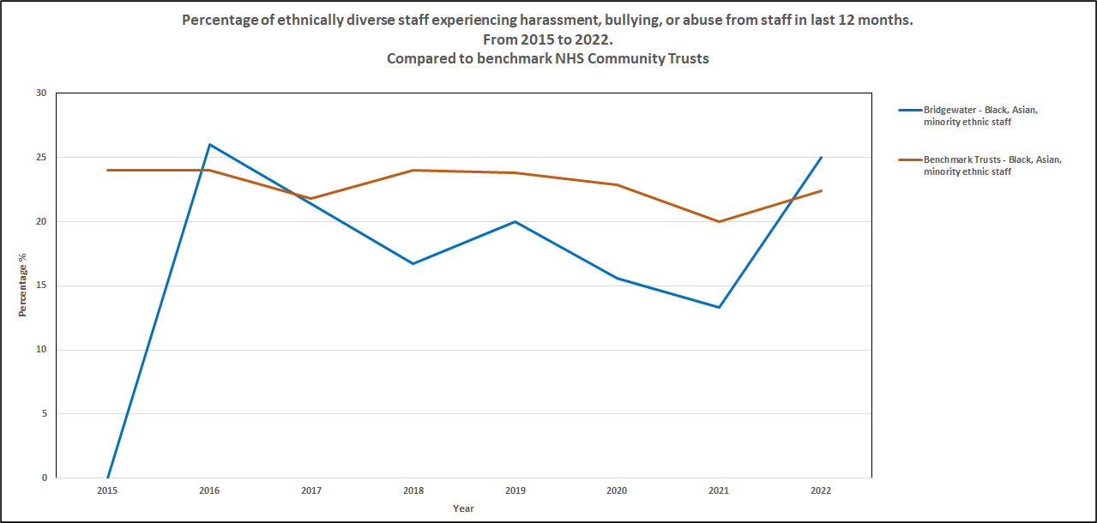

Indicator 7
The next staff survey indicator reports on the percentage of ethnically diverse and white staff who believe that their employer provides equity of opportunity for career progression.
In 2022 this indicator has deteriorated for ethnically diverse staff, and the gap in positive belief has grown between the groups of staff.
Table 8: Showing the percentage of staff who believe the Trust provides equity of opportunity for career progression and promotion. From 2015 to 2022.
Bridgewater: | 2017 | 2018 | 2019 | 2020 | 2021 | 2022
Ethnically diverse staff | 50.0 | 48.0 | 48.0 | 33.3 | 51.1 | 45.8
White staff | 55.6 | 59.1 | 58.4 | 60.1 | 58.9 | 62.0
Benchmark: | 2017 | 2018 | 2019 | 2020 | 2021 | 2022
Ethnically diverse staff | 47.3 | 47.5 | 47.8 | 46.8 | 50.3 | 50.2
White staff | 61.7 | 60.7 | 62.5 | 66.3 | 66.0 | 65.9

Figure 8, on the page to follow, shows the results for Bridgewater and for comparator Trusts from 2015 to 2022, the gap between ethnically diverse and white staff in both groups can be clearly seen. It is evident that, other than in 2020, this is the first year when Bridgewater results for ethnically diverse staff have been below the results for ethnically diverse staff in benchmark organisations. Engagement with staff network members will be undertaken to better understand this result.

Figure 8: Showing the percentage of staff who stated that they believed the Trust provided equity of opportunity for career progression in Bridgewater and benchmark Trusts. From 2015 to 2022.
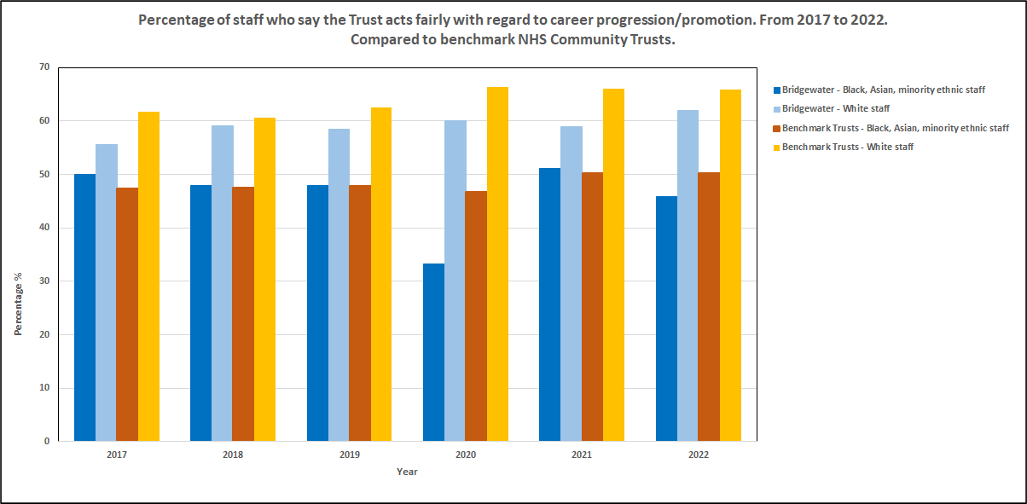

Indicator 8
Experience of discrimination in the last 12 months from colleagues is indicator 8, the last of the NHS Staff Survey indicators. Discrimination has legal definitions based on type, but what all discrimination has in common is unfair treatment based on a protected characteristic, whether this is direct, indirect, by association, or perceived. Harassment is also a type of discrimination but is reported separately in the NHS Staff Survey. Discrimination is an illegal act under the Equality Act 2010 and the Human Rights Act 1998.
As can be seen in table 9 this indicator has seen an improvement in 2022 for ethnically diverse staff in Bridgewater and in benchmark Trusts. In both groups a large gap remains between ethnically diverse and white staff, and anti-discrimination work is a key priority for Bridgewater through action plans to implement the North West Black, Asian, and Minority Ethnic Assembly’s Anti-Racism Framework, a commitment made by Board and supported in 2022/23 by Board and staff development days and gap analysis reports to Board.
Table 9: Showing the percentage of ethnically diverse and white staff stating they experienced discrimination from colleagues in the last 12 months. From 2015 to 2022.
Bridgewater: | 2015 | 2016 | 2017 | 2018 | 2019 | 2020 | 2021 | 2022
Ethnically diverse staff | * | 6.0 | 11.1 | 8.3 | 16.0 | 12.1 | 13.3 | 10.4
White staff | 4.0 | 7.0 | 8.1 | 4.4 | 4.9 | 4.4 | 3.6 | 3.8
Benchmark: | 2015 | 2016 | 2017 | 2018 | 2019 | 2020 | 2021 | 2022
Ethnically diverse staff | 12.0 | 4.0 | 12.1 | 10.7 | 12.2 | 13.5 | 12.7 | 12.1
White staff | 5.0 | 11.0 | 5.5 | 4.9 | 4.3 | 4.3 | 4.3 | 4.2

*Note: Figure too low to report for Black, Asian, or minority ethnic staff in 2015
The figure below shows the difference in experience of discrimination for ethnically diverse staff in Bridgewater and benchmark Trusts. The gap with white staff is clear. While white staff can experience discrimination it is more likely to be experienced by minority groups across the protected characteristics, e.g. ethnically diverse staff, disabled staff, staff from UK minority religions, and staff with diverse gender and sexual identities.
Figure 9: Showing the percentage of ethnically diverse and white staff who experienced discrimination from colleagues in the previous 12 months. From 2015 to 2022.
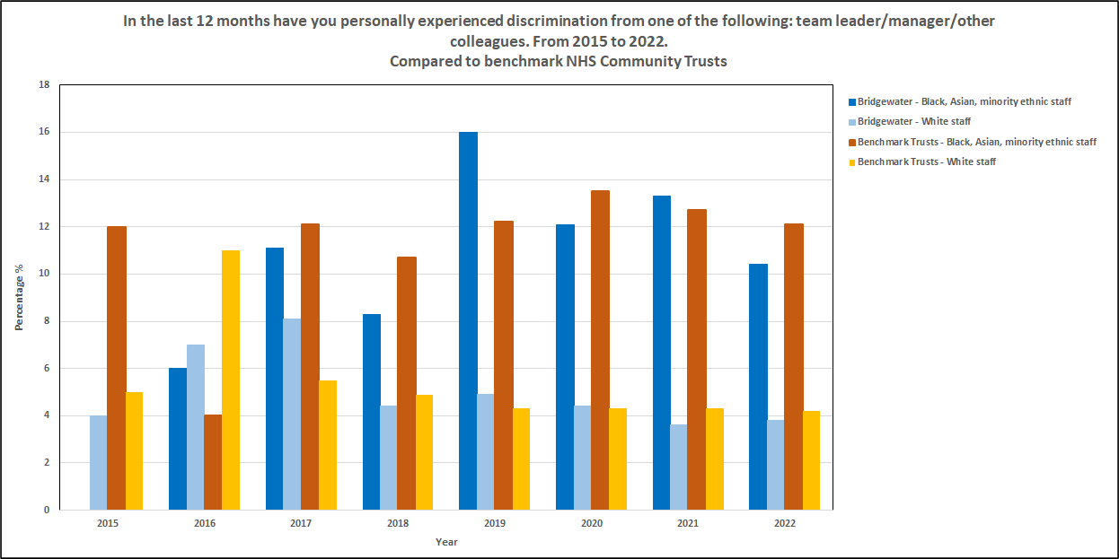
The final figure for this indicator shows the changes in this data set over the period from 2015 to 2022. The fluctuations in both Bridgewater and in comparator Trusts is clear – greater in Bridgewater likely as a result of smaller sample sizes when compared to comparator Trusts. While an improvement in this indicator this year is positive what is needed is year on year consistency in Bridgewater and the benchmark Trusts.
Figure 10: Showing the percentage of ethnically diverse staff in Bridgewater and in comparator Trusts who experienced discrimination from colleagues in the previous 12 months. From 2015 to 2022.
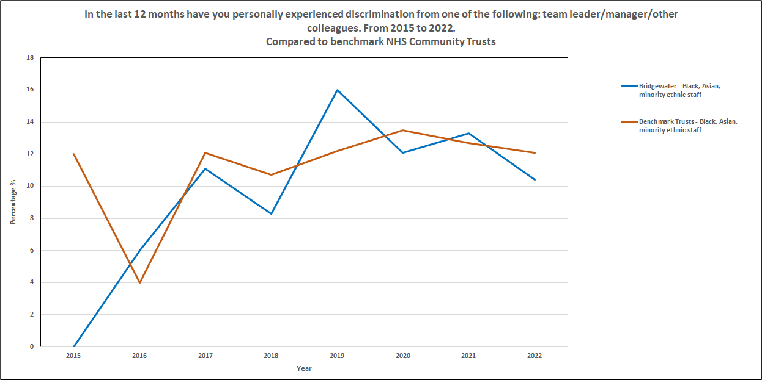

Indicator 9
The final Workforce Race Equality Standard indicator looks at Board ethnicity representation as compared to the overall workforce. Table 1 detailed the workforce profile from 2015 to 2022, and in 2022 the percentage of ethnically diverse staff in the workforce was 6.2%.
The Bridgewater Board is comparatively small and is comprised of both executive and non-executive members. As can be seen in the table below since 2020 the Board has been over-representative in respect of white members compared to the overall ethnically diverse workforce, caution however should be used due to small numbers.
Table 10: Showing the percentage difference between ethnically diverse and white representation at Board compared to overall workforce. From 2015 to 2023.
Board Representation
2015 - 2023
 | 2015 | 2016 | 2017 | 2018 | 2019 | 2020 | 2021 | 2022 | 2023
Ethnically diverse | * | -2.5 | -2.6 | -2.9 | -3.0 | 3.4 | 8.9 | 7.6 | 8.1
White | * | 2.5 | 9.2 | -4.1 | -8.1 | -25.6 | -19.0 | -17.4 | -20.7
Not known | * | 0.0 | -6.6 | 7.0 | 11.0 | 22.2 | 10.1 | 9.8 | 12.6

*Note: Data unavailable for 2015 – national reporting templates updated in 2016 to capture this data

Workforce Race Disparity Ratio Results 2023
The race disparity ratio action plan was mandated for all Trusts by NHS England in summer 2021. Nationally the WRES 2020 data was used to calculate individual Trusts race disparity ratio as at 31st March 2020. This information was sent to all Chief Executives with instructions on what was expected next – the reduction of the ratio to a likelihood of 1.5 or below.
Trusts are required to understand their data in relation to race disparity in pay and career progression and set targets and actions to level up representation so that it is reflective across the whole Trust. For us, this target representation is 5.4%. The mandate allows 4 years to reach targets, with improvements expected to be evidenced by March 2025.
The disparity ratio looks at the likelihood of progression of white, and ethnically diverse staff from the lower pay bands (bands 1 to 5) to middle (bands 6 to 7), and upper bands (bands 8a to 9). Very senior managers, and medical and dental staffing are excluded.
Table 11 shows the total race disparity ratio results as at 31st March 2023. Ongoing improvements can be observed, with ethnically diverse staff now more likely to progress from middle to upper, and lower to upper pay bands than white staff. The ultimate goal is a level playing field where the race disparity ratio is 1.0 across all three indicators, but it is positive to see in particular that shift in likelihood to date of ethnically diverse staff overall progressing better between the lower and highest pay bands.
Table 11: Showing race disparity ratio results from 2020 to 2023.
 | Lower to Middle | Middle to Upper | Lower to Upper
March 2020 | 1.13 | 2.08 | 2.35
March 2021 | 1.32 | 1.35 | 1.78
March 2022 | 1.24 | 1.45 | 1.8
March 2023 | 1.34 | 0.55 | 0.74

The next table shows the race disparity ratio for non-clinical staff, along with the overall ethnically diverse workforce representation in this group – full percentage breakdown by pay band can be found in indicator 1 in the summary table on page 28. This table shows that a disparity remains for ethnically diverse staff in progression from middle to upper pay bands, while overall staffing numbers in these upper bands are low ethnically diverse staff are under-represented in non-clinical roles banded at 8a to 9.
Table 12: Showing race disparity ratio results for non-clinical staff group as at 31st March 2023.
Non-clinical Staff | Lower to Middle | Middle to Upper | Lower to Upper
March 2023 | 0.47 | 2.1 | 0.99
% Representation compared to overall workforce | At 5.3% the non-clinical workforce overall is under-representative of target ethnically diverse staff representation by 0.1%

Table 13 shows representation data for clinical staff. As can be observed there is a disparity in the likelihood of progression from lower to middle pay bands for ethnically diverse staff, while there are greater numbers of ethnically diverse staff in pay bands 5 and 6 there are very few in band 7 – less than 2% of staff in clinical band 7 roles are from ethnically diverse backgrounds. This levels up in higher bands, 8a to 9, as is reflected in the disparity result.
Table 13: Showing race disparity ratio results for non-clinical staff group as at 31st March 2023.
Clinical Staff | Lower to Middle | Middle to Upper | Lower to Upper
March 2023 | 1.64 | 0.38 | 0.62
% Representation compared to overall workforce | At 6.6% the non-clinical workforce overall is over-representative of target for ethnically diverse staff by 1.0%

Work in 2022 - 2023
A number of actions have been undertaken in 2022 – 2023 to improve equity and inclusion in employment for ethnically diverse staff:
- Just Culture Programme – programme commenced in 2021. In the last 12 months a fact-finding process has been developed and launched to understand the factors that led to an incident; and policy, process, and toolkits are being updated to reflect the changes to the former disciplinary process, placing a focus on wellbeing, communication, and learning, with only necessary incidents progressing to formal disciplinary. Staff and teams from across the Trust have been involved in ambassador training, programme development, and testing.
- Civility and Respect Programme – alignment to equality, diversity, and inclusion has included co-delivery of messages at corporate induction, and development of new programme materials and project plan to launch in spring 2023. Support and involvement from staff and teams from across the Trust, including alignment to the national Violence Prevention and Reduction Standard through leadership by the Trust’s Health, Safety, and Fire lead.
- Board Development Day: Anti-Racism – held in September 2023 the event was facilitated by Real and Authentic Representations of Africans and Caribbeans Education Project (RARA), and focused on understanding racism, privilege, and bias, followed by Board planning on the Northwest Black, Asian, and Minority Ethnic Assembly Anti-Racism Framework.
- Leader in Me Event – Held in December 2022 for 100+ members of staff from across the Trust. Facilitated by RARA the event focused on discrimination and anti-racism and feedback from attendees has supported development of the equality action plan 2023 – 2024.
- Board anti-discrimination paper – presented to Board in December 2022 the paper provided a gap analysis of employment policy and practice in relation to discrimination in the workplace.
- Race Inclusion Network – ongoing engagement with the staff network members to understand workplace experience, to provide support and guidance, and to further develop ideas and programmes in the Trust.
- Reciprocal Mentoring for Inclusion Programme – to launch in June 2023 the programme has been developed in partnership with Liverpool John Moores University, with six partnerships of staff and senior leaders recruited for this pilot year.
- Staff Engagement Champions: Race Equality – launch of specialist role within the over-arching staff engagement champions network. Designed by the Race Inclusion Network the champions role supports new staff, and anti-racism work across the Trust.
- Recruitment – ongoing working group delivering NHS People Plan mandate to overall recruitment practices to embed equity and inclusion. Work in 2022 – 2023 has included review of current job description database, review of job description content, updates to recruitment web pages, with more actions planned for 2023 – 2024.
- Career development opportunities – continued sharing of opportunities with ethnically diverse staff mailing list, for example Talent Surgeries led by the North West Talent Team at NHS England.
- Operational Managers Training – session designed and delivered, including information and data regarding race, racism, and race equality.
- Students Training – session designed and delivered looking at basics of equity, discrimination, and inclusion.

Summary
To follow is a summary table of the 2023 data for the Bridgewater Workforce Race Equality Standard as submitted to NHS England.

Indicator 1:
Percentage of staff in each Agenda for Change pay band (1-9), or Medical and Dental pay grades, compared with the percentage of staff in the workforce overall. Disaggregated by non-clinical staff, clinical staff, and medical and dental staff.
Note rounding up of numbers may mean a slightly higher figure than 100% is seen in the below. A * means that numbers are below 10 and therefore not published for data protection.
 | Total workforce
 | Ethnically Diverse | White | Not known
Total percentage % | 3.18 | 80.47 | 16.35
 | Non-clinical
 | Ethnically Diverse | White | Not known
Under Agenda for Change Band 1 | 0.39 | 0.06 | 0.0
Agenda for Change Band 1 | n/a | n/a | n/a
Agenda for Change Band 2 | 4.54 | 0.06 | 0.0
Agenda for Change Band 3 | 8.89 | 0.52 | 0.19
Agenda for Change Band 4 | 2.21 | 0.0 | 0.0
Agenda for Change Band 5 | 2.27 | 0.26 | 0.19
Agenda for Change Band 6 | 1.56 | 0.0 | 0.0
Agenda for Change Band 7 | 1.04 | 0.26 | 0.0
Agenda for Change Band 8a | 1.30 | 0.6 | 0.0
Agenda for Change Band 8b | 0.58 | 0.06 | 0.0
Agenda for Change Band 8c | 0.71 | 0.0 | 0.0
Agenda for Change Band 8d | 0.13 | 0.0 | 0.0
Agenda for Change Band 9 | 0.6 | 0.0 | 0.0
Very Senior Manager | 0.19 | 0.06 | 0.13
Total non-clinical workforce % | 23.9 | 1.4 | 0.5
 | Clinical
 | Ethnically Diverse | White | Not known
Under Agenda for Change Band 1 | 0.0 | 0.0 | 0.0
Agenda for Change Band 1 | n/a | n/a | n/a
Agenda for Change Band 2 | 2.01 | 0.19 | 0.06
Agenda for Change Band 3 | 7.92 | 0.13 | 0.13
Agenda for Change Band 4 | 7.92 | 0.58 | 0.06
Agenda for Change Band 5 | 15.12 | 0.84 | 0.19
Agenda for Change Band 6 | 18.04 | 0.71 | 0.26
Agenda for Change Band 7 | 9.99 | 0.19 | 0.13
Agenda for Change Band 8a | 3.24 | 0.19 | 0.06
Agenda for Change Band 8b | 0.26 | 0.0 | 0.0
Agenda for Change Band 8c | 0.19 | 0.13
Agenda for Change Band 8d | 0.06 | 0.0 | 0.06
Agenda for Change Band 9 | 0.0 | 0.0 | 0.0
Very Senior Manager | 0.06 | 0.0 | 0.0
Total clinical workforce % | 64.9 | 3.0 | 1.0
 | Medical and Dental Grades:
 | Ethnically Diverse | White | Not known
Consultants | 0.19 | 0.32 | 0.13
Non-Consultant Career Grade | 2.92 | 1.56 | 0.13
Trainee Grades | n/a | n/a | n/a
Total medical and dental workforce % | 3.1 | 1.9 | 0.3
Indicator 2:  Relative likelihood of being appointed from shortlisting across all posts | 1.44 times  A figure below 1.0 suggests ethnically diverse candidates are more likely to be appointed than white candidates from shortlisting to appointment
Indicator 3:  Relative likelihood of entering formal disciplinary processes | 2.46 times  A figure above 1.0 suggests ethnically diverse staff are more likely to enter formal disciplinary process compared to white staff.  Caution should be used in determining statistically relevance in this indicator due to low numbers – less than 10 staff in total in the period.
Indicator 4:  Relative likelihood of accessing non-mandatory training/CPD | 1.79 times  A figure below 1.0 suggests ethnically diverse candidates are more likely to be undertake non-mandatory training and CPD compared to white staff.
Indicator 5:  Percentage of ethnically diverse staff compared to white staff experiencing bullying, harassment, and abuse from patients/relatives/public in last 12 months | 29.2% ethnically diverse staff  21.6% white staff
Indicator 6:  Percentage of ethnically diverse staff compared to white staff experiencing bullying, harassment, and abuse from staff in last 12 months | 25.0% ethnically diverse staff  16.9% white staff
Indicator 7:  Percentage of ethnically diverse staff compared to white staff who stated that they believe that their organisation provides equal opportunities for career progression and promotion | 45.8% ethnically diverse staff  62% white staff
Indicator 8:  In the last 12 months personally experiencing discrimination from manager/team leader/other colleagues | 10.4% ethnically diverse staff  3.8% white staff
Indicator 9:  Percentage difference between the Trusts Board voting membership and its overall workforce | 8.1% ethnically diverse  -20.6% white  12.5% not known

Appendix 1: Bank Workforce Race Equality Standard 2023
In 2023 the Workforce Race Equality Standard reporting has been expanded to include a separate data collection for bank staff.
With an estimated 150,000 bank-only workers in the NHS nationally, and to support NHS England’s strategic aim of improving the quality of bank provision as a flexible option for staff, the national Workforce Race Equality Standard team has developed a set of nine indicators that will explore the experience of staff who hold solely zero hours contracts in NHS Trusts, that is staff who don’t have another substantive role in an organisation.
In this first year as not all Trusts, Bridgewater included, have taken part in the NHS Bank Survey, (piloted in autumn 2022 alongside the regular annual NHS Staff Survey), the focus is on indicators one to three only. However, for fullness all nine indicators, including sub-indicators, are detailed below:
- Percentage of active bank staff by ethnicity and gender across pay scales and staff groups.
2. Relative likelihood of active bank staff entering formal disciplinary processes in the last 12 months by ethnicity.
3. Relative likelihood of active bank staff being dismissed following formal processes in the last 12 months by ethnicity.
4a. Percentage of active bank staff experiencing harassment, bullying, or abuse by patients/public/families in last 12 months by ethnicity.
4b. Percentage of active bank staff experiencing harassment, bullying, or abuse by colleagues in the last 12 months by ethnicity.
4c. Percentage of active bank staff experiencing harassment, bullying, or abuse by managers in the last 12 months by ethnicity.
4d. Percentage of active bank staff who proceeded to report these experiences by ethnicity.
5a. Percentage of active bank staff who have personally experienced physical violence from patients/families/public in the last 12 months by ethnicity.
5b. Percentage of active bank staff who proceeded to report these experiences.
6a. Percentage of active bank staff who in the next 12 months would consider moving into permanent role in the NHS.
6b. Percentage of active bank staff who believe there are opportunities to develop their career in the Trust.
6c. Percentage of active bank staff who’s main paid source of work is the bank.
6d. How long have active bank staff worked solely on the bank.
7a. Percentage of active bank staff who have personally experienced discrimination in the last 12 months at work from colleagues.
7b. Percentage of active bank staff who have personally experienced discrimination in the last 12 months from patients/families/public.
8a. Percentage of active bank staff who feel the Trust values their contribution.
8b. Percentage of active bank staff who feel safe to speak up about anything that concerns them in the Trust.
8c. Percentage of active bank staff who believe the Trust respects individual differences (cultures, working styles, backgrounds, ideas, etc.).
8d. Percentage of active bank staff who feel they receive the respect they deserve from colleagues.
9. Percentage of active bank staff who were originally recruited to the NHS from outside of the UK and who now hold bank only positions.
Our results for indicators one to three have been submitted to NHS England, and a summary is given below – full details can’t be provided due to the small number of staff involved.

Indicator 1
- The Trust had less than 40 active bank only staff in the reporting period, the majority being white British.
- 2.7% of bank only staff were ethnically diverse, with 2.7% not known.
- 5.4% were male staff, this is lower than the representation of male staff in the Trust overall.
- 73% of bank only staff were in clinical roles, 5.4% in medical and dental roles, and 22% in non-clinical roles.
Indicators 2 and 3
No active bank only staff were involved in formal disciplinary processes, and there were no dismissals as a result of disciplinary or capability.
More information on the Bank Workforce Race Equality Standard can be found on the NHS England website at:
https://www.england.nhs.uk/publication/workforce-race-equality-standard-wres-indicators-for-bank-only-workers/

Appendix 2: Medical Workforce Race Equality Standard 2023
The Medical Workforce Race Equality Standard was initially undertaken as a national exercise by NHS England in 2020, data contributions were provided by Health Education England, the General Medical Council, the medical royal colleges, and the Medical Schools Council. Providers were excluded in this first data collection, though information on all doctors and dentists in England was collated using data held by these organisations.
2023 is the first year that NHS provider Trusts are expected to submit their own locally held data. The data to be collected has been simplified in late May 2023 following feedback and queries from NHS Trusts who were challenged with some of the initial specific data regarding origin of primary medical qualification, and data disaggregation by postgraduate training completion.
The eleven indicators are detailed below.
1a. Percentage of BME and white staff in each medical and dental sub-group in NHS trusts and clinical commissioning groups.
1b. Ethnicity pay gap: Average monthly earnings.
1c. Clinical academics by ethnicity.
2. Consultant recruitment.
3. Revalidation percentage deferred.
4a. Differential attainment in medical schools.
4b. Differential pass rates in royal college postgraduate examinations.
4c. Annual review of competence progression (ARCP) - unsatisfactory outcomes by primary medical qualification - core medical training (2019).
5. Staff experiencing harassment, bullying or abuse from patients, relatives or the public in last 12 months.
6. Staff experiencing harassment, bullying or abuse from staff in last 12 months.
7. Staff believing their trust provides equal opportunities for career progression or promotion.
8. Staff in the last 12 months having personally experienced discrimination at work.
9. Staff feeling “motivated”, otherwise known as work engagement; the extent to which individuals are fully engaged in their job while working (score out of 10).
10. Staff feeling “involved”, also referred to as proactivity, or voice; the extent to which individuals are given (and take) the opportunity to contribute ideas and make changes at work (score out of 10).
11a. Percentage of BME doctors on royal colleges boards, compared to the BME percentage of the overall workforce.
11b. Percentage of deans of medical schools, compared to the BME percentage of the overall workforce.
Most indicators will require data from other NHS and medical bodies, with providers expected to submit the following data:
- Number of staff in medical and dental roles, (medical directors and clinical directors) disaggregated by ethnicity. This supports indicator 1a.
- Number of medical and dental staff disaggregated by ethnicity eligible for, applying, and receiving Clinical Excellence Awards in the reporting period. This contributes data for indicator 1b, ethnicity pay gap.
- Consultant recruitment, disaggregated by ethnicity, and for applications, shortlisted, and appointed stages. This supports indicator 2.
Trust data for 2023 has been submitted to NHS England and where it is possible is detailed in this report – due to the very low number of staff most results can’t be published as the data is personally identifiable.

Indicator 1a
This indicator required data on just medical directors and clinical directors be submitted to NHS England. As the total number of staff is less than 10 it is not possible to report on ethnicity in this report to comply with data protection requirements.

Indicator 1b
Less than 10 staff were eligible to apply for local Clinical Excellence Awards in 2022 – 2023. All applied and were awarded. Staff from ethnically diverse backgrounds were represented in the eligible cohort. Due to data protection requirements further information can’t be provided in this report.
Indicator 2
There was no consultant recruitment in 2022 – 2023.

Appendix 1: Staff survey results 2022 - full

To follow is a full breakdown of NHS Staff Survey results as they relate to the difference in experience between ethnically diverse and white members of staff.

The Key to the table is:

First line – ethnically diverse staff
Second line – white staff

Table 14: Showing NHS Staff Survey results from 2018 to 2022 for all questions. Breakdown is between ethnically diverse staff (first line of each question) and white staff (second line of each question).
 | 2018 | 2019 | 2020 | 2021 | 2022
I look forward to going to work (often/always) | 76.0 | 76.9 | 60.6 | 68.9 | 66.7
 | 55.5 | 56.4 | 61.4 | 59.2 | 60.4
I am enthusiastic about my job (often/always) | 66.7 | 84.6 | 78.1 | 77.8 | 66.7
 | 73.4 | 73.7 | 75.4 | 73.2 | 75.1
Time passes quickly when I am working (often/always) | 75.0 | 84.6 | 81.3 | 77.8 | 70.8
 | 79.2 | 79.3 | 81.6 | 81.9 | 80.7
I always know what my work responsibilities are (agree/strongly agree) | 96.0 | 88.5 | 84.8 | 88.9 | 95.8
 | 86.3 | 84.0 | 82.8 | 82.8 | 84.6
I am trusted to do my job (agree/strongly agree) | 100.0 | 96.2 | 97.0 | 95.6 | 97.9
 | 93.3 | 91.9 | 89.5 | 91.0 | 91.8
There are frequent opportunities for me to show initiative in my role (agree/strongly agree) | 75.0 | 76.9 | 57.6 | 75.6 | 70.8
 | 75.1 | 71.9 | 74.1 | 74.0 | 73.5
I am able to make suggestions to improve the work of my team/dept. (agree/strongly agree) | 76.0 | 73.1 | 84.8 | 82.2 | 81.3
 | 80.7 | 79.1 | 77.4 | 74.9 | 77.0
I am involved in deciding on changes that affect my work area, team, or dept. (agree/strongly agree) | 41.7 | 53.8 | 54,5 | 53.3 | 52.1
 | 60.0 | 57.9 | 58.6 | 54.8 | 58.4
I am able to make improvements happen in my area (agree/strongly agree) | 60.0 | 61.5 | 63.6 | 57.8 | 54.2
 | 60.3 | 61.8 | 62.3 | 58.4 | 60.7
I am able to meet all the conflicting demands on my time at work (agree/strongly agree) | 58.3 | 42.3 | 62.5 | 52.3 | 37.5
 | 41.8 | 39.5 | 42.8 | 43.1 | 45.5
I have adequate equipment, supplies, and materials to do my work (agree/strongly agree) | 60.0 | 46.2 | 66.7 | 71.1 | 66.7
 | 45.9 | 41.3 | 59.2 | 60.6 | 65.7
There are enough staff at this Trust for me to do my job properly (agree/strongly agree) | 32.0 | 26.9 | 33.3 | 37.8 | 37.5
 | 30.8 | 28.4 | 38.3 | 30.1 | 35.0
The recognition I get for good work (satisfied/very satisfied) | 68.0 | 73.1 | 60.6 | 63.6 | 50.0
 | 61.0 | 60.0 | 58.6 | 56.7 | 57.6
The extent to which the Trust values my work (satisfied/very satisfied) | 40.0 | 38.5 | 51.5 | 56.8 | 45.8
 | 43.2 | 45.0 | 47.4 | 46.2 | 46.6
My level of pay (satisfied/very satisfied) | 36.0 | 38.5 | 39.4 | 52.3 | 29.2
 | 39.5 | 41.0 | 41.3 | 37.9 | 28.6
The opportunities for flexible working (satisfied/very satisfied) | 64.0 | 53.8 | 51.5 | 54.5 | 56.3
 | 61.8 | 59.0 | 64.0 | 60.1 | 60.1
I have unrealistic time pressures (never/rarely) | 20.0 | 38.5 | 30.3 | 27.3 | 27.1
 | 22.4 | 23.6 | 26.1 | 28.2 | 31.5
I have a choice in deciding how to do my work (often/always) | 69.6 | 69.2 | 54.5 | 48.8 | 56.3
 | 65.4 | 64.2 | 66.4 | 65.6 | 62.1
Relationships at work are strained (never/rarely) | 52.4 | 73.1 | 54.5 | 40.9 | 43.8
 | 48.8 | 49.9 | 49.0 | 49.5 | 53.6
I feel that my role makes a difference to patients (agree/strongly agree) |  |  |  | 95.3 | 80.3
 |  |  |  | 88.1 | 88.5
My Trust is committed to helping me balance work/home life (agree/strongly agree) |  |  |  | 40.0 | 58.3
 |  |  |  | 49.4 | 54.5
I achieve a good work/life balance (agree/strongly agree) |  |  |  | 53.3 | 52.2
 |  |  |  | 58.7 | 59.7
I can approach my line manager to talk about flexible working (agree/strongly agree) |  |  |  | 64.4 | 68.1
 |  |  |  | 74.7 | 74.4
The team I work in has a set of shared objectives (agree/strongly agree) | 80.0 | 61.5 | 72.7 | 71.1 | 80.9
 | 77.5 | 76.6 | 74.0 | 74.4 | 77.0
The team I work in often meets to discuss the team’s effectiveness (agree/strongly agree) | 72.0 | 76.9 | 64.5 | 75.6 | 74.5
 | 74.1 | 73.7 | 64.3 | 68.9 | 71.9
I receive the respect I deserve from colleagues (agree/strongly agree) | 83.3 | 80.8 | 78.8 | 75.6 | 76.6
 | 80.5 | 82.1 | 74.8 | 78.3 | 81.3
Team members understand each other’s roles (agree/strongly agree) |  |  |  | 75.6 | 89.4
 |  |  |  | 76.9 | 79.5
I enjoy working with the colleagues in my team (agree/strongly agree) |  |  |  | 88.6 | 87.2
 |  |  |  | 87.2 | 87.5
My team has enough freedom to do its work (agree/strongly agree) |  |  |  | 68.9 | 59.6
 |  |  |  | 61.3 | 61.8
In my team disagreements are dealt with constructively (agree/strongly agree) |  |  |  | 51.1 | 51.1
 |  |  |  | 63.2 | 62.3
I feel valued by my team (agree/strongly agree) |  |  |  | 86.7 | 72.3
 |  |  |  | 76.2 | 75.7
I feel strong personal attachment to my team (agree/strongly agree) |  |  |  | 71.1 | 63.8
 |  |  |  | 71.2 | 75.4
Teams within this Trust work well together to achieve their objectives (agree/strongly agree) |  |  |  | 62.2 | 53.2
 |  |  |  | 54.8 | 56.8
The people I work with are understanding and kind to each other (agree/strongly agree) |  |  |  | 84.4 | 72.3
 |  |  |  | 80.1 | 81.9
The people I work with are polite and treat each other with respect (agree/strongly agree) |  |  |  | 86.7 | 78.3
 |  |  |  | 81.1 | 81.4
The people I work with show appreciation to each other (agree/strongly agree) |  |  |  | 79.5 | 72.3
 |  |  |  | 76.2 | 77.1
My line manager encourages me in work (agree/strongly agree) | 70.8 | 84.6 | 69.7 | 71.1 | 72.9
 | 74.0 | 73.8 | 70.3 | 74.7 | 73.8
My line manager gives me clear feedback on my work (agree/strongly agree) | 58.3 | 73.1 | 53.1 | 57.8 | 60.4
 | 65.5 | 66.8 | 60.0 | 66.3 | 63.6
My line manager asks for my opinion before making decisions that affect my work (agree/strongly agree) | 50.0 | 69.2 | 57.6 | 59.1 | 66.7
 | 59.9 | 60.9 | 58.5 | 62.7 | 61.2
My line manager takes a positive interest in my health and wellbeing (agree/strongly agree) | 64.0 | 73.1 | 75.8 | 62.2 | 72.9
 | 72.9 | 75.4 | 73.2 | 73.6 | 74.0
My line manager values my work (agree/strongly agree) | 75.0 | 76.9 | 81.3 | 73.3 | 75.0
 | 75.3 | 76.3 | 73.2 | 76.5 | 74.9
My line manager works together with me to come to an understanding of problems (agree/strongly agree) |  |  |  | 60.0 | 68.8
 |  |  |  | 73.1 | 70.3
My line manager is interested in listening to me when I describe the challenges I face (agree/strongly agree) |  |  |  | 66.7 | 75.0
 |  |  |  | 74.0 | 73.1
My line manager cares about my concerns (agree/strongly agree) |  |  |  | 63.6 | 72.9
 |  |  |  | 74.7 | 72.9
My line manager takes effective action to help me with any problems I face (agree/strongly agree) |  |  |  | 64.4 | 75.0
 |  |  |  | 70.3 | 69.1
Working addition paid hours (% yes) | 13.6 | 25.0 | 19.4 | 15.9 | 24.4
 | 21.1 | 17.8 | 16.5 | 16.0 | 17.9
Working additional unpaid hours (% yes) | 59.1 | 45.8 | 59.4 | 50.0 | 56.5
 | 59.5 | 57.9 | 57.2 | 60.0 | 54.8
My Trust takes positive action on health and wellbeing (agree/strongly agree) |  |  |  | 75.6 | 68.8
 |  |  |  | 63.4 | 64.6
In the last 12 months have you experienced musculoskeletal problems as a result of work (% yes) | 28.0 | 37.5 | 39.4 | 31.1 | 38.3
 | 25.8 | 22.2 | 27.9 | 23.9 | 20.5
During the last 12 months have you felt unwell as a result of work- related stress (% yes) | 32.0 | 37.5 | 42.4 | 40.9 | 43.8
 | 41.7 | 40.1 | 43.7 | 44.7 | 37.0
In the last 3 months have you ever come to work despite not feeling well enough to do your duties (% yes) | 60.0 | 54.2 | 46.9 | 48.9 | 62.5
 | 58.2 | 57.6 | 45.6 | 53.3 | 53.4
Have you felt pressure to attend work from your manager (% yes) | 26.7 | 8.3 | 33,3 | 19.0 | 26.7
 | 20.3 | 20.4 | 18.7 | 15.8 | 15.9
How often do you find your work emotionally exhausting (often/always) |  |  |  | 28.9 | 29.2
 |  |  |  | 35.5 | 32.4
How often do you feel burnt our because of your work (often/always) |  |  |  | 22.2 | 29.2
 |  |  |  | 31.7 | 27.9
How often does your work frustrate you (often/always) |  |  |  | 22.7 | 40.4
 |  |  |  | 35.8 | 35.0
How often are you exhausted at the thought of another day/shift in work (often/always) |  |  |  | 22.7 | 25.0
 |  |  |  | 26.5 | 21.8
How often do you feel worn out at the end of the working day (often/always) |  |  |  | 37.8 | 36.2
 |  |  |  | 39.8 | 35.9
How often do you feel that every working hour is tiring for you (often/always) |  |  |  | 18.2 | 22.9
 |  |  |  | 18.3 | 16.1
How often do you not have enough energy for family and friends in leisure time (often/always) |  |  |  | 26.7 | 35.4
 |  |  |  | 29.4 | 27.1
In the last 12 months how many times have you experienced physical violence at work from patients, family members, or the public (at least one incidence) | 4.0 | 0.0 | 3.0 | 6.8 | 12.5
 | 5.8 | 6.1 | 3.3 | 4.5 | 5.3
In the last 12 months how many times have you experienced physical violence at work from managers (at least one incidence) | 0.0 | 0.0 | 0.0 | 2.3 | 0.0
 | 0.4 | 0.1 | 0.0 | 0.0 | 0.0
In the last 12 months how many times have you experienced physical violence at work from other staff (at least one incidence) | 0.0 | 0.0 | 0.0 | 2.3 | 0.0
 | 1.2 | 0.9 | 0.1 | 0.3 | 0.0
In the last 12 months have you seen any errors, near misses, or incidents that could hurt staff or patients (yes) |  |  |  |  | 16.7
 |  |  |  |  | 17.8
My Trust treats staff involved in a error, near miss, or incident fairly (agree/agree strongly) |  |  |  |  | 71.4
 |  |  |  |  | 64.0
My Trust encourages us to report errors, near misses, or incidents (agree/agree strongly) |  |  |  |  | 93.3
 |  |  |  |  | 92.3
When errors, near misses, or incidents are reported the Trust takes action to ensure they do not happen again (agree/agree strongly) |  |  |  |  | 74.4
 |  |  |  |  | 74.6
We are given feedback about changes made in response to errors, near misses, or incidents (agree/agree strongly) |  |  |  |  | 73.2
 |  |  |  |  | 65.6
I would feel secure reporting concerns about unsafe clinical practice (agree/agree strongly) | 79.2 | 78.3 | 69.7 | 75.6 | 72.9
 | 68.4 | 69.6 | 75.3 | 85.2 | 80.6
I am confident that my Trust would address my concern (agree/agree strongly) | 60.9 | 45.8 | 45.5 | 64.4 | 72.9
 | 59.1 | 58.8 | 65.6 | 72.4 | 69.6
I think that my Trust respects individual differences, e.g. cultures, working styles, backgrounds, ideas, etc. (agree/agree strongly) |  |  |  | 68.9 | 70.8
 |  |  |  | 72.3 | 77.6
In the last 12 months have you had an appraisal/PPDR (yes) | 80.0 | 92.0 |  | 81.8 | 85.4
 | 88.5 | 83.8 |  | 69.1 | 76.0
It helped me improve how I do my job (agree/agree strongly) | 41.1 | 34.8 |  | 27.8 | 31.7
 | 15.4 | 16.3 |  | 18.8 | 21.6
It helped me agree clear objectives for my work (agree/agree strongly) | 38.9 | 30.4 |  | 51.4 | 36.6
 | 28.6 | 30.0 |  | 29.9 | 31.8
It left me feeling that my work is valued by this Trust (agree/agree strongly) | 31.6 | 30.4 |  | 38.9 | 29.3
 | 24.4 | 28.7 |  | 30.7 | 33.9
This Trust offers me challenging work (agree/agree strongly) |  |  |  | 60.0 | 70.8
 |  |  |  | 68.3 | 71.7
I have opportunities to improve my knowledge and skills (agree/agree strongly) |  |  |  | 51.1 | 50.0
 |  |  |  | 41.1 | 44.9
I feel supported to develop my potential (agree/agree strongly) |  |  |  | 55.6 | 59.6
 |  |  |  | 50.1 | 51.5
I am able to access the right learning and development opportunities when I need to (agree/agree strongly) |  |  |  | 66.7 | 68.8
 |  |  |  | 54.7 | 60.8
Care of patients is my Trust’s top priority (agree/agree strongly) | 75.0 | 84.0 | 75.0 | 82.2 | 85.4
 | 75.8 | 72.4 | 76.9 | 79.3 | 79.1
My Trust acts on concerns raised by patients (agree/agree strongly) | 80.0 | 80.8 | 69.7 | 80.0 | 83.3
 | 74.6 | 72.5 | 77.7 | 80.6 | 79.4
I would recommend this Trust as a place to work (agree/agree strongly) | 50.0 | 61.5 | 63.6 | 64.4 | 58.3
 | 54.3 | 50.9 | 60.1 | 57.4 | 57.5
If a relative or friend needed treatment I would be happy with the standard of care provided by this Trust (agree/agree strongly) | 62.5 | 69.2 | 75.8 | 79.5 | 79.2
 | 72.5 | 69.1 | 79.7 | 78.0 | 80.6
I feel safe to speak up about anything that concerns me in this Trust (agree/agree strongly) |  |  | 72.7 | 64.4 | 60.4
 |  |  | 67.4 | 70.2 | 70.1
If I spoke up about something that concerned me I am confident that this Trust would address my concerns (agree/agree strongly) |  |  |  | 55.6 | 52.1
 |  |  |  | 57.8 | 58.8
I often think about leaving this Trust (agree/agree strongly) | 34.8 | 23.1 | 25.0 | 11.1 | 31.3
 | 32.3 | 33.8 | 26.1 | 31.5 | 28.8
Themes:

We are compassionate and inclusive |  |  |  | 7.5 | 7.4
 |  |  |  | 7.6 | 7.7
We are recognised and rewarded |  |  |  | 6.6 | 5.9
 |  |  |  | 6.2 | 6.2
We each have a voice that counts |  |  |  | 7.1 | 6.9
 |  |  |  | 7.1 | 7.1
We are safe and healthy |  |  |  | 6.5 | 6.1
 |  |  |  | 6.2 | 6.4
We are always learning |  |  |  | 5.8 | 5.7
 |  |  |  | 4.9 | 5.3
We work flexibly |  |  |  | 6.1 | 6.4
 |  |  |  | 6.5 | 6.5
We are a team |  |  |  | 6.9 | 6.9
 |  |  |  | 7.0 | 7.0
Staff engagement | 7.1 | 7.5 | 6.9 | 7.5 | 7.1
 | 7.0 | 7.0 | 7.2 | 7.1 | 7.2
Morale | 5.8 | 6.0 | 6.3 | 6.4 | 6.1
 | 5.8 | 5.7 | 6.1 | 5.9 | 6.1

Contact Details
Ruth Besford (Equality & Inclusion Manager)
ruth.besford@nhs.net

