Gender Pay Gap Report

31 March 2023

Date: Published 7 August 2023

Contents

 | Page
Introduction | 3
Results For 31 March 2023 | 5
Comparison to Previous Years 2017 – 2023 | 7
Current Work Programmes | 12

Introduction
Welcome to the Gender Pay Gap report for March 2023 for Bridgewater Community Healthcare NHS Foundation Trust (the Trust).
Since 2017 Gender Pay Gap legislation has required all employers with more than 250 staff to publish annual information on the pay gap between their male and female staff. For public sector organisations such as the NHS the snapshot date for data capture is 31 March every year.
The Gender Pay Gap regulations require six figures to be reported annually:
- Mean (average) gender pay gap in hourly ordinary pay
- Median (middle) gender pay gap in hourly ordinary pay
- Mean (average) gender pay gap in bonus pay
- Median (middle) gender pay gap in bonus pay
- Proportion of men and women in each pay quartile
- Proportion of men and women receiving bonus pay
Ordinary pay includes basic pay, allowances, and enhanced and special duties pay. It does not include any type of bonus pay. For this calculation just the snapshot date is used, so if staff were not paid for any reason (career break, or statutory sick or maternity pay for example) on 31 March 2023 they are not included.
Bonus pay in the Trust relates to Clinical Excellence Awards, a national scheme for medical consultants that recognises contribution to high quality care, and service improvement and innovation. The relevant dates for bonus pay is the full year, so in this report 1 April 2022 to 31 March 2023.
More information on gender pay gap and calculations can be found on the Government website at https://www.gov.uk/government/publications/gender-pay-gap-reporting-guidance-for-employers
Outlined in this report are the results for our gender pay gap for 31 March 2023 with a comparison to previous years showing any changes, both positive and negative. There is also a brief overview of the work programmes being delivered to improve equity and workplace experience for our female staff.
The Trust’s strategic equality objective is to ‘actively promote equality, diversity, and inclusion by creating the conditions that enable compassion and inclusivity to thrive’. Gender equity is an important part of this strategic objective.
Our mission to improve the health and wellbeing of our local communities can only be achieved through sustainable recruitment and retention of our workforce, supported by their ongoing development. It is vital that we consider and understand barriers to equity at every stage of the workforce journey, and this includes gender equity issues.
The Trust understands the importance of gender pay equity not just as an employer but also how it impacts at a personal and societal level. We understand that there are many factors that can contribute to the gender pay gap.

Equitable and transparent pay
As an employer we are committed to ensuring that our pay practices are transparent, fair, and equitable.
It is important to recognise that the gender pay gap is not the same as equal pay. Equal Pay legislation relates to unequal pay, a difference in pay between a man and a woman, or a group of men and a group of women, doing the same or a similar job (or a job of equal value) – unequal pay is unlawful, unless objectively justified showing the treatment being proportionate as a means to achieving a legitimate business aim.
The gender pay gap shows the difference in average pay of all men and all women employed by an organisation – everyone, in every role. It is possible to have equal pay within an organisation while still having a gender pay gap, however it should be noted that a particularly large gender pay gap can indicate pressing issues needing to be addressed.
As a Trust we operate the national NHS Job Evaluation Scheme and Terms and Conditions of Service. Roles in the Trust are placed within one of these agreed pay grades, with grades being determined based on level of responsibility, qualification, and experience required to effectively undertake the job.
Progression for all staff in Agenda for Change pay bands from 2021 is through the nationally agreed pay step progression process which we have assessed for equality impact internally, noting that this has also had a national equality assessment. We also operate Medical and Dental pay and terms. The Trust works closely with staff-side colleagues to ensure the schemes are implemented fairly and consistently at every stage of employment.
It is important to note is that staff are positioned within the national pay scales based on length of service and experience. Jobs may be rated as equivalent by banding and have staff within the same job role at different points of the pay spine; this will be as a consequential result in pay differentials and differences in hourly rates
It is important before we begin to highlight that while the national reporting mandate for the gender pay gap is for the binary norm of male and female, as a Trust we recognise that not all staff will identify within these confines. We are working to engage with these staff, to listen to their lived experience so that we can ensure that their employment experience is equitable, and that they feel supported, valued, and included within the team that is Bridgewater.

Results for 31 March 2023

Ordinary pay
On 31 March 2023 we employed 1,486 staff who were relevant to gender pay gap reporting. This includes some bank staff who were paid for work in the relevant period but excludes some permanent staff who were on statutory sick or maternity pay only on that date for example.
Table 1 shows the number of female and male staff in each pay quartile, the division of female and male staff into four roughly equal groups based on hourly rate of pay.
Table 1: Showing the numbers and percentages of female and male staff in the four gender pay gap quartiles at 31 March 2023
 | Female |  | Male
 | Total | Percentage % | Total | Percentage %
1 | 328 | 88.17 | 44 | 11.83
2 | 347 | 93.53 | 24 | 6.47
3 | 343 | 92.20 | 29 | 7.80
4 | 316 | 85.18 | 55 | 14.82

The next table shows the mean (average) and median (middle) gender pay gaps for 31 March 2023.
Table 2: Showing the hourly rate of pay for female and male staff, the difference in pay between the two groups, and the gender pay gap. For both mean (average) and median pay at 31 March 2023
 | Mean (average) hourly rate of pay | Median (middle) hourly rate of pay
Female £ | 18.30 | 16.84
Male £ | 21.78 | 17.39
Difference £ | 3.48 | 0.55
Pay Gap % | 15.97 | 3.16

Bonus pay – results for year ending 31 March 2023

Bonus pay for the Trust refers to Clinical Excellence Awards; this is a national scheme that recognises and rewards consultants who contribute most to the delivery of safe and high-quality care to patients and to continuous improvement of NHS services. This is awarded annually based on a full year, April to March, and is determined by a panel convened to review applications made.
In 2022 – 2023 less than 10 members of staff, based on relevant staff lists as opposed to full pay staff lists used for ordinary pay, received Clinical Excellence Awards.
The percentage of female and male staff, as a percentage of all relevant staff, and the mean and median gender pay gap results can be seen in Table 3.
Table 3: Showing the bonus pay gender pay gap for 2022/2023
Bonus Pay
Female £ | 7,637 | Female % relevant staff | 0.3
Male £ | 7,637 | Male % relevant staff | 0.6
Difference £ | 0
Mean Pay Gap % | 0
Median Pay Gap % | 0

Comparison to previous years 2017 to 2023

Workforce

As a Trust, Bridgewater has seen significant changes in its workforce since the start of gender pay gap reporting. For example, as a result of the changing landscape of the NHS and the move to place-based systems i.e. borough and regional footprints, a number of services have left the organisation to join Trusts in Greater Manchester, Cheshire, and Merseyside. In addition, we have seen some services move into Bridgewater, particularly specialist dental services from across the region.
When a service transfers into or out of the Trust there is a change in the overall make up of the workforce, including numbers in differing staff roles, gender profile, and potentially gender pay gap quartiles and results.
Figure 1, below, shows the changes in overall staffing by gender from 2017 to 2023.
The reduction in staff can be clearly seen, approximately halving the overall staff number from 2017 to 2023.
Figure 1: Showing the total number of female and male staff from 2017 to 2023.
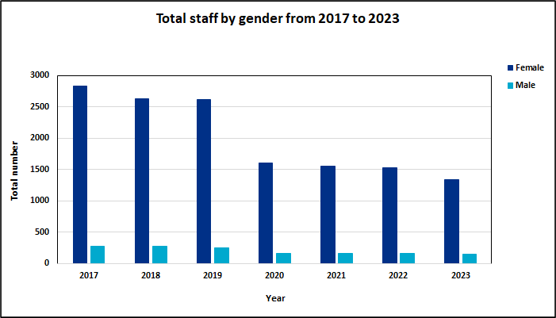

Analysis shows that the reduction of female and male staff by quartile from 2017 to 2023 has differed, and this is shown in figure 2 on the following page.
The percentage changes to the female and male staff by quartile can impact on pay gaps and can mean that impact of work undertaken to reduce pay gaps can be difficult to observe.
Figure 2: Showing the percentage reduction in female and male staff by quartile between 2017 and 2023.
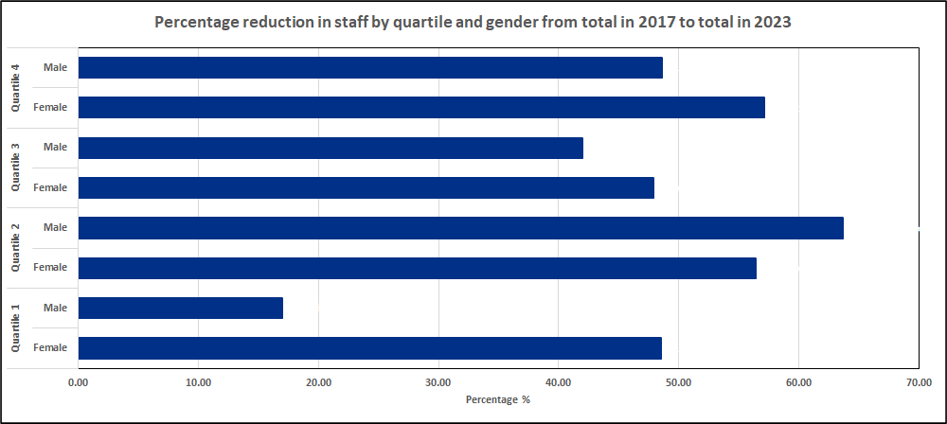
The final workforce comparison figure details the changes to the female and male workforce by quartile for each year from 2017 to 2023:

Figure 3: Showing total male and female staff by quartile from 2017 to 2023
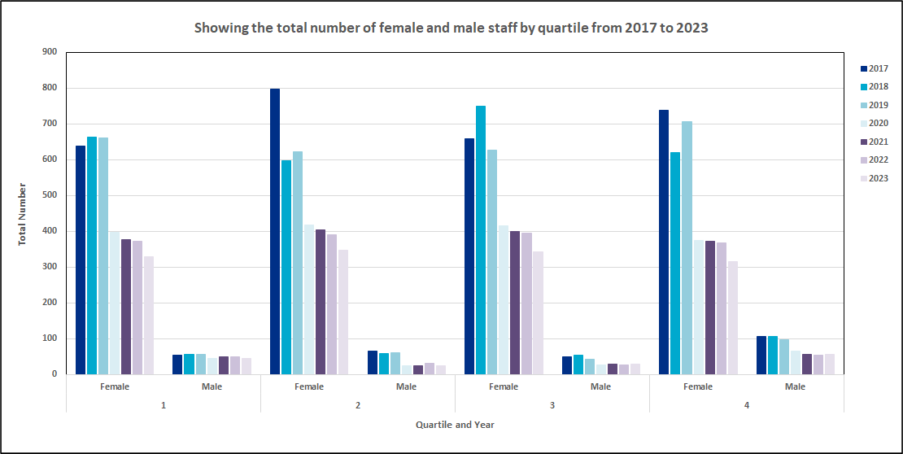

Ordinary pay

The information to follow offers a comparison of gender pay gaps for ordinary pay from 2017 to 2023.
Table 4 and figure 4 show the change to both mean and median gender pay gaps as a percentage from March 2017 to March 2023.
It can be observed that results have fluctuated, but overall pay gaps are reducing for the Trust.
Table 4: Showing mean and median gender pay gap results (%) from 2017 to 2023.
 | Mean GPG  % | Median GPG  %
2017 | 23.52 | 8.48
2018 | 23.87 | 7.34
2019 | 22.38 | 1.53
2020 | 25.34 | 9.19
2021 | 16.24 | 4.13
2022 | 14.45 | 0.34
2023 | 15.97 | 3.16

Figure 4: Showing the results trend for mean and median gender pay gap (%) from 2017 to 2023.
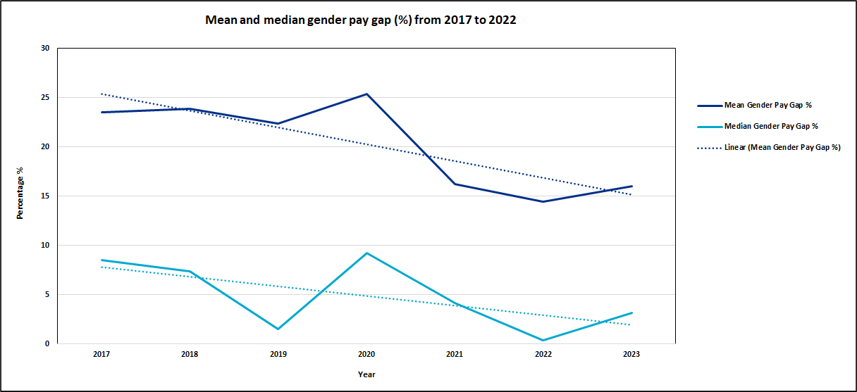

Figure 5 shows the mean and median gender pay gaps as a monetary value – the real cost difference between female and male staff.
Figure 5: Showing the mean and median gender pay gap as a monetary value from 2017 to 2023.
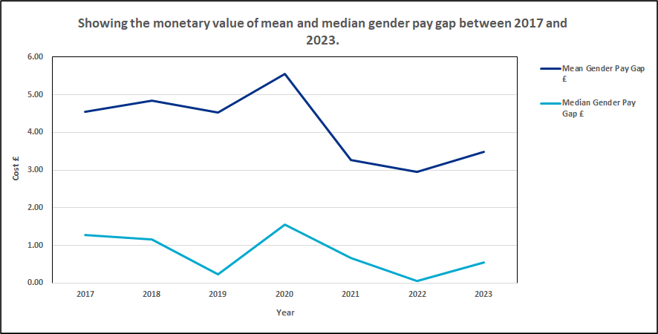

The fluctuations in the gender pay gap results likely arise as a result of the changing workforce profile of the organisation.
In 2020 there were approximately 1,000 staff transferred out of the Trust as a result of changes to place-based commissioning. This saw a greater percentage of female staff lost when compared to male staff, and a greater percentage of female staff in quartile 4 being lost – this had the effect of increasing our gender pay gap significantly in that year.
In 2023, as a result of changes to staffing i.e. leavers and new starters, the profile of the quartiles has shifted. For example, there has been a reduction in female staff in quartile 4 of 51 members of staff, and the male staff number has reduced by just one.
The Trust is working hard to deliver the commitments of the NHS People Promise, and through People Operational Delivery groups and associated task and finish groups are looking at actions and programmes that should positively influence staff recruitment and retention. The reasons for leaving the organisation have been challenging to analyse as many staff records state ‘other’; this is being addressed through the recruitment and retention working group so that better information is available for action planning.
The Trust is aware that its largest workforce is nursing and midwifery and that this is a predominantly female workforce with a large number of older staff, nearing retirement age. Effective support for existing staff, and an attractive recruitment offer are therefore key priorities for the Trust.

Bonus pay
Due to the very small numbers of staff involved a comparison with previous years is not provided, however all previous gender pay gap reports can be viewed at https://bridgewater.nhs.uk/aboutus/equalitydiversity/equalityact2010/

Current work programmes
The Trust is committed to equity and creating a diverse, inclusive, and compassionate workplace for all our staff.
As referenced earlier in this report gender pay gaps are not the same as unequal pay. As an employer however we recognise that there are factors, many personal, that affect women more frequently than men, and that these factors can lead to inequity in career progression and therefore renumeration. For example, parenthood and childcare responsibilities, unpaid caring roles for elderly or ill loved ones, and for some women the menopause and its potentially difficult and limiting symptoms. We recognise intersectionality too can increase inequity where more than one characteristic is at play, for example we know that in the UK there are pay gaps and employment gaps for ethnicity and disability also.
Detailed below are some of the work programmes being undertaken that should have a positive impact on our workforce:

Just and Learning Culture
The Trust in 2019 committed to implementing the Just and Learning Culture programme, a programme already developed and further evolving in one of our neighbouring NHS Trusts, Mersey Care NHS Foundation Trust. Whilst Just Culture has focussed largely upon employee relations matters across the NHS, the Trust is concerned to ensure that the internal culture is characterised by those values and behaviours which underpin fairness and equity for our whole workforce.

Civility and Respect
Civility and respect are the new NHS terms for bullying and harassment and together with kindness are core principles of a Just Culture.
Alongside equity, diversity, and inclusion, civility and respect are critical to a Just Culture, our implementation of a culture of mutual respect, support, and psychological safety.
Our approach to Civility and Respect builds on the existing work that has already taken place around anti-bullying and harassment. It is reliant on effective communication, training, relevant policy, and improved accountability, with greater alignment to the Trust’s values and other work programmes.
Where civility and respect is absent staff can be disengaged, unhappy, unwell, and may not feel in a position where they want or feel able to advance their careers.
With a large female workforce, and with the intersectionality with other protected characteristics such as disability, ethnicity, and religion or belief it is important that all our staff feel they work within a culture that allows them to thrive and reach their full potential.

HR Policy Update
With the two work programmes above there has been an increasing focus on updating HR policies within the last 12 months to ensure they align with our Just Culture and inclusivity values, and that they are more concise and user friendly. Central to this has been a move towards developing toolkits for staff and managers.
Key policy updates in progress are Disciplinary, Dignity and Respect at Work, Grievance, and toolkits to support health and wellbeing that will impact on guidance and policy such as employee adjustment passports for disability and carers.
Nationally, in partnership with staff side organisations the NHS is developing a series of policies that will ensure consistency across all providers. Bridgewater is an early adopter of the Wellbeing Policy in the North West and is part of a small working group that is finalising and then supporting implementation of this policy across the region. To follow in 2023 are further policy updates including:
- Menopause
- Pregnancy and baby loss
- Flexible working
- Equality, diversity, and inclusion

Menopause
For Bridgewater menopause is an important issue and one which we have focused heavily on. The NHS generally is over-representative of a female workforce when compared to the overall population, and as a Trust, Bridgewater has a higher percentage of female staff than male, averaging around 90 – 91% female.
A review of Trust data for age and gender in 2022 highlighted that nearly half of the overall workforce was female and aged 45 or over. We recognised that we needed to be promoting dialogue about menopause to understand how we could support our staff better. There is also national recognition and Trusts have received significant support at both national and regional levels.
In 2022 – 2023 we have undertaken the following actions, and this is just the start of our menopause work which we are extremely proud of, resulting in more open conversations:
- Established a menopause support network
- Established a menopause working group
- Published a menopause support policy
- Engaged with teams through face to face meetings and presentations
- Rolled out fresh packs to services for emergency sanitary supplies
- Celebrated Bridgewater’s first menopause fortnight and World Menopause Day
- Set up a staff menopause support page populated with resources and signposting support
- Held three menopause events during Bridgewater’s health and wellbeing fortnight

Carers support
The Trust undertook a survey for Carers Week in 2021, and that data together with that in the annual NHS Staff Survey (where it was revealed that 38% of staff stated they provided unpaid care) was used to develop first steps in support for carers.
National research informs us that having an unpaid caring role can impact on work, in terms of decisions to stay in employment, reduce working hours or choosing not to take opportunities to train and advance career. The impacts on health and wellbeing are well documented and women are more likely to be undertaking caring roles; there can be an impact on gender equity in later life with a potential impact on gender pay gaps.
While not everything is within the power of the Trust as an employer to change, there is a lot that can be done to make the workplace supportive of the additional and changing needs of our carers. These changes can allow staff to remain in the workplace and continue to advance their careers, providing the Trust as employers the wealth of experience and knowledge gained over a career.
While in the early stages the Trust has:
- Established a carers support network
- Regularly promoted the employee adjustment passport for disability/reasonable adjustments and carers
- Signposted staff throughout the pandemic and on-going to the resources and support available via Employers for Carers
- Drafted a carers support policy that has been signed off in January 2023 including provision of additional paid leave for specific times in the caring role
The Trust is working towards accreditation with Employers for Carers in 2023.

Career development
Career development opportunities are important to the Trust and the Educational and Professional Development team lead on a number of opportunities for staff, these include:
- Apprenticeships – opportunities for new, and existing staff to develop their skills, earn a qualification, retrain in a new career or progress in a current role, all while supported through a paid role and opportunity to access learning
- Talent for Care, and Widening Participation – programmes to improve education, training, and development opportunities for the support workforce (typically pay bands 1 - 4) and to improve representation when compared to local populations. Programmes include pre-employment programmes, traineeships, work experience placements, and support to achieve basic maths and English qualifications
- Study support – options to apply for funding to access external learning opportunities for career development
- Leadership Academy programmes – promotion of opportunities led by the North West Leadership Academy, such as Mary Seacole, and Edward Jenner programmes
- Scope for Growth – the Trust is a pilot site for the NHS Scope for Growth programme. This tool has been designed to support staff and line managers have person centred conversations about career development aspirations, personal potential and health and wellbeing, and to identify any actions and support staff need to realise their potential

Reciprocal Mentoring for Inclusion
In 2023 the Trust is working with Liverpool John Moores University to launch a Reciprocal Mentoring Programme. This change programme will link staff and senior leaders in partnerships of shared power to allow honest discussion about experiences around equality and inclusion, and with facilitated support to develop and deliver change programmes for equality. This is not aimed directly at female staff but through intersectionality with ethnicity and disability female staff should be involved and positively impacted.

Recruitment and retention
The final area highlighted in this report is the work being done around recruitment and retention and how we increase diversity, address under-representation, and how as an anchor organisation we can positively impact inequality in our boroughs through employment opportunities that are open to all.
Work programmes include:
- New approaches to how we recruit – where we advertise, what our recruitment paperwork looks like and how we support applicants. We have seen really positive results so far such as our recruitment of a cohort of healthcare support workers, recruiting a much more diverse group of new staff, many of who had never considered a career in the NHS as being available to them. Our campaign received a Nursing Times Award
- Updated job descriptions, adverts, webpages – ensuring that equity is embedded, and that the Trust’s public facing information for applicants is accessible, engaging, informative, and welcoming
- Returnees – supporting formally registered staff to return to the workplace
- Flexible working – an option open to all staff
- Volunteers – developing opportunities for people to gain experience, or just volunteer their time, through volunteer roles across services
- Armed Forces Friendly – working towards accreditation for Defence Employers silver award, and Veterans Aware. This includes the wider armed forces family including partners and spouses, many of whom can struggle to find employment due to lack of previous experience, re-location, and need to support loved ones who are serving or have served.

Contact details
Thank you for taking the time to read our gender pay gap report. Should you have any queries or questions or if you would prefer the contents of this report in another language or format, please contact our Equality & Inclusion Manager in the first instance, details below.
Paula Woods (Director of People and Organisational Development)
Ruth Besford (Equality & Inclusion Manager) ruth.besford@nhs.net

