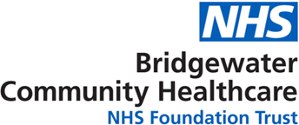

**Children & Young People feedback form**

**Talk to Us…**

Please use the

QR code to complete the form online.

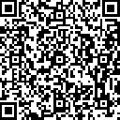

Service used: Borough:

Where treatment was received:

Date:

|  |  |  |  |  |  |
| --- | --- | --- | --- | --- | --- |
| **Thinking about your recent visit please tell us about?** | **Great** | **Good** | **Not good** | **Bad** | **Does not**  **apply** |
| The time you waited to be seen |  |  |  |  |  |
| The way our staff welcomed you |  |  |  |  |  |
| The way they listened to you |  |  |  |  |  |
| The information you were given |  |  |  |  |  |
| The way you were treated |  |  |  |  |  |
| The way you were included in your care |  |  |  |  |  |
| Your time with us today |  |  |  |  |  |

|  |  |  |  |  |  |
| --- | --- | --- | --- | --- | --- |
| **Overall, how was your experience of our service?** (please tick one box) | | | | | |
| **Very good** | **Good** | **Neither good nor poor** | **Poor** | **Very poor** | **Don’t know** |
|  |  |  |  |  |  |
| **Please can you tell us why you gave your answer?** | | | | | |

Please tick this box if you DO NOT wish anyone else to see your comments

**Talk to Us…**



If you would like to speak to Patient Services on please contact:

Freephone **0800 587 0562** or email: [**bchft.patientservices@nhs.net**](mailto:bchft.patientservices@nhs.net)

Bridgewater Community Healthcare NHS Foundation Trust

Europa Point, Europa Boulevard, Warrington, Cheshire, WA5 7TY

**What to do next:**

Please hand the form to a member of staff.

Put it in the box provided or

Post to: **FREEPOST BRIDGEWATER**

**Please tell us about you:**

I am: (please circle one of the following) The patient Relative/carer

I am: (please circle one of the following)

A boy A girl Other

Parent Representative/Carer

I am: years old

Thank you

