Public Sector Equality Duty

Annual Report

March 2023

Contents

Introduction | 3
Executive Summary | 4
About Bridgewater | 7
Equality In Bridgewater | 10
Due Regard in Employment | 14
Due Regard in Service Delivery | 23
Appendix 1: Equality Delivery System 2022 | 33
Appendix 2: Gender Pay Gap 31st March 2022 | 35
Appendix 3: Workforce Disability Equality Standard | 36
Appendix 4: Workforce Race Equality Standard | 38
Appendix 5: Workforce Equality Data | 40
Appendix 6: Language Interpretation 2022 | 42

Glossary of acronyms

BOOST | Building On Our Strengths Together (Programme)
BSL | British Sign Language
EDI | Equality, Diversity, and Inclusion
EDS | Equality Delivery System
GP | General Practice
HR | Human Resources
LGBTQIA+ | Lesbian, Gay, Bisexual, Transgender, Questioning, Intersex, Agender/Asexual. + denotes other gender and sexual identities
NICE | National Institute of Clinical Excellence
NHS | National Health Service
PDSA | Plan, Do, Study, Act
POD | People Operational Delivery (Group)
WDES | Workforce Disability Equality Standard
WRES | Workforce Race Equality Standard

Introduction

Welcome to our Public Sector Equality Duty Annual Report for 2023.
This report will provide you with information on our equality, diversity, and inclusion activities over the last year, together with an update on our current projects.
If you have any questions or queries regarding the information in this report, or if you require the information in another language or format, please do not hesitate to contact us using the contact details below.
Thank you.
Paula Woods (Director of People and Organisational Development).
Ruth Besford (Equality & Inclusion Manager).

Contact Details:
Ruth Besford
ruth.besford@nhs.net
07919 898475 (mobile)
1st Floor Spencer House, 81 Dewhurst Road, Birchwood, Warrington. WA3 7PG

Executive Summary
The Equality Act came into force in England in 2010.
The Act brought together 116 separate pieces of equality legislation into one simplified and streamlined act that brought protection from discrimination for nine protected characteristic groups:
- Age
- Disability. This includes:
  - Physical, mental, sensory, learning, and hidden disabilities
  - Neurodivergent differences such as for example autism, dyslexia, and dyspraxia
  - Some people with long term conditions, where their impact is significant on day to day living.
- Gender Reassignment (Transgender)
- Marriage & Civil Partnership (including same sex marriage)
- Pregnancy and Maternity
- Race (Ethnicity)
- Religion or Belief, including no belief
- Sex (we recognise and value the diversity of gender identity and expression beyond the male/female binary)
- Sexual Orientation (we recognise and value all sexual identities, recognising that this is a wide and not static spectrum of personal identity)
Bridgewater also recognises other often disadvantaged and vulnerable groups. These include:
- Carers
- Military veterans and the armed forces community
- The homeless and vulnerably housed
- Asylum seekers and refugees
- Those with ‘chaotic lifestyles’ – drug and alcohol abuse, and sex workers
- People living in areas of high social deprivation
For organisations providing public services the Equality Act introduced a Public Sector Equality Duty (Section 149 of the Act). The Public Sector Equality Duty has two duties:
- The General Equality Duty - see below
- The Specific Duties
There are two parts to the Specific Duties:
- To publish at least annually evidence of compliance with the Equality Duty
- To publish at least every four years measurable and achievable equality objectives
This report is our 2023 compliance with the first of these two Specific Duties.
Our two actions plans, the second of the two Specific Duties, are on our website at http://bridgewater.nhs.uk/aboutus/equalitydiversity/equalityact2010/
The General Equality Duty
The General Equality Duty requires public sector organisations to have due regard to three aims in all they do:
- To eliminate discrimination, harassment, victimisation, and other conduct prohibited by the Act
- To advance equality of opportunity between people who share a protected characteristic and people who do not, the Act states that this includes:
  - Removing or minimising disadvantages suffered by people due to their protected characteristics
  - Taking steps to meet the needs of people from protected groups where these are different from the needs of other people
  - Encouraging people from protected groups to participate in public life or in other activities where the participation is disproportionately low
- To foster good relations between people who share a protected characteristic and people who do not, which includes promoting understanding of and between different groups and tackling prejudice, racism, homophobia, transphobia, religious hatred and disability harassment and hatred
Due regard means thinking about these three aims in all Trust business. This consideration should be robust, timely, conscious, and carried out with an open mind as to the outcomes.
In this report we provide brief information about the Trust, i.e. where services are delivered, the Trust’s mission and objectives, including strategic equality objective, and details of the Board’s anti-racism statement.
The way in which equality is managed and action plans are overseen and delivered is covered briefly, as is how we ensure due regard to the General Equality Duty in employment and service delivery is observed on a day-to-day basis.
It is expected that the information provided is comprehensive and provides assurance that due regard to equality and inclusion is embedded throughout Trust business.
The report also provides more details on some specific programmes of work being undertaken within our employment functions, and in service delivery and community engagement.
Recent updates on important accreditations including Disability Confident, Navajo, and Veteran Aware are detailed. The Trust has been privileged to receive these accreditations in 2022 and are working hard to develop, improve upon, and maintain them.
Finally, the appendices to the report will refer to language interpretation usage, and results for Workforce Disability and Race Equality Standards, Equality Delivery System 2022, and Gender Pay Gap 2022.

About Bridgewater
Bridgewater provides community services in Halton (Runcorn and Widnes), and Warrington, these services include:
- 0 – 19s services
- District nurses and community matrons
- Therapy services including physiotherapy and speech and language/communication therapies
- Specialist services such as palliative care and mental wellbeing
We also have a small number of services who deliver in St Helens and Knowsley, and our Drive Ability North West Service delivers across the North West of England.
The Trust also provides dental services across a wide geographical area within Cheshire, Merseyside, and Greater Manchester.
We have specialist dental care that provides treatment to patients who because of differing needs and vulnerabilities are unable to access high street dental services.
Figure 1: Bridgewater Map of Services
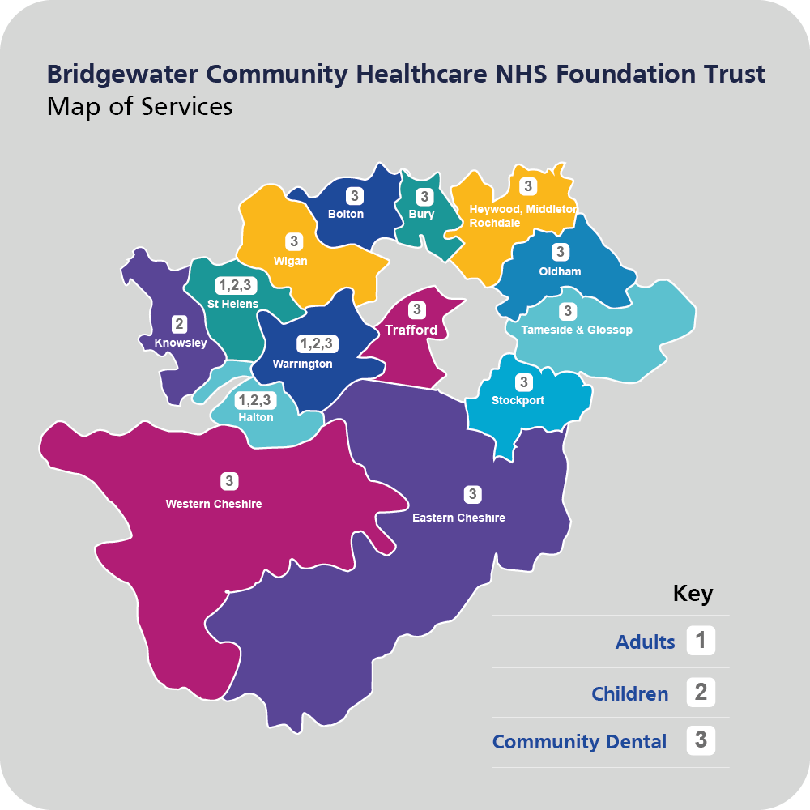
Trust Mission, Strategy and Objectives
The Trust’s mission is ‘to improve local health and promote wellbeing in the communities we serve’. To do this ‘we will work closely with local people and partners to promote good health and to be a leading provider of excellent community healthcare services in the North-West’.
This mission is underpinned by our People values which are supported by behavioural statements:
Figure 2: Bridgewater People Values image
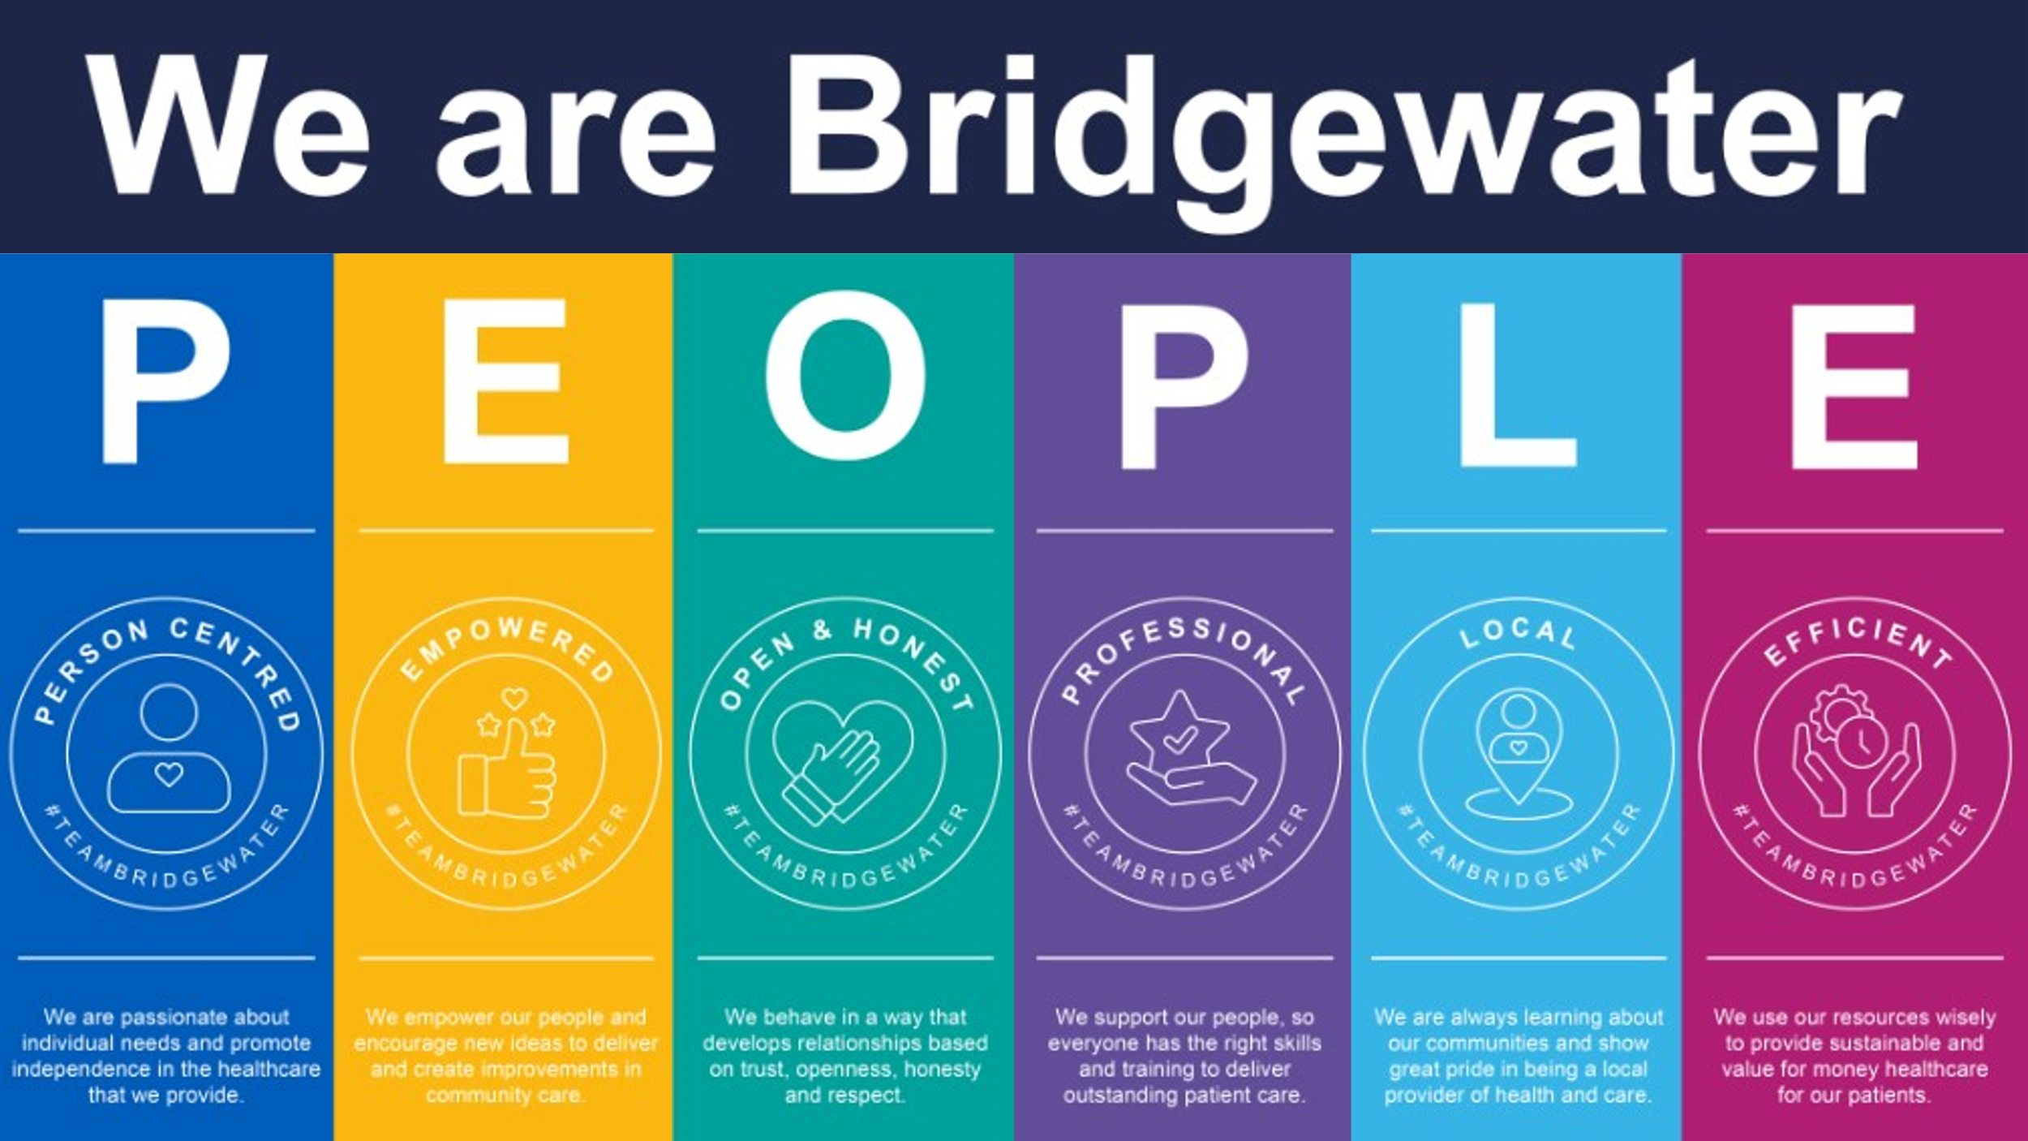
Our overarching Trust Strategy, Quality and Place, was refreshed in 2021. It details plans for the next three years to deliver high quality, place-based care, as a key partner in local care organisations. Further details can be found on our website at https://bridgewater.nhs.uk/aboutus/qualityandplace/
Our Strategy Objectives, refreshed in 2020 to add our equality objective, are:
- Quality – to deliver high quality, safe and effective care which meets both individual and community needs
- Innovation and collaboration – to deliver innovative and integrated care closer to home which supports and improves health, wellbeing, and independent living
- Sustainability – to deliver value for money, ensure that the Trust is financially sustainable and contributes to system sustainability
- People – to be a highly effective organisation with empowered, highly skilled, and competent staff
- Equality, Diversity, and Inclusion – to actively promote equality, diversity, and inclusion by creating the conditions that enable compassion and inclusivity to thrive.
The last objective is our mandated objective as per the Specific Duties of the Equality Act 2010. The actions to deliver it are set out in our two equality action plans, see page 10.
Anti-Racism Statement and Commitment
Bridgewater is committed to improving race equality for our staff and our communities, and to being actively anti-racist.
We are committed to improving awareness and understanding, from an individual to a Trust level, of the ways in which many of us have benefitted from privilege and systemic racial discrimination throughout our lives.
We will as a Trust demonstrate honestly and transparency; we will admit where we have gaps in knowledge, understanding, data, representation; we will be open and honest about where we believe we can do better; and we will actively facilitate and listen to the voices of our diverse workforce and communities, recognising that Black, Asian and minority ethnic groups are not a collective whole any more than ‘White British’ is a group with identical views, needs, aspirations and inequalities.
We will work in true partnership with our staff networks and with our wider communities to develop and deliver real and sustainable plans that address racism, discrimination, and inequality.

Equality in Bridgewater
Equality Strategy and Action Plans
Our Equality, Diversity, & Inclusion Strategy 2020 - 2023, is built on the conversations we held with our Staff Networks and is aligned to national actions such as the NHS People Plan.
The Strategy, signed off with the full commitment and active support of our Executive and Non-Executive Directors, recognises that every member of staff is a key stakeholder in the delivery of the Strategic Equality Objective and action plans for Bridgewater. The aim is to ensure that equality is fully embedded across the Trust, and integral to the everyday narrative of all our staff.
The Strategy’s vision, aims and principles promote a workplace and services that are compassionate, inclusive, representative, respectful, value diversity, and embed respect and support for individual contributions, needs and aspirations.
Our Strategy will be reviewed in 2023 in consultation with our staff and staff networks, whereby we ensure equality is an integral part of every strategy across the Trust, with its own clear narrative and commitments within each.
The current strategy can be found on our website.
Equality, diversity, and inclusion is inherent within several programme action plans, including our Just Culture journey and Civility and Respect programme. In addition, there are specifics set out in two overarching action plans, and a number of smaller specialist plans referenced within these. The two overarching action plans can be found on the website link above and are:
- Six High Impact Areas for Equality – workforce focused
- Equality Action Plan – Services and Communities

Equality governance
Day to day responsibility sits with the Equality & Inclusion Manager, with executive responsibility in the portfolio of the Director of People & Organisational Development.
Governance is in place that provides challenge around the equality work of the Trust and provides assurance to Board. This is as follows:
- People Operational Delivery groups, or PODs. These are tasked by Board to deliver the People Plan and its People Promises across Bridgewater. There are four PODs which oversee task and finish and working groups delivering specific pieces of work. Equality is aligned to the Culture and Leadership POD, albeit the agenda is pertinent and vital to all areas of work:

  - Culture and Leadership POD
  - Education and Professional Development POD – talent management and succession planning, Workforce Race Equality Disparity action plan, any training identified as required.
  - Health and Wellbeing POD – menopause, carers, and Equality Delivery System (EDS) outcomes.
  - Recruitment and Retention POD – armed forces friendly and Veteran Aware, Disability Confident, and general support for all recruitment and retention workstreams

- People Committee

- Joint Negotiating and Consulting Committee

- HR Policy Group

- Quality Impact Assessment Panel, including equality impact assessment

- Board
There are also strong connections with the community engagement and Quality and Place Strategy working groups.
The Trust also reports to Halton and Warrington commissioners through the quarterly assurance meetings – equality has a distinct section within the NHS Standard Contract on which compliance and progress must be reported on quarterly.

And the Trust is accountable to Government Equalities Office, NHS England, and NHS North West for progress on equality specifically in relation to:
- Workforce Race Equality Standard (WRES)

- Workforce Disability Equality Standard (WDES)

- NHS Anti-Racism Framework

- Gender Pay Gap

- Equality Delivery System
All reports related to these frameworks are scrutinised through the governance structure until given final approval by the Trust’s Board.
Staff voice
The annual NHS Staff Survey has a number of equality and inclusion related questions and provides all staff with an opportunity to anonymously feed back to us their views based on their own experiences of the workplace.
The Trust has seen a steady increase in the number of respondents every year, with more than half of all staff now completing the survey. We have observed an increasing number of responses from staff within diverse groups, notably those from Black, Asian, and minority ethnic heritages, and staff with disabilities and long-term conditions. This is encouraging as it is critical to our aims of really understanding the lived experience of our minority groups.
Since 2020 we have been building our staff networks to provide a safe space for the voice of diverse groups of staff. The staff networks, and their Executive sponsors are as follows:
- Carers Support Network – Chief Nurse, and Deputy Chief Executive

- Enabled Network – Director of Finance

- LGBTQIA+ Staff Network – Chief Operating Officer, and Trust Secretary

- Menopause Support Network – Trust Secretary

- Paths to Parenthood – new network in late 2022, in development

- Race Inclusion Network – Medical Director (network chair), Chief Executive, Trust Chair
The networks are also supported by the Trust’s Freedom To Speak Up Guardian, ensuring that staff who raise issues can be supported to further highlight those concerns where appropriate.
A key priority for 2023 is development of the networks – membership, objectives, and programmes of work and events for 2023.

Figure 3: Staff networks logo
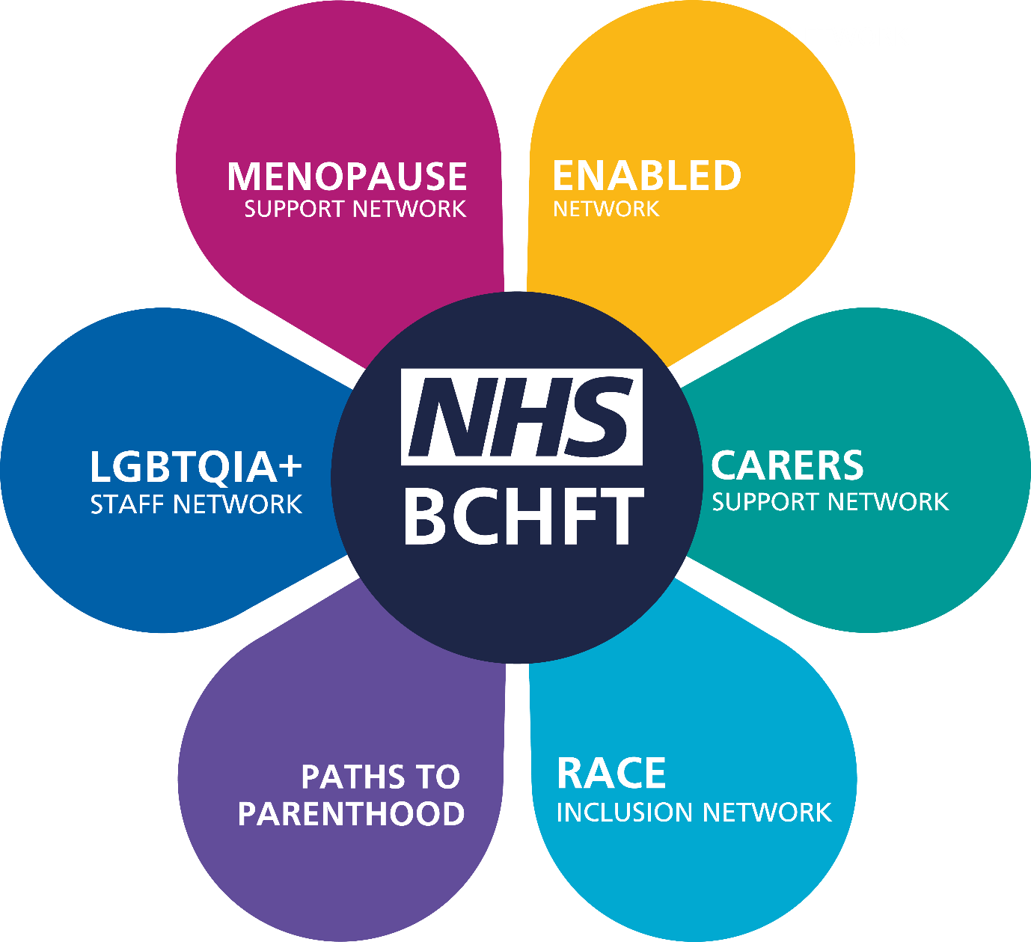

Due regard in employment
Due regard in employment requires us to consider the three aims of the Equality Duty in all workforce related issues, including for those potentially joining our Trust, and those who support our work through their invaluable volunteering contributions.
Data regarding our staff can be seen in the Appendix, but here are the fundamental functions we carry out which support due regard in our employment actions and decisions.
- The Trust’s People Strategy was refreshed in 2022 with some support from the Trust’s equality lead. It aligns with the national NHS People Plan and NHS People Promise, both of which have equality and inclusion throughout. Priority three of the People Strategy is specific to equality, but equality and inclusion are woven throughout the priorities set out in the document.
- All Trust workforce policies undergo scrutiny for equality impact at design or review. Sign off is not given until such time as any identified potential negative impact is addressed through minimisation or elimination.
- Policy governance is overseen through the Joint Negotiating and Consulting Committee (JNCC) and People Committee, the latter providing assurance to Board. Day to day policy design and review is managed through the HR Policy Group, where the Trust’s equality lead is a management member.
- Staff-side colleagues work closely with corporate and clinical/medical leads through the Joint Negotiating and Consulting Committee and Local Negotiating Committee (LNC). Their insight and challenge on staff issues ensures the Trust considers impact, including equality impact, of workforce policy, strategy, and plans.
- The vast majority of job vacancies are advertised through the national NHS Jobs website with prospective candidates signposted to this.
- As a Disability Confident Leader, and Defence Employer Recognition Scheme Trust we offer a guaranteed interview to any candidates who identify as disabled, or an armed forces community member on their application, and who meet the essential criteria of the role.
- All job descriptions undergo thorough scrutiny and are evaluated through the Agenda for Change Job Evaluation Scheme. This is a process which has membership support from HR and Staff-side colleagues.
- All staff, except those in very senior leadership roles, are recruited on nationally agreed terms and conditions, either Agenda for Change or Medical and Dental.
- All staff can access occupational health services, who provide support and advice on health and wellbeing, including advice and support for staff with disabilities requiring reasonable adjustments.
- There are a range of other health and wellbeing support offers available, managed by the Trust’s Health & Wellbeing Co-ordinator. This includes Able Futures, (the Department for Work and Pensions Mental Health Service), and Cheshire and Merseyside Resilience Hub.
- Bespoke health and wellbeing offers, for example for Black, Asian, and minority ethnic staff, are flagged to staff through staff network mailing lists and through the Bridgewater Bulletin.
- Flexible working is open to all staff, taking into consideration the needs of the service, and more than half of our staff work flexibly. Retire and return is also an option that many staff eligible to retire, have taken up in recent years.
- We make reasonable adjustments for staff with disabilities, or unpaid caring responsibilities, and these can be recorded and held by the staff member in the Trust’s Employee Adjustment Passport.

- In April 2021, the costs for making reasonable adjustments for staff with disabilities was centralised in line with best practice set out by the NHS Workforce Disability Equality Standard team.
- A lot of work has been undertaken in 2022 to embed support for the working carers within Bridgwater. This has included the establishment of the Carers Support Network, and the drafting of a Carers Support Policy. The latter is due to finish governance sign off in early 2023 and will support our application to Carers UK’s Employers for Carers Accreditation Scheme. Work has been led by the Trust’s Health & Wellbeing Co-ordinator and HR with support from the Trust’s equality lead.
- Menopause friendly cultures and workplaces have been a priority focus in the NHS and Bridgewater in 2022. Work has included the establishment of a Support Network, a Working Group, publishing of the Menopause Support Policy, events for our Health & Wellbeing Fortnight, regular communications, and practical aspects such as a roll out of Fresh Packs to services.
- In 2022 the Board signed the Armed Forces Covenant, and the Trust was successful in applications to the Defence Employers Recognition Scheme bronze level, and Veteran Aware accreditation.
- Employment, and health and safety laws also underpin our employment practice, including providing protection and reporting processes for staff from discrimination, violence, bullying and harassment.
- Staff can report incidents through a number of channels including Ulysses (for incidents related to patients/families), through online and anonymous reporting for staff incidents, directly to HR and Staff-side colleagues, and to the Trust’s Freedom To Speak Up Guardian and Champions.
- The Freedom To Speak Up programme in the Trust has been refreshed in 2022, with the recruitment of staff from the staff networks into Champions roles with clear messaging regarding alignment to equality and inclusion.
- Annual data is provided by the NHS Staff Survey and through the Gender Pay Gap, and Workforce Disability and Race Equality Standards. These provide us with a profile of progression across the years, and through engagement with our staff networks we are able to identify barriers, gaps, issues, and then agree actions to take to continue the work of eliminating any discriminatory practices, or behaviours witnessed or experienced by our staff.

- We have a quality impact assessment panel that looks at service changes and the potential impact on protected groups, including within the workforce, and equality impact and risk is included within this.

- We ensure due regard through robust processes that are reported through our governance structures to Board. These structures ensure that all areas of Trust business are appropriately under scrutiny, and are, most importantly, interlinked with issues arising in our People Committee - for example being brought to the attention of our Audit, Finance and Performance Committees.

- We have undertaken awareness events for several years, but with our staff networks, are focusing more clearly on just a small number of events every year, through communications, events, and bitesize equality learning events.

- Awareness events in 2022 have focused on Gypsy, Roma, and Traveller History Month, Bridgewater Menopause Fortnight, and Ramadan.

- In September 2022 the Board held a development day looking at anti-racism, and how they as leaders embedded a culture of anti-racism. The day was facilitated by Real and Authentic Representations of Africans and Caribbeans (RARA) Education Project.

- RARA supported the Trust again in December 2022 at its Leader in Me event. These events are run throughout the year and are open to all staff. 100 members of staff joined the day looking at anti-discrimination and anti-racism. Feedback was overwhelmingly positive, with support for further events to raise awareness and provide time and space to discuss these important issues.
Outlined below is more information on our essential work programmes that support due regard in equality and inclusion.
Disability Confident
The Trust was delighted to be awarded Disability Confident Leader level in March 2022. This was in collaboration with the Shaw Trust who provided leadership, advice, and final verification of evidence of progress in relation to disability equality.
An action plan is being delivered through the Recruitment and Retention POD to fill gaps, embed best practice, and further develop our employment and service delivery practices in anticipation of re-assessment in March 2024.
Figure 4: Disability Confident Leader Logo
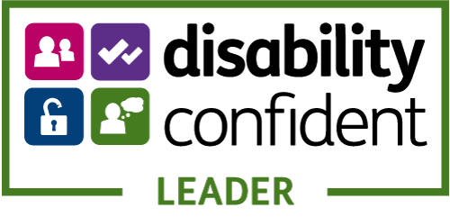

Navajo Charter Mark
In summer 2022 we were proud to be re-accredited with the Navajo Charter Mark for LGBT+ inclusion in employment and service delivery.
Assessed externally by Navajo staff and volunteers the re-accreditation looked at current policy and practice, and progress on the action plan agreed in 2018 when first awarded the Charter Mark.
Work has now commenced on delivery of the action plan up to 2024.
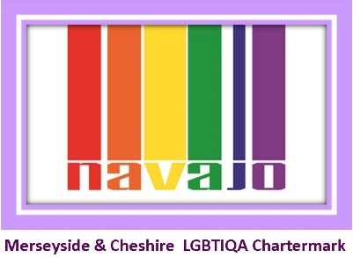
Figure 5: Navajo Charter Mark logo

Armed Forces Friendly
The Armed Forces Act 2021 placed a new due regard duty on organisations in relation to the armed forces community, due regard to the commitments of the Armed Forces Covenant.
Bridgewater has for several years been a signatory of local covenants across our boroughs, Royal Assent of the new Act felt the time was right for the Trust to review and make its own commitments to this community.
The Armed Forces Covenant was signed by Board in 2022 and set out the following additional commitments:
- Promoting the Armed Forces: promoting the fact that we are an armed forces-friendly organisation, to our staff, customers, suppliers, contractors and wider public.

- Accessible health and dental services: ensuring our services are accessible and inclusive for the armed forces community, and that there is no disadvantage suffered in accessing our services for members of the community.

- Veterans: supporting the employment of veterans, recognising military skills and qualifications in our recruitment and selection process; and working with the Career Transition Partnership to support the employment of service leavers.

- Service families: supporting the employment of service family members and providing flexibility in granting leave for service family members before, during and after deployment.

- Reserves: supporting our employees who are members of the Reserve Forces; granting additional leave for annual Reserve Forces training; supporting any mobilisations and deployment; and actively encouraging members of staff to become Reservists.

- Cadet Organisations: supporting our employees who are volunteer leaders in military cadet organisations, granting additional leave to attend annual training camps and courses; actively encouraging members of staff to become volunteer leaders in cadet organisations; and recognising the benefits of employing cadets/ex-cadets within the workforce.

- National Events: supporting Armed Forces Day, Reserves Day, the Poppy Appeal Day, and Remembrance activities.

The Trust was awarded Defence Employers Recognition Scheme bronze level in November 2022.
With the support of the Trust’s Veteran Health Care Alliance representative, Bridgewater was delighted to be awarded Veteran Aware accredited status in February 2023. This is a significant recognition of the work undertaken so far to develop and embed armed forces friendly cultures in employment and in service delivery.

Figure 6: Defence Employers Recognition Scheme bronze award logo
Figure 7: Veteran Aware logo
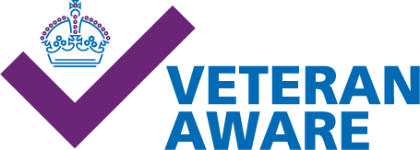

Our next steps are the delivery of an action plan through the Recruitment and Retention POD to fill those identified gaps and implement a number of actions, including refresh of communications and literature produced a number of years ago.
The Trust is part of local and regional armed forces networks and is looking to develop further engagement with the armed forces community in the workforce and in the community.
Staff Engagement Champions
The Trust has had a network of Staff Engagement Champions since 2017. These are staff who volunteer a little of their time to feed back some key Trust messages to their teams, and to feedback team messages to the Trust’s senior leaders and Executives.
In 2022 it was agreed to refresh the champions programme, and to bring in a number of specialist areas that Staff Engagement Champions could volunteer to focus on. These specialists would continue to act as a conduit for messages in their teams, but would have the opportunity to access additional training and support to enable them to focus on supporting an area of interest to them.
These additional champions roles are:
- Carers Support Champions

- Digital Champions

- Enabled Champions for disability equality

- Freedom to Speak Up Champions – as per national programme

- Health and Wellbeing Champions

- Menopause Champions

- Race Equality Champions
The equality focused champions will be aligned to the Trust’s equality lead. The champions will provide information to their teams about events and news, feedback issues and ideas to the equality lead, and will support where able with equality focused events They will also act as support to staff in certain areas (for example disability peer support, LGBTQIA+ buddy, or support for new international staff).
Apprentices
The Trust is increasingly utilising apprenticeship programmes as a way of offering on-the-job training and development opportunities to individuals who are new to the sector or looking to progress within their current role. The apprenticeships are proving to be powerful for promoting equality, diversity, and inclusion within the workforce and community.
Increased apprenticeship opportunities:
Increased apprenticeship opportunities are being provided for those who may have no prior experience in the sector but who have the potential to succeed and make valuable contributions to our workforce. This approach helps to break down barriers to entry and create more inclusive workplaces that reflect the diversity of our wider community.
Supporting existing staff:
In addition to providing external apprenticeship opportunities, our programmes also provide existing staff with opportunities to develop and progress. This helps to ensure that all members of our can achieve their full potential, regardless of their background or previous experience.
By investing in our staff through apprenticeships we are demonstrating our commitment to promoting equality, diversity, and inclusion at all levels of our organisation.
Engaging with our local partners:
The Trust regularly engages with local partners including schools, colleges, youth organisations, and local Job Centres, to support members of our community to access our vacancies. By offering job application and interview advice and guidance, we are helping to break down barriers to entry and ensure everyone has an equal opportunity to succeed. This approach also helps to build stronger connections between our organisation and the wider community, promoting a more inclusive and collaborative working environment.
Supporting learning needs:
We recognise that everyone learns differently and that some individuals may require additional support to complete their apprenticeship successfully. That is why we are committed to supporting all apprentice learners who have dyslexia or other learning needs to access and complete our programmes. By providing additional support, including access to diagnosis and workplace assessment, we are ensuring that everyone has an equal opportunity to succeed and contribute to our workforce.
Maths and English qualifications:
We offer our staff the opportunity to gain Maths and English qualifications, enabling them to apply for higher level apprenticeship opportunities. This approach is particularly important for promoting diversity and inclusion as it helps to ensure that everyone has an equal opportunity to progress and achieve their full potential, regardless of their previous education or qualifications.
The Trust is demonstrating its commitment to creating a more inclusive and equitable workplace for all. We will continue to work hard to ensure that our apprenticeship programmes remain a driving force for positive changes within our organisation and the wider community.
Just Culture, and Civility and Respect
The principles of our Just and Learning Culture programme are being continually assimilated and embedded into routine practice.
In essence a Just and Learning Culture is fundamental and integral to the culture of the Trust underpinned by an emphasis on the values and behaviours of civility and respect, kindness, and compassion. The Trust has made significant progress in reviewing and revising its human resources, employee relations policies and procedures to ensure that justice and inclusion are cornerstones of practice.
Promotion of our Just and Learning Culture has expanded with routine delivery of training to new employees and learners in addition to the established workforce.
A programme of Civility and Respect training has been developed and delivered to staff groups with whom it has been well received and successfully evaluated in the context of insight into behaviours and commitment to improve where necessary.
This agenda features on our Corporate Induction Programme that we run monthly.

Due regard in service delivery
Due regard to our patients, their families, and carers, and our diverse communities requires us to consider the three aims of the Equality Duty in all service delivery and healthcare related issues. This includes a focus on accessibility, experience, outcomes, and inequalities.
Outlined below are the fundamental functions which support and promote due regard in our employment actions and decisions.
- The Trust’s Quality and Place Strategy, Strategic Objectives, Mission, and Values, all have equality and inclusion embedded. Valuing diversity and meeting individual needs are at the heart of the Trust’s delivery of community and specialist dental services.
- Equality is a regular feature on Committee agendas up to Board. Monthly attendance by the equality lead is required at the Trust’s Senior Leadership Team meetings where issues, strategy, and delivery of the strategy in services is discussed. This allows equality issues and impacts to be discussed and understood before decisions are made.
- All Trust policies, procedures and guidelines related to patients and services have an equality impact assessment completed by the Trust’s equality lead as part of consultation. Final sign off is given through the governance pathway from the Trust’s Corporate and Clinical Policy Group on to our Quality & Safety Committee and ultimately, to Board.
- All policies are drafted and reviewed by subject matter experts and are reviewed by a large consultation group that includes clinical and corporate staff. Clinical policies are taken from national best practice including NICE guidelines and the Royal Marsden Manual of Clinical and Cancer Nursing Procedures.
- Many policies relate at least in part to equality, but of particular note are the Equal Opportunities Policy, Language Interpretation Policy, Reasonable Adjustments for Patients Policy, and Violence and Aggression Policy. Policies also cover consent, Mental Capacity Act, and Safeguarding, which includes child sexual exploitation, female genital mutilation, honour-based violence and other topics.
- All Trust staff must undertake mandatory training, of which some is standard for all and some role specific. This includes equality eLearning every three years that covers legislation and also scenario-based learning.
- Many Trust services are commissioned and designed to support people from protected characteristic groups, for example children’s services, including those for children and young people with additional and specific needs related to disability, long term, and life limiting conditions.
- Services can be delivered in many cases at a place suited to patient need, many services are domiciliary, or in schools or community venues. Some services meet with patients in safe spaces determined by the patients. There are of course some services that are less easy to move about, for example dental, but these services also look at how they can offer care within people’s homes and places of residence where the treatment involved allows.
- EDS2022 looked at two services connected to NHS Core20Plus5 maternity outcomes – Health Visiting Halton, and Family Nurse Partnership Warrington. The evidence gathering, engagement with services, and evaluation allowed us to demonstrate how these two services, part of the wider 0 – 19 Children’s Services in these boroughs show due regard to the three aims of the General Equality Duty, and embed individual patient and community need at the heart of service delivery.
- A review of these two services evidenced how at service level the Trust engages with patients, communities, partners, and voluntary sector organisations to support the best outcomes for patients and families. Service action plans are agreed and implemented to support improvements and sharing of best practice.
- Patient data in relation to equality can be challenging for the Trust as many fields are not mandatory for completion and of course patients have the choice not to declare this information. EDS2022 demonstrated how some services have undertaken review of their records and standard letters to ensure inclusion for diverse gender and sexual identities, same sex marriage/civil partnership, and diverse family units within their service delivery.
- The 0 – 19s Children’s Chat Health service offers free and confidential health advice for 11 – 19 year olds in Halton and Warrington. This includes topics such as sexual health, gender identity, and sexual identity.
Figure 8: Chat Health logo

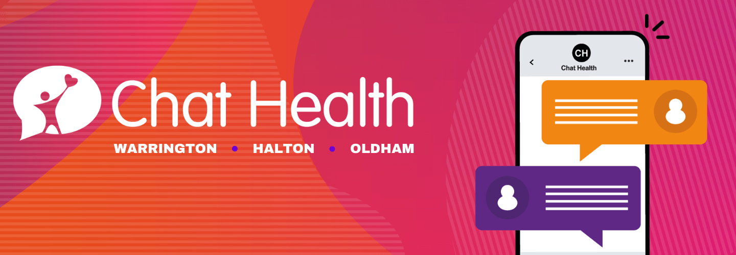

- Patient experience reports are collated monthly and shared within governance structures, through to Board. Patient stories are a regular Board agenda item, both good news stories, and stories where things may not have gone to plan, and lessons have been learned through governance reviews.
- The Trust’s incident reporting systems and Freedom to Speak Up processes ensure that any issues in relation to patient experience are flagged, recorded, analysed, and lessons learned and shared.
- The 0 – 19 Children’s Service Leads have been engaging with Irish Community Care to deliver some awareness/training sessions with all staff in spring 2023. This will look at access and outcome for Gypsy, Roma, and Traveller communities in our region.
- All services have access to interpretation and translation providers, this includes information and communication support in community languages, BSL, and other formats such as audio, easy read and Braille. Please see Appendix 6 for our language interpretation usage in 2022.
- The Trust has action plans for d/Deaf patients following engagement led by Liverpool CCG on behalf of all local providers, and for the Accessible Information Standard. These are monitored by our commissioners in Halton and Warrington.
- The Trust’s internet has been refreshed in 2022, based on national accessibility guidelines. The website hosts ReachDeck accessibility software that allows patients to tailor their view to best suit their needs, whether this is translation, screen masks, text to speech, or creation of MP4 files.
- The house writing guide for leaflets and patient information was refreshed in 2022 based on national accessibility guidelines. The new templates are created to allow easy access using digital technology, but paper copies, translations and other formats will always still be produced based on patient need.
- AccessAble have produced access guides to some Trust clinics through Community Health Partnerships, our landlord in some services. These are available on their website, and the Trust is looking to engage with AccessAble about guides for our Trust owned buildings in 2023-2024.
- Staff are supported by the internal Library Service who advise on updated NICE guidance, changes to legislation, current news, and who provide an invaluable source of support in developing the patient policies, procedures, and guidelines.
- The Trust’s services are effectively supported by our Safeguarding Teams, with staff and named nurses working collaboratively with outside agencies to ensure the most vulnerable in our communities are identified and supported.
- There is robust health and safety, and risk management in place with policy, training, and governance to ensure the safety and wellbeing of staff and patients accessing services.
- Our Just Culture programme referenced earlier in the report is an improvement tool that, through the creation of a psychological safe space for staff, enables everyone to speak up when they experience an instance where something did not go to plan and/or was unexpected, including in patient care. This programme and culture change should ensure ongoing improvements for patients in the delivery and outcome of care.
- The Trust has a strong focus on the ‘voice of the child’ and has published information and training to support staff in this important area. The webpage introduction states:
  - The voice of the child is a phrase used to describe the real involvement of children and young people. It means more than seeking their views, which could just mean the child saying what they want, rather than being really involved in what happens. Lord Laming said of Victoria Climbié that no-one could describe a day in her life.
  - Children and young people should have the opportunity to describe things from their point of view. They should be continually involved, and have information fed back to them in a way that they can understand.
  - There should always be evidence that their voice has influenced the decisions that professionals have made. Voice of the child can help others gain a sense of a child's life experience.
  - Understanding the life experience can help professionals make the right decisions for children.
- We understand that patients and carers are often best placed to gauge how services are performing. Patient Partners is an approach that aims to actively encourage patients, their families and carers to work in collaboration with services to identify areas for improvement in quality of care and service delivery. A network of clinical staff meets regularly to discuss and share good practice in involving patients and carers in service improvement activities. The network aims to ensure all services continually listen to the unique insight of patients and carers in order to inform service development and to improve patient care and service quality.

- Our public governors have a key role to play as a link to our local communities, and we have public governors for each of our boroughs. Most will also have strong links with local voluntary sector organisations where they have a particular personal interest, for example due to a family member having a disability; and while their role isn’t to act as a mediator, they can provide valuable feedback from these groups when other charity service users have accessed Trust services.
- The Trust published its Carers Strategy in 2022 in recognition of the valuable support that unpaid carers provide the NHS, and their often unmet health and wellbeing needs
- Trust teams undertake regular communications and awareness raising to ensure all staff are aware of diverse need and experience. This includes annual religious and cultural events such as Ramadan, Diwali, and Spring Festival, and also awareness raising such as hate crime awareness, violence against women, and safeguarding children.
- As stated earlier in the report the Trust was awarded a number of accreditations in 2022 that recognise equality in service delivery, and action plans are being implemented to continue to improve in these areas:
  - Disability Confident Leader
  - Navajo Charter Mark for LGBT+ inclusion
  - Veteran Aware
- To help us to consider our equality impact, and to support us in meeting due regard to equality, we use borough health inequality documents; these provide local population demographics by protected characteristic, and inequalities information for protected groups.
Outlined below is some more information on important work programmes that support due regard in equality and inclusion.
Quality and Place 2023
Since the publication of our original Quality and Place Strategy in 2018 the NHS has seen some significant changes and challenges.

In 2022 the launch of the Health and Care Act, and the subsequent establishment of Integrated Care Systems, has changed the NHS landscape:
- New Integrated Care Boards and Integrated Care Partnerships bringing together NHS providers, commissioners, local authorities, and other partners to design and deliver services that will effectively address the health inequalities so starkly and tragically evidenced by the Covid 19 pandemic.

- New place-based approaches and teams with new levels of autonomy to address disparity in equality at local levels – for Bridgewater mainly Cheshire and Merseyside, with some provision in Greater Manchester.

- Launch of Provider Collaboratives, smaller groups of NHS Trusts based on specialism whether that is acute hospital Trusts, specialist Trusts for cancer care for example, and community and mental health Trusts.
Professor Sir Michael Marmot and the Institute of Health Inequity present a compelling picture about the health inequality challenges nationally, regionally and locally to Bridgewater.

Whilst these changes and challenges present complexity and uncertainty at the moment they also present a great opportunity for the NHS and its partners.

Through the delivery of the Trust’s current Quality & Place strategy, we have made fundamental changes to our internal governance and ways of working – devolving greater levels of decision-making and leadership autonomy to our directorates, teams and front line staff.

We now have an opportunity to:
- Embrace the opportunities of the new health and care act.

- Build on the great foundations and progress of the current Quality & Place strategy.

- Ensure new priorities, ‘must dos’, and opportunities are identified and embedded as we move forward.

- Ensure our approach and actions deliver our mission to improve the health and wellbeing of local people.
In 2023 we are refreshing our Quality and Place Strategy to ensure it remains aligned to national, regional, and local priorities and plans. Underpinning this, we want to use this strategy refresh to launch a new, continuous, and collaborative approach to our engagement and relationship with local people and local communities, embracing and embedding a strengths-based approach in how we co-design and co-produce services, support, care and health creation.

Digital inclusion
The Covid 19 pandemic led to a very rapid change in how NHS services were delivered, moving many patient contacts into a digital or remote format, whether that was telephone consultations, video appointments, or information sent digitally.
While this change has been great for many people, supporting them to access services in a way that suits their work and home lives, for others it has led to the potential for further exclusion.
Evidence shows that there are particular groups that are more likely, though not unilaterally or exclusively, to be excluded digitally, whether that is through access to technology and smart devices, financial constraints, language and communication barriers, or other factors.
As a Trust we are working to engage with our communities and voluntary sector organisations to understand the reasons and issues behind digital exclusion. And we are considering steps that we could take as an anchor organisation in our communities to upskill and digitally enable communities.
Digital will never and should never be the default option for all. However, we believe that by better engaging with digitally excluded groups, seeking to remove barriers, and upskilling where appropriate, and simply acknowledging that for some groups digital is not a solution, we can identify the inequalities that are a consequence of digital exclusionary policies and practices.
Learning disabilities
The Trust has a small working group that meets to discuss action plans agreed following the regular submission of data and evidence to the national NHS Learning Disability Improvement Framework.
Actions this year have included engagement with local groups, a competition for service users to develop a working group logo, co-development of a talk to us form for learning disability patients with service users, relaunch of the Trust’s learning disabilities webpage, and publishing of a regular newsletter.
Veterans and armed forces community
In February 2023 we were proud to be awarded Veteran Aware accreditation through the Veterans Health Care Alliance. This allowed us to join more than 100 other NHS Trusts who work to ensure equitable access and outcome for members of the armed forces community in our boroughs.
The armed forces community is itself diverse, including veterans and service leavers, reservists, adult cadet force volunteers, and of course family members. Needs can vary, can be based on injury sustained in service, or can result from frequent moves around the country and abroad, but the community as a whole can suffer disadvantage when accessing public services, something recognised within the Armed Forces Covenant.
As stated earlier the Trust has an action plan to continue to improve its offer to the armed forces community, particularly in our service delivery, and this is led by our Champions Dyad of Chief Operating Officer, Public Health Lead, and equality lead.
Community Health and Wellbeing Workers
Figure 9: Community Health and Wellbeing Worker logo
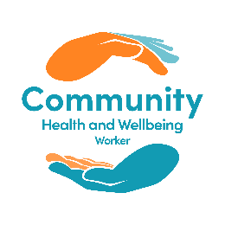
The Community Health and Wellbeing Worker pilot is a new model of care that provides universal and integrated geography-based outreach in peoples own homes, based on the Brazilian Family Health Strategy model. It is currently running within the Oakwood area of Birchwood, which according to the Index of Multiple Deprivation is ranked in the top 20% of the most deprived areas in the UK.
This is a proactive approach, whereby the Community Health and Wellbeing Workers actively seek out engagement in the service at a household level, thereby allowing for the discovery of unmet health needs, with the ultimate aim of reducing inequality.
Developing links with all community services that affect any of the social determinants of health, including charities, voluntary organisations and GP services allows for connections to be developed between service users and providers, allowing for increased support for those most in need.
Employment requirements are kept to a minimum to allow for increased diversity in the team of Community Health and Wellbeing Workers, with the aim of employing as locally as possible.
BOOST
The Trust’s approach to transformation and quality improvement is known as the BOOST (Building On Our Strengths Together) programme.
The approach features a strong ethos of staff inclusion and engagement, with programmes of work being agreed and developed from the "bottom up” – usually starting with a series of staff workshops that are open to staff at all levels within the organisation, where ideas are gathered to form the basis of directorate and service work streams.
BOOST’s methodology is based on NHS England’s Change Model, using simple PDSA (Plan, Do, Study, Act) cycles to drive change, and is supported by the Trust’s Transformation Team.
Upon creation of a transformation or quality improvement plan, follow up staff workshops are arranged, to ensure that staff engagement remains central to the steering and delivery of the plans.
Progress with transformation and quality improvement plans are monitored by the Trust’s Transformation Council to ensure appropriate governance is in place, and that plans have high visibility within the organisation.
Governors
As an NHS Foundation Trust we have some devolved decision making authority, with our members and governors supporting and challenging the Trust in our strategy and how we operate and run services.
Our members can be service users, carers, staff, and other local people interested in Bridgewater. They represent the areas in which the Trust delivers services, i.e. Halton, Warrington and those parts of the North West region where we provide community dental services including Bolton, Oldham, Rochdale, Bury, Ellesmere Port, St Helens, Widnes, Warrington and Leigh.
We strive to ensure our members are representative of the communities in which they live. When recruiting members we pay due regard to the diversity of an area and endeavour to encourage people from a diverse range of groups through targeted engagement with local groups.
Our public governors are elected by our members to undertake specific roles, including the appointment of the Trust Chair and non-executive directors, and holding the Board to account on decision making and progress; we make every effort to encourage diversity in applications to public governor roles as they are advertised.
Looking at just one protected characteristic - race and ethnicity, we know that the most culturally diverse of our constituencies is the Rest of England which represents our community dental services and as described serves a large, culturally diverse population. Trust public members in ‘Rest of England’ area are currently predominantly White (English, Welsh, or Scottish British), but there are a number who describe their ethnicity as Asian/Asian British-Indian or Pakistani, and black/British Caribbean. Although there are no governors from an ethnic minority background at present, we have attempted to actively engage with communities in advance of public governor elections – attending community events in Bolton and Oldham.
In the summer of 2022, the Trust held elections for several governor vacancies. In advance of the elections, we contacted groups and organisations whose members use our services. We were delighted when a member of staff from a local Deaf organisation was elected a public governor and ensured the induction into the organisation was fully supported and enabled. Unfortunately, due to personal reasons, the individual has since resigned their governor position but we continue to work with the sector in an effort to build on these firm foundations and encourage further participation in forthcoming elections.
We have also utilised the knowledge of one of our Non-Executive Directors to target our recruitment activity within the ethnic communities in Greater Manchester, and have successfully recruited a partner governor representing the voluntary/ third sector in the Halton area.
Many of our serving governors are members of groups/organisations that support our communities including Warrington Foodbank, Healthwatch Halton, Healthwatch Warrington, and parent/carers support networks.
Our staff governors are elected by our staff members. Again, we are seeking to harness the knowledge of our colleagues who are members of our Race Inclusion Network, Enabled Network, and other staff networks, by encouraging them to consider standing for election in 2023.
It is important our Council of Governors is reflective of the communities they serve and the staff they represent, and we make every effort to consider the diversity of the towns where we deliver services. We remain cognisant of the need to encourage greater representation of culturally diverse and challenged sectors and shall be working closely with those groups in the months to come.

Appendix 1 – EDS2022
The Equality Delivery System, or EDS, was refreshed by NHS England in 2022 to streamline and align its outcomes to Core20Plus5, and to staff health and wellbeing following the Covid 19 pandemic and ongoing disparity in workplace experience for some groups within the workforce.
The 11 outcomes of EDS2022 cover three domains:
- Service delivery

- Workforce experience

- Inclusive leadership
In partnership with providers and equality leads in the Cheshire and Merseyside Integrated Care Board the Trust focused for EDS2022 on two services for domain 1:
- Health Visiting Halton

- Family Nurse Partnership Warrington
Both services aligned to the maternity element of Core20Plus5 – as a collaborative most providers in the region looked at elements of maternity, some general and some very specialised, to give a holistic view of maternity provision and outcome across our boroughs.
Engagement for evidence review and grading was undertaken with stakeholders from staff side and staff networks, and peer review was given, with thanks to them, by local Health Watch representatives.
The full EDS2022 report can be viewed on our website, but results are detailed below.

EDS2022 Domain and Outcome | Rating
Domain 1: Commissioned or provided services
1A: Patients (service users) have required levels of access to the service | Developing
1B: Individual patients (service users) health needs are met | Achieving
1C: When patients (service users) use the service, they are free from harm | Achieving
1D: Patients (service users) report positive experiences of the service | Achieving
Domain 2: Workforce health and wellbeing
2A: When at work, staff are provided with support to manage obesity, diabetes, asthma, COPD, and mental health conditions | Achieving
2B: When at work, staff are free from abuse, harassment, bullying and physical violence from any source | Excelling
2C: Staff have access to independent support and advice when suffering stress, abuse, bullying, harassment, and physical violence from any source | Achieving
2D: Staff recommend the organisation as a place to work and receive treatment | Under-developed
Domain 3: Inclusive leadership
3A: Board members, system leaders (Band 9 and VSM) and those with line management responsibilities routinely demonstrate their understanding of, and commitment to, equality and health inequalities | Excelling
3A: Board/Committee papers (including minutes) identify equality and health inequalities related impacts and risks and how they will be mitigated and managed | Excelling
3C: Board members and system leaders (Band 9 and VSM) ensure levers are in place to manage performance and monitor progress with staff and patients | Excelling
Overall rating | Achieving

Appendix 2 - Gender Pay Gap 2022
The full report for Gender Pay Gap at 31st March 2022 can be found on our website, but please see below in brief our 2022 results.
 | March 2019 |  | March 2020 |  | March 2021 |  | March 2022
Percentage of male and female staff in quartiles
 | Female | Male | Female | Male | Female | Male | Female | Male
1 | 660 | 57 | 397 | 44 | 370 | 50 | 371 | 50
2 | 621 | 61 | 416 | 24 | 397 | 23 | 391 | 30
3 | 626 | 42 | 415 | 25 | 392 | 28 | 395 | 26
4 | 707 | 97 | 373 | 67 | 364 | 56 | 367 | 54
Mean Gender Pay Gap
Percentage % | 22.38 |  | 25.35 |  | 16.14 |  | 14.45
Cost £ | 4.53 |  | 5.56 |  | 3.26 |  | 2.95
Median Gender Pay Gap
Percentage % | 1.54 |  | 9.19 |  | 2.37 |  | 0.34
Cost £ | 0.23 |  | 1.56 |  | 0.38 |  | 0.06
Bonus pay
Note | No bonus pay gap, all clinical excellence awards to female staff in relevant period

Appendix 3 – Workforce Disability Equality Standard 2022 (WDES)
The full report for WDES 2022 can be found on our website, but please see below in brief our 2022 results.
Metric
- Percentage of staff in each AfC Band 1-9 or Medical and Dental pay grades, compared with the percentage of staff in the workforce overall. Disaggregated by non-clinical staff, clinical staff, and medical and dental staff. Note rounding up of numbers may mean a slightly higher figure than 100% is seen in the below. A * means that numbers are below 10 and therefore not published for data protection.
 | Non-clinical |  |  |  | Clinical
 | Disabled | Not Disabled | N/S |  | Disabled | Not Disabled | N/S
AfC1 - 4 | 10 | 219 | 52 |  | * | 224 | 91
AfC5 - 7 | * | 77 | 22 |  | 27 | 630 | 158
AfC8a – 8b | 0 | 14 | * |  | * | 40 | 22
AfC8c - VSM | * | 12 | 13 |  | 0 | * | *
 | Medical and Dental Grades:
Consultants | 0 | * | *
Non-Consultant Career Grade | 0 | 52 | 19
Trainee Grades | 0 | 0 | 0
- Relative likelihood of being appointed from shortlisting across all posts |  |  |  | 0.69 times more likely to be appointed if you are not disabled
- Relative likelihood of entering capability processes |  |  |  | No formal capability procedures related to performance  No formal capability procedures related to ill health for staff with a disability

Metric
- A) Percentage of staff experiencing bullying, harassment, and abuse from patients/relatives/public in last 12 months | 27.5% Disabled  17.6% Not Disabled
Percentage of staff experiencing bullying, harassment, and abuse from managers in last 12 months | 12.8% Disabled  5.1% Not Disabled
Percentage of staff experiencing bullying, harassment, and abuse from staff in last 12 months | 18.7% Disabled  12.6% Not Disabled
- Percentage staff reporting bullying, harassment, and abuse in last 12 months | 40.5% Disabled  55.6% Not Disabled
- Percentage believing the Trust provides equal opportunities for career progression and promotion | 51.8% Disabled  60.0% Not Disabled
- Percentage feeling pressure by manager to attend work even when feeling unwell | 28.3% Disabled  10.1% Not Disabled
- Feeling valued by the Trust | 35.5% Disabled  50.1% Not Disabled
- Satisfaction that reasonable adjustments made to support them in their work | 73.4% Disabled
- A) Staff engagement score (Disabled staff only) | 6.7 Disabled  7.3 Not Disabled
B) Have you taken action to facilitate the voices of Disabled staff | Yes
- Percentage difference between Board membership and overall workforce  Disaggregated by voting and non-voting members | -3.0% Disabled  -32.0% Not Disabled  35.0% Not Stated
Trust Overall Workforce:
Disabled: 52 (3.02%)
Non-Disabled: 1281 (74.39%)
Unknown: 389 (22.59%)

Appendix 4 – Workforce Race Equality Standard 2022 (WRES)
The full report for WRES 2022 can be found on our website, but please see below in brief our 2022 results.
Indicator
- Percentage of staff in each AfC Band 1-9 or Medical and Dental pay grades, compared with the percentage of staff in the workforce overall. Disaggregated by non-clinical staff, clinical staff, and medical and dental staff
 | Non-clinical |  |  |  | Clinical
 | White | Black, Asian, or minority ethnic | Not stated, or unknown |  | White | Black, Asian, or minority ethnic | Not stated, or unknown
Under AfC Band 1 | * | * | 0 |  | 0 | 0 | 0
AfC1 | 0 | 0 | 0 |  | 0 | 0 | 0
AfC2 | 94 | * | * |  | 39 | * | *
AfC3 | 131 | * | * |  | 121 | * | *
AfC4 | 40 | * | 0 |  | 133 | * | *
AfC5 | 41 | * | * |  | 245 | 18 | *
AfC6 | 32 | * | * |  | 341 | 16 | 15
AfC7 | 15 | * | * |  | 168 | * | *
AfC8a | 10 | 0 | * |  | 59 | 0 | *
AfC8b | * | * | 0 |  | * | 0 | 0
AfC8c | 11 | 0 | 0 |  | * | * | 0
AfC8d | * | 0 | 0 |  | 0 | * | *
AfC9 | * | 0 | 0 |  | 0 | 0 | 0
VSM | * | * | * |  | * | 0 | 0
 | Medical and Dental Grades:
Consultants | * | * | *
(Senior medical manager) | * | 0 | *
Non-Consultant Grade | 45 | 20 | *
- Relative likelihood of being appointed from shortlisting across all posts |  |  |  | 1.17 times more likely to be appointed if you are White
- Relative likelihood of entering formal disciplinary processes |  |  |  | 0.0 times more likely to enter formal disciplinary processes if you are Black, Asian, or minority ethnic
- Relative likelihood of accessing non-mandatory training/CPD |  |  |  | 0.57 times more likely to access this training if you are Black, Asian, or minority ethnic
- Percentage of staff experiencing bullying, harassment, and abuse from patients/relatives/public in last 12 months |  |  |  | Black, Asian, or minority ethnic 22.2%  White 20.1%
- Percentage of staff experiencing bullying, harassment, and abuse from staff in last 12 months |  |  |  | Black, Asian, or minority ethnic 13.3%  White 16.9%
- Percentage believing the Trust provides equal opportunities for career progression and promotion |  |  |  | Black, Asian, or minority ethnic 51.1%  White 58.9%
- In the last 12 months personally experiencing discrimination from manager/team leader/other colleagues |  |  |  | Black, Asian, or minority ethnic 13.3%  White 3.6%
- Percentage difference between Board membership and overall workforce  Disaggregated by voting and non-voting members |  |  |  | White -17.4%  Black, Asian, or minority ethnic 7.6%  Not Stated 9.8%
Trust Overall Workforce:
Black, Asian, and minority ethnic: 99 (5.75%)
White: 1,562 (90.7%)
Not stated: 61 (3.5%)

Appendix 5 – Workforce Equality Data
Please see in the table below information on the workforce by protected characteristic group as at the snapshot date of 31st December 2022.
Staff Equality Demographics (excluding Bank, career break, and external secondment)
 |  | Clinical Staff | Non- Clinical Staff
Age | Under 21 | * | *
 | 21 – 30 | 137 | 32
 | 31 – 40 | 311 | 64
 | 41 – 50 | 350 | 96
 | 51 – 60 | 305 | 164
 | 61 – 70 | 93 | 47
 | Over 70 | * | *
Disability | No | 949 | 324
 | Yes | 36 | 22
 | Not Stated | 213 | 68
Pregnancy and Maternity | Maternity and adoption (pregnancy not recorded on staff record except for sickness absence purposes) | 33 | *
Race/Ethnicity | Asian, Asian British (inc Indian, Pakistani, Bangladeshi, Sri Lankan, and other) | 48 | *
 | Black British, Black African and Caribbean | * | *
 | Chinese | * | *
 | Mixed ethnicity | 11 | *
 | Other Ethnicity | * | -
 | White, (inc White British, Irish, European, and Other) | 1103 | 385
 | Not Stated | 24 | *
We recognise that the figures above do not reflect the diversity of our multi-racial workforce. However, figures for minority ethnic staff are too low to report when disaggregated into detailed individual identities, so we have aggregated them to provide reportable figures
Continued…

Staff Equality Demographics (excluding Bank, career break, and external secondment) continued.
 |  | Clinical Staff | Non- Clinical Staff
Religion/Belief | Christianity | 581 | 199
 | Islam, Buddhism, Hinduism, Sikhism | 37 | *
 | No Religion | 121 | 38
 | Other | 69 | 20
 | Not Stated/ Do Not Wish To Disclose | 390 | 151
Gender Identity | Male | 92 | 72
 | Female | 1106 | 342
Our Electronic Staff Record records gender as identified by the member of staff, however we recognise that at this time for gender identity, and also sexual identity, there is limited capability to record the full spectrum of identities and this is being reviewed nationally
Sexual identity | Heterosexual | 873 | 311
 | LGB+ | 11 | 14
 | Not Stated/Do Not Wish To Disclose | 314 | 89
Note: Where numbers are 10 or below the figure is replaced with * to protect identity

Appendix 6 – Language Interpretation 2022
The provision of language and communication support for people whose first language isn’t English, or for people with disabilities or impairments with communication support needs, is very important for effective and safe provision of care, and equity of outcome.
As a Trust through the EDS Collaborative we have implemented the use of a language interpretation quality standard for procurement of interpretation services across Cheshire and Merseyside providers.
Total | Bookings
Face to Face | 1,751
Telephone | 227
Video | 41
Translation | 54
Total | 2,073

Most frequently requested languages for face-to-face interpretation have been (by number of bookings):
- Urdu - 344
- Bengali - 225
- British Sign Language - 196
- Polish - 165
- Arabic – 137
For translations this has been:
- Arabic - 15
- Urdu – 7
- Polish – 6
- Simplified Chinese – 6
- Turkish – 6
And for video remote interpreting:
- Turkish - 7
- Polish - 4
- Tamil - 4
- Kurdish Sorani- 4
We have been working closely with our language interpretation provider throughout 2022 as we have worked through difficulties sourcing particularly face to face interpretation in some languages, especially Kurdish Sorani, Farsi, Albanian, and Ukrainian.
There are different factors that are influencing this issue including a shortage of trained interpreters in the region, and a culture change to home working. Our language interpretation provider has worked to actively recruit throughout 2022.

