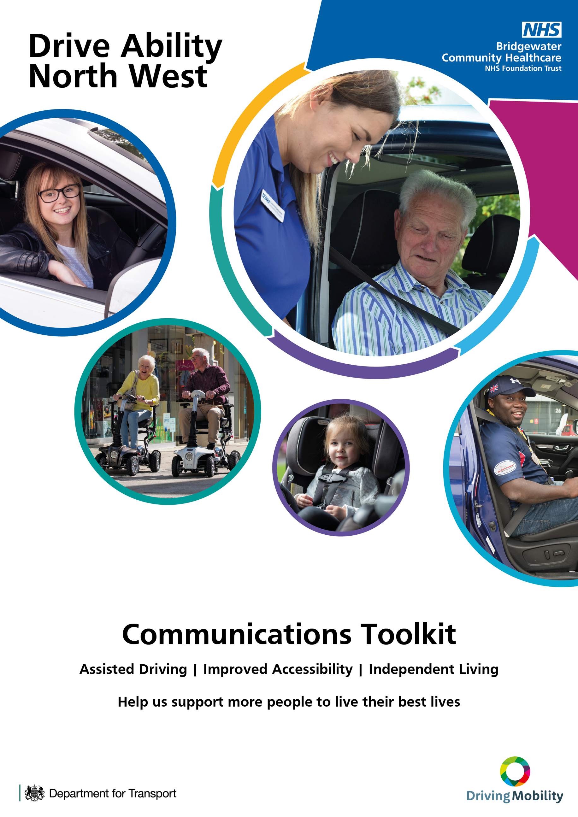

Contents

Why our service is important to the people you support  How do we help people?  Which geographical areas do we cover?  How you can help us to support more people  How to make a referral to Drive Ability North West  How you can promote Drive Ability North West  Frequently Asked Questions  Get in touch | 3  3  4  4  4  5 – 11  11 – 12  12

Make a referral
Online: www.bridgewater.nhs.uk/drive
Telephone: 01942 483 713
Email: BCHFT.DriveAbility@nhs.net

Why our service is important to the people you support

Being able to use a car as a driver or passenger is invaluable – especially for people with restricted mobility or a disability.

At Drive Ability North West, our Occupational Therapists and Approved Driving Instructors support people with medical conditions, disabilities, and those affected by old age, to drive safely and maintain or regain their independence as drivers or passengers.

We also advise on other mobility options to help people live a good and independent life, such as mobility scooters and car seats and harnesses for children with disabilities or challenging behaviour.

Help us reach as many people as possible with our service – we know it changes lives

How do we help people?

People use our service for lots of reasons, because of a disability, becoming less able following a stroke for example, after diagnosis of a condition such as dementia, or for reassurance as they get older and their reactions may slow.

We support people to stay mobile and independent for as long as possible, with tailored support, advice and assessments on:

- Their ability to drive safely for longer
- Adaptations to overcome physical problems with vehicle control
- Passenger / driver access to vehicles, seating and posture
- Wheelchair and scooter loading and transportation
- Children’s car seats and harnesses
- Mobility scooters
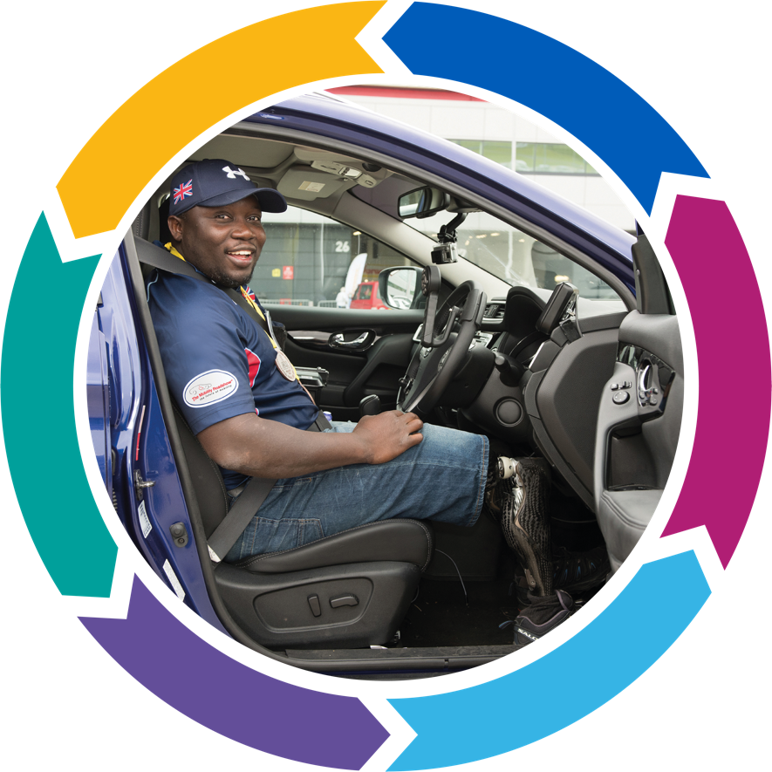
  - Alternatives to driving, including public transport

We also offer driving assessments for people with disabilities, Police Fit to Drive assessments, plus a range of tuition and training.

More information can be found at www.bridgewater.nhs.uk/drive

Which geographical areas do we cover?

Our main centre is based in St Helens, Merseyside. We also have centres in a number of other locations, which means that we can bring our service closer to you.

We offer our service to people living throughout North West England, from Barrow in Furness and the Lake District down to areas around the River Mersey.

If we discover that there is a closer Mobility Centre to your registered address, we will give you the opportunity to select that one.

How you can help us to support more people

We’re asking you to help promote our service, so that we can support many more people.
You can do this by:

- Easily referring people to our service
- Letting more people know about our service, using the resources in this, our Communications Toolkit.

This Communications Toolkit can be found online within our professional resources area at www.bridgewater.nhs.uk/drive

How to make a referral to Drive Ability North West

It’s easy to make a referral. You can refer individuals yourself or give them the details below so that they can refer themselves.

Make a referral using our simple online referral form at www.bridgewater.nhs.uk/drive, or call or email us:

Telephone referrals: 01942 483 713
Email referrals: BCHFT.DriveAbility@nhs.net

How you can promote Drive Ability North West

A range of resources have been created to help you easily promote our service.

For ease, you can also download all digital resources, including social media images and digital screens.

Download our social media images from: www.bit.ly/DANWsocialmedia

Download our digital screen resources from: www.bit.ly/DANWdigitalscreens

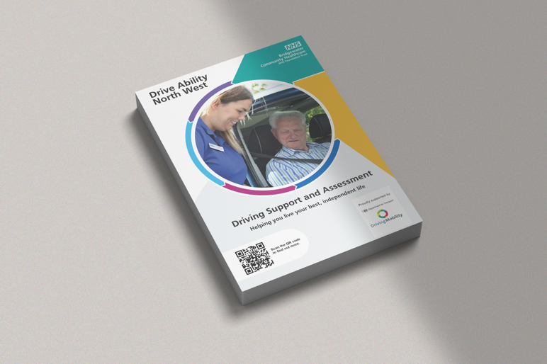
Print resources

A range of leaflets and A4 posters, shown below, have been designed to promote Drive Ability North West. You can display these across your sites and areas visible to your staff and members of the public.
To order these, please use our online order form: www.bit.ly/DANWorderform
Alternatively call us on 01942 483 713 or email BCHFT.DriveAbility@nhs.net.

Leaflets
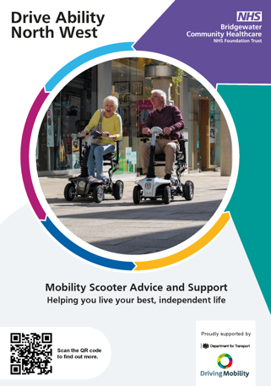 | 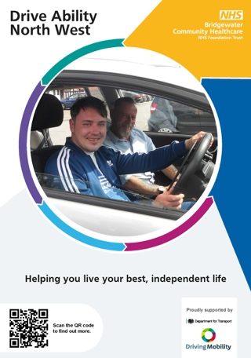 | 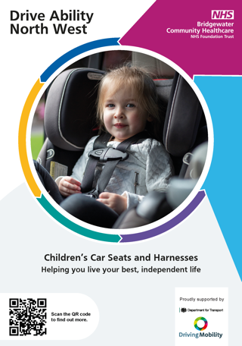 | 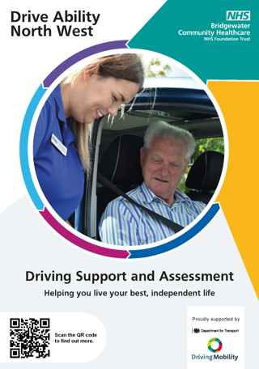
Mobility Scooter Advice and Support Leaflet | Generic – All Services Leaflet | Child Car Seat and Harness Assessment Leaflet | Driving Support and Assessment Leaflet

Posters
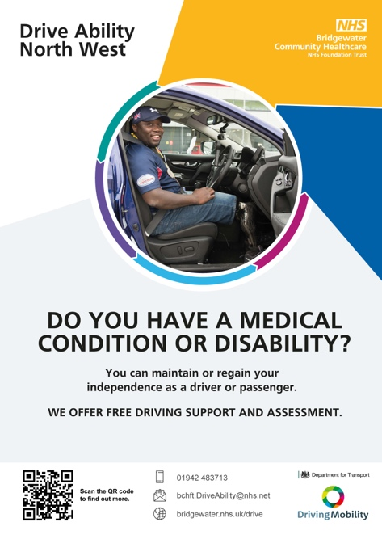 | 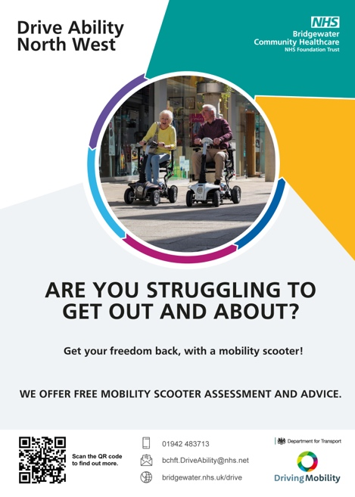
Medical Condition or Disability Support and Assessment Poster | Mobility Scooter Advice and Assessment Poster
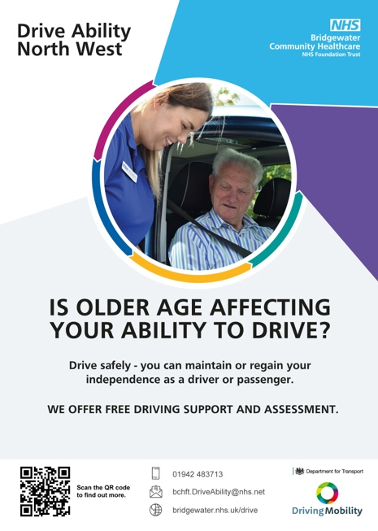 | 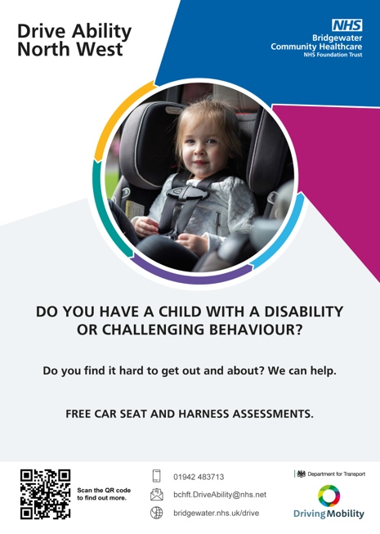
Older Driver Support and Assessment Poster | Child Car Seat and Harness Assessment Poster

Social media resources

A variety of social media images and text are available for you to use on your social media and external communications channels.

You will find the suggested copy below for use on Facebook, Twitter and Instagram. Add the Alt text copy to your images for increased accessibility.

You can download the social media images from: www.bit.ly/DANWsocialmedia

Social media image | Copy | Alt text
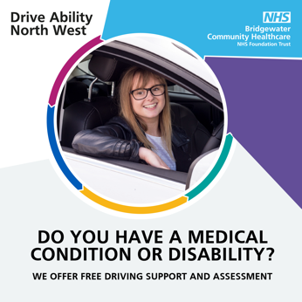 | Feel a medical condition or disability is affecting your ability to drive? Drive Ability North West can help you drive safely, maintaining your independence as a driver or passenger. For free driving support and assessment call 01942 483 713. bridgewater.nhs.uk/drive @DriveAbilityNW #DrivingSafety | A young woman smiles as she drives a car. Do you have a medical condition or disability? Drive Ability North West offer free driving support and assessment.
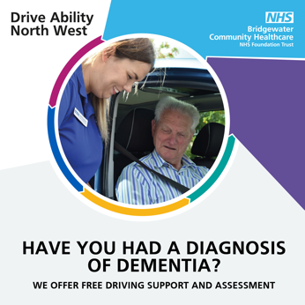 | Want to know you can still drive safely following a dementia diagnosis? Drive Ability North West can help. For free driving support and assessment call 01942 483 713. bridgewater.nhs.uk/drive @DriveAbilityNW #dementia #DrivingSafety #Driving Assessments | An older man sits in a car and is happy to be supported by an Occupational Therapist.  Have you had a diagnosis of dementia? Drive Ability North West offer free driving support and assessment.
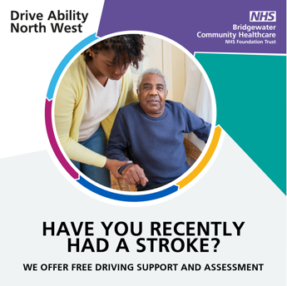 | Need support getting back on the road after a stroke? Drive Ability North West can help. For free driving support and assessment call 01942 483 713. bridgewater.nhs.uk/drive @DriveAbilityNW #DrivingSafety #Driving Assessments | An older man is supported by an Occupational Therapist. Have you recently had a stroke? Drive Ability North West offer free driving support and assessment.
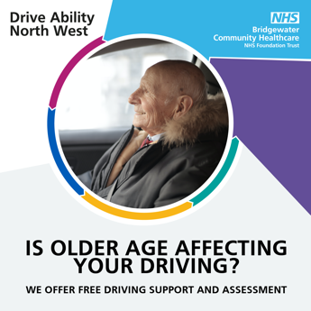 | Feel older age may be affecting your driving? Drive Ability North West can help you drive safely, maintaining your independence as a driver or passenger. For free driving support and assessment call 01942 483 713. bridgewater.nhs.uk/drive @DriveAbilityNW #Olderdrivers | An older man sits in the driver’s seat of a car. Is older age affecting your driving? Drive Ability North West offer free driving support and assessment.
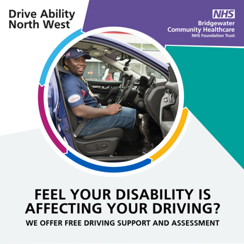 | Feel your disability is affecting your ability to drive? Drive Ability North West can help you drive safely, maintaining your independence as a driver or passenger. For free support and assessment call 01942 483 713. bridgewater.nhs.uk/drive @DriveAbilityNW #AccessibleTravel | A man with an amputation sits in the driver’s seat of a car. Feel your disability is affecting your driving? Drive Ability North West offer free driving support and assessment.

Social media image | Copy | Alt text
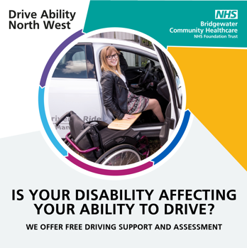 | Hundreds of people with disabilities have stayed on the road for longer, with Drive Ability North West. Call 01942 483 713 for free driving support and assessment. bridgewater.nhs.uk/drive @DriveAbilityNW #DisabledDrivers #Disabilities #AccessibleTravel | A woman happily moves from her wheelchair into the driver’s seat of a car.  Is your disability affecting your ability to drive? Drive Ability North West offer free driving support and assessment.
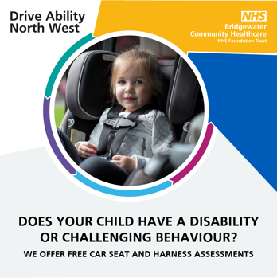 | Find it hard to get out and about? If your child has a disability or challenging behaviour, Drive Ability North West can help with a free car seat and harness assessment. Call 01942 483 713. bridgewater.nhs.uk/drive @DriveAbilityNW #CarSeat #SafeTravel #AccessibleTravel | A child with a disability sits happily in a car seat.  Do you have a child with a disability? Drive Ability North West offer free car seat and harness assessments.
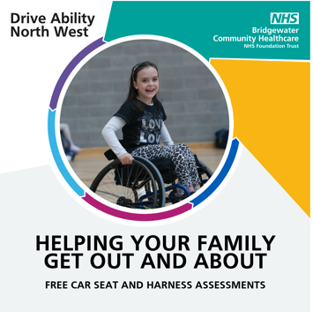 | Drive Ability North West help hundreds of children with disabilities get out and about, with free car seat and harness assessments. Call 01942 483 713. bridgewater.nhs.uk/drive @DriveAbilityNW #CarSeat #SafeTravel #AccessibleTravel | A smiling child in a wheelchair plays sport. Drive Ability North West. Helping your family get out and about. Free car seat and harness assessments.
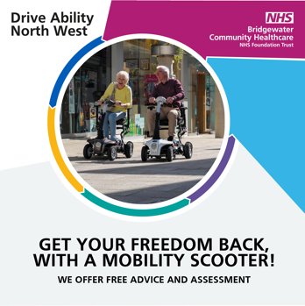 | Struggling to get out and about? Get your freedom back, with a mobility scooter! Call Drive Ability North West for free assessment and advice 01942 483 713. bridgewater.nhs.uk/drive @DriveAbilityNW #AccessibleTravel #Disabled #Disabilities | A man and a woman happily ride mobility scooters in a shopping district. Get your freedom back, with a mobility scooter! Drive Ability North West offer free advice and assessment.
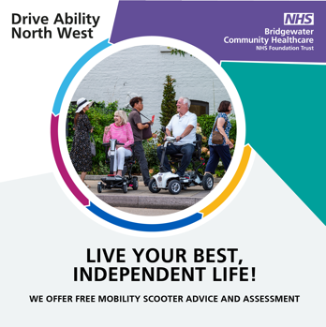 | Live your best, independent life with a mobility scooter! Call Drive Ability North West for free assessment and advice 01942 483 713. bridgewater.nhs.uk/drive @DriveAbilityNW #AccessibleTravel #Disabled #Disabilities | A man and a woman happily wait for a bus whilst sitting on their mobility scooters. Live your best, independent life! Drive Ability North West offer free mobility scooter advice and assessment.

Digital screens

Images have been designed for use on any digital screens, including televisions, within your buildings.

Download them from: www.bit.ly/DANWdigitalscreens
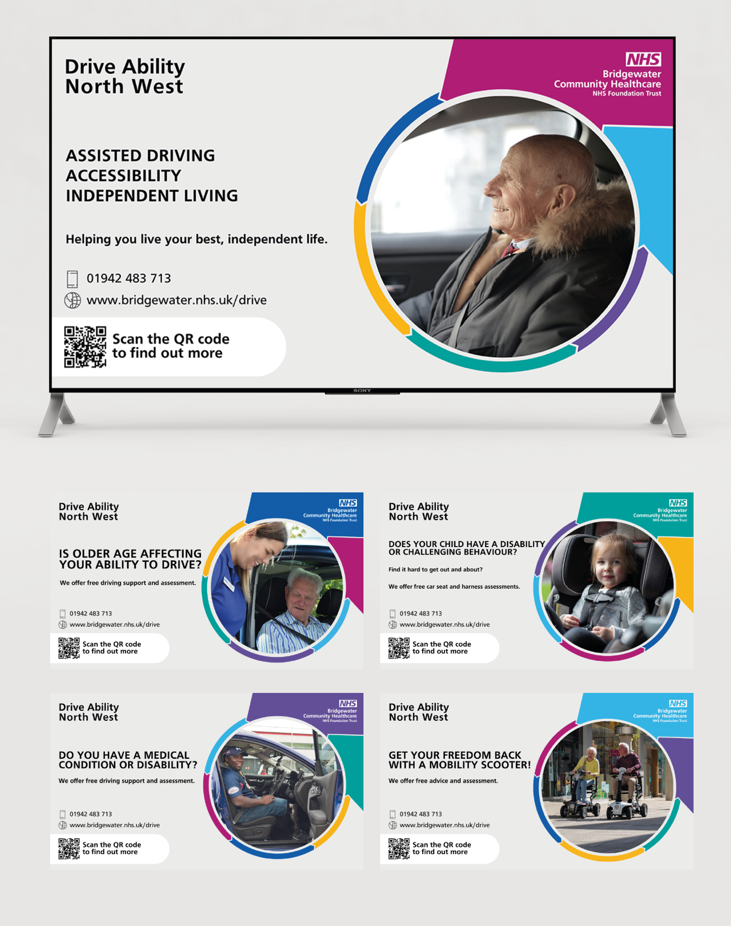

Key message and promotional text for newsletters, intranet and email

Use the key message and promotional text below on your communications channels such as email, intranet and newsletters, to communicate core messages to your colleagues and members of the public.

Key message

Drive Ability North West helps people to live their best, independent lives, through assisted driving, accessibility and independent living.

Shorter promotional text: 133 words

Drive Ability North West – helping people retain or regain their independence through assisted driving and increased accessibility.

If you have a medical condition, a disability, or feel older age is affecting your ability to drive, Drive Ability North West’s team of Occupational Therapists and Approved Driving Instructors can help you drive safely and maintain or regain your independence as a driver or passenger.

We also give advice on a variety of different mobility options, including mobility scooters and car seats and harnesses for children with disabilities or challenging behaviour. Our aim is to help people live their best, independent lives.

Part of Bridgewater Community Healthcare NHS Trust and Driving Mobility, Drive Ability North West was formerly the North West Driving Assessment Service. Contact us on 01942 483 713, email bchft.DriveAbility@nhs.net or visit www.bridgewater.nhs.uk/drive.

Longer promotional text: 250 words

Drive Ability North West – helping people retain or regain their independence through assisted driving and increased accessibility.

Being able to use a car as a driver or passenger is invaluable – especially if you have restricted mobility or a disability.

If you have a medical condition, a disability, or feel older age is affecting your ability to drive, Drive Ability North West’s team of Occupational Therapists and Approved Driving Instructors can help you drive safely and maintain or regain your independence as a driver or passenger.

We also give advice on a variety of different mobility options, including mobility scooters and car seats and harnesses for children with disabilities or challenging behaviour. Our aim is to help people live their best, independent lives.

How can we help?

We can support you to stay mobile and independent for as long as possible, with help, advice and assessments on:

- Your ability to drive safely for longer
- Adaptations to overcome physical problems with vehicle control
- Passenger / driver access to vehicles, seating and posture
- Wheelchair and scooter loading and transportation
- Children’s car seats and harnesses
- Mobility scooters
- Alternatives to driving, including public transport

We also offer driving support and assessments for people with disabilities, Police Fit to Drive assessments, plus a range of tuition and training, all tailored to your needs.

Part of Bridgewater Community Healthcare NHS Trust and Driving Mobility, Drive Ability North West was formerly the North West Driving Assessment Service.

Contact us on 01942 483 713, email bchft.DriveAbility@nhs.net or visit www.bridgewater.nhs.uk/drive.

Frequently Asked Questions
FAQs

What is a driving assessment?

Different from a driving test, a driving assessment is designed to review your driving and give you an honest opinion of your skills and ability. You can find out more about our driving assessments at: www.bridgewater.nhs.uk/drive

Who will undertake the driving assessment?

All our assessments are undertaken by our trained Occupational Therapists and Approved Driving Instructors. We understand that the idea of an assessment can seem daunting, but we’re a friendly team and will put you at ease.

What is an Occupational Therapist?

Occupational therapists help people overcome challenges completing everyday tasks or activities (occupations). They look at your hopes and aspirations and identify how you may be able to undertake specific activities despite any challenges you may face.

Our Occupational Therapists will support you by assessing you and then creating a plan of goals and adjustments to help you remain as mobile and independent as possible. This will be tailor made to your own individual needs.

Can I use my own car for a driving assessment?

To ensure the maximum safety of everyone involved, we carry out assessments in our own dual-controlled vehicles. We will always try to match the vehicle you use as closely as possible to your own, from our fleet, which includes manual transmission, automatic transmission and adapted vehicles with specialist controls.

Can I have a relative or friend present during a driving assessment?

It is possible for a relative or friend to be present during the initial interview, up to a maximum of two people. In fact, we recommend that you bring somebody with you who can drive you to and from our Driving Centre. This means you can focus on the assessment beforehand and not worry about being tired afterwards.

There are occasions when unfortunately we have to advise our clients that they are not safe to drive. In these circumstances it would not be appropriate for you to drive yourself home. A supporting person can be present during the initial interview, however they cannot be present during the on-road assessment – this is for safety reasons. During the driving assessment your relative or friend can wait comfortably at our Driving Centre.

Can Drive Ability North West fit vehicle adaptations?

We don’t fit adaptations, but we are able to signpost you to adaptation specialists in the area, where you can get all the help you need.

Will I be expected to complete a full driving assessment in one appointment?

Yes, normally the full assessment is completed in one appointment. However, sometimes this may not be appropriate. For example, you might be driving with new controls for the first time and lack the confidence to drive in busy traffic. In such cases, we might recommend further tuition usually with an Approved Driving Instructor in your area. You would then return for a follow-up assessment at a later date.

Do I have to complete every part of a driving assessment?

We do understand that completing an assessment can possibly be a tiring or anxious experience. Nevertheless, we always endeavour where appropriate to include all the elements as they are essential for comprehensive assessment. Please bear in mind though our Occupational Therapists will always use clinical discretion depending on the nature of your medical condition and how it might affect your driving.

If I’ve been referred for an assessment by the DVLA, can I drive whilst my application is with them?

It’s important to ensure that you’re driving legally. You can call the DVLA for more information about this on 0300 790 6802.

Get in touch
Get in touch

To contact the Drive Ability North West Operational Manager, please email BCHFT.DriveAbility@nhs.net.
To contact the Bridgewater Community Healthcare NHS Foundation Trust Communications Team, please email BCHFT.global@nhs.net.

