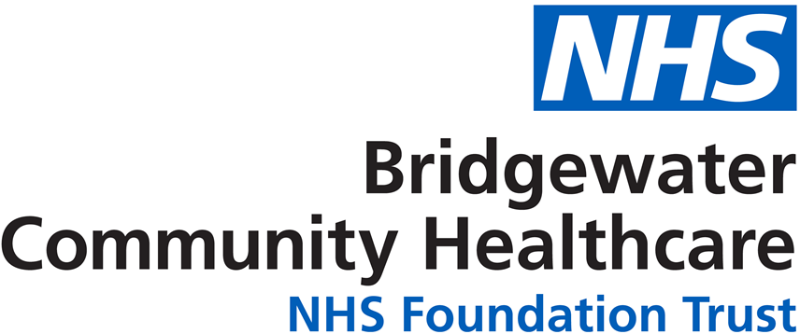

NHS Workforce Race Equality Standard
For 31 March 2021


Contents
 | Page Number
Introduction | 2
Executive Summary | 3
Our Results – 31 March 2021 | 5
Indicator 1: Staff Pay | 7
Indicator 2: Recruitment | 14
Indicator 3: Disciplinary | 16
Indicator 4: Training | 17
Indicator 9: Board | 18
NHS Staff Survey 2020 Results  - Indicator 5: Bullying & Harassment: Public  - Indicator 6: Bullying & Harassment: Staff  - Indicator 7: Equal Opportunities  - Indicator 8: Discrimination | 19  21  24  26
Action Plan | 28
Contact Details | 28

Introduction
Welcome to our NHS Workforce Race Equality Standard Report 2021.
The last year has been challenging for the NHS and for many in our workforce and communities. The Covid 19 pandemic has affected us all, but for some, including those from Black, Asian, or minority ethnic heritages the impact has been disproportionate, and the effects may be felt for a long time to come.
As a community and specialist dental provider it has been a very different year. Our corporate services functions transitioned to agile and home working arrangements, many services were stepped down, resulting in a change to the way they delivered care to their patients. Some staff continued with ‘business as usual’ arrangements, but with higher volumes of patients through discharge to home and increased need from those recovering from Covid. Other staff were redeployed to support both these high priority services and the swabbing and vaccination teams. Others provided care to Covid positive patients alongside colleagues in social care.
As a Trust we have endeavoured to support all our staff and have put in place extra measures such as risk assessments to ensure we mitigate risk from the virus as much as we can. This has included personal messages from our Chief Executive to all Black, Asian, or minority ethnic staff, and establishment of a risk assessment quality panel to review all assessments related to these or other high-risk staff.
We have carried out home based working risk assessments to ensure staff have the equipment, including reasonable adjustments, to enable them to work safely and in a way that supports their health and wellbeing and meets individual needs.
And we have established our Race Inclusion Network and consulted Black, Asian, or minority ethnic staff via online surveys to get feedback on what is working, what isn’t, and what is ok but could be improved.
We have engaged with our Network on the results published in this report and we thank them for the time they have taken to review the data and to feedback both their comments and their own experiences to enhance our understanding of workplace race equality and inclusion.
Throughout this document we will use the abbreviations WRES for the Workforce Race Equality Standard, ESR for Electronic Staff Record, EDI for Equality, Diversity and Inclusion, and AfC for Agenda For Change.
Should you have any queries or questions or if you would like to request the contents of this report in another language or format, please contact our Equality & Inclusion Manager in the first instance, details below.

Paula Woods (Director of People and Organisational Development) paula.woods1@nhs.net
Ruth Besford (Equality & Inclusion Manager) ruth.besford@nhs.net

Executive Summary
The Standard was mandated in 2015 following extensive research into the experiences of staff from Black, Asian, or minority ethnic heritages in the NHS, research that showed consistent inequality and poor experience when compared to white colleagues.
As we look back at our seventh year of results for the WRES we can see areas of progress and equally areas where we are not progressing as we would like to.
Indicators 1 to 4 analyse career progression, recruitment, disciplinary, and training and development, and for these results we rely on the data provided in our Electronic Staff Record (ESR). Our data in this is improving, less than 5% of staff records have no ethnicity data against them meaning that we can analyse with a fairly high level of accuracy for this report.
Indicators 5 to 8 are taken from the NHS Staff Survey 2020. The Trust in 2020 achieved its highest ever response rate, with 769 staff, 50% of the workforce, completing the online survey. Of these 33 were from Black, Asian, or minority ethnic staff, this is about a third of known minority ethnic staff, so a lower percentage than the overall responses but more than responded in 2019 and enough to give us some detail about experience for those staff in these specific indicators.
Due to low numbers for some indicators, we have throughout this report kept confidential real figures where they are below ten by using a *, or we have clustered staff together into bigger groups so that analysis can be shown while maintaining protection of personal and sensitive data. We have also tried to provide visual representation that can demonstrate without being identifiable.
The results in full can be found in Table 1 on pages 5 and 6, and with additional narrative regarding analysis and results on pages 7 onwards, but to summarise our findings in 2021:
- Indicator 1: Pay Progression. While we have seen an increase in the overall percentage of Black, Asian, or minority ethnic staff this is not consistent across all pay bands and staff groups. Medical and Dental staff in particular are over-representative, and whilst higher pay bands in clinical and non-clinical staff groups may be representative of the overall workforce figure for minority ethnic staff there is not diversity within that representation, with some minority ethnic groups represented more than others.
- Indicator 2: Recruitment. An improvement in 2021, with Black, Asian, or minority ethnic applicants more likely to be appointed than white applicants. A result of 0.61 likelihood.
- Indicator 3: Disciplinary. In 2021 there were no Black, Asian, or minority ethnic staff in new formal disciplinary cases, as a result we have a zero likelihood figure to submit.
- Indicator 4: Non-Mandatory Training and Development. This has seen a slight deterioration with white staff being more likely to access these opportunities in this reporting period.
- Indicator 5: Bullying, Harassment and Abuse From Patients/Public. A deterioration this year and a widening of the gap between white and Black, Asian, or minority ethnic staff.
- Indictor 6: Bullying, Harassment and Abuse From Staff. An improvement this year and our best result to date, but work needed on consistent improvement.
- Indicator 7: Equal Opportunities. An improvement this year, but not yet a return to the levels in 2016 and 2017.
- Indicator 8: Discrimination. An improvement after 2019 sharp deterioration, but work needed to close the gap with white staff and reduce this figure altogether.
- Indicator 9: Board. The Board is representative of overall workforce figures for ethnicity. Due to the small numbers the Board isn’t, and maybe can’t be, representative of the diversity of ethnic groups in our workforce, but the commitment in relation to race equality is strong, with allies in the Medical Director (Chair of the Race Inclusion Network), the Chief Executive, Chair, and Lead Governor (as invited members of the Network) and the Director of People and Organisational Development (as Executive with overall responsibility for day-to-day equality in relation to workforce).
As can be seen we have made progress in some areas, others we remain challenged on; but as a Trust, from Board down we are committed to race equality, diversity, and inclusion.
Our work to improve race equality and inclusion is referenced throughout this report, and we have undertaken data analysis and engagement with staff to better inform our understanding. This has allowed us to develop an action plan for equality that addresses the issues raised by staff, highlighted by the results in this report, and aligned to the NHS People Plan and People Promise. Information on our action plan can be found on page 28.

Our Results – 31 March 2021
We have provided in the table to follow a summary of our results against the nine indicators of the WRES. The pages to follow provide further detail and a brief analysis, including looking at results since 2015 against each indicator.
Table 1: Summary WRES Results 2021
Indicator
- Percentage of staff in each AfC Band 1-9 or Medical and Dental pay grades, compared with the percentage of staff in the workforce overall.
Disaggregated by non-clinical staff, clinical staff, and medical and dental staff
 | Non-clinical |  |  |  | Clinical
 | White | BAME | N/S |  | White | BAME | N/S
Under Band 1 | 0.35 | 0.06 | 0 |  | 0 | 0 | 0
AfC1 | 0 | 0 | 0 |  | 0 | 0 | 0
AfC2 | 6.01 | 0.17 | 0.12 |  | 1.50 | 0.06 | 0.06
AfC3 | 7.46 | 0.17 | 0.58 |  | 6.36 | 0.23 | 0.23
AfC4 | 2.20 | 0 | 0 |  | 8.73 | 0.46 | 0.81
AfC5 | 2.49 | 0.23 | 0.12 |  | 14.51 | 1.04 | 0.23
AfC6 | 1.73 | 0.06 | 0.12 |  | 19.65 | 0.87 | 0.87
AfC7 | 0.87 | 0.17 | 0.06 |  | 9.71 | 0.17 | 0.29
AfC8a | 0.69 | 0 | 0.12 |  | 3.29 | 0.06 | 0.06
AfC8b | 0.46 | 0.06 | 0 |  | 0.23 | 0 | 0
AfC8c | 0.64 | 0 | 0.06 |  | 0.23 | 0.06 | 0
AfC8d | 0.12 | 0 | 0 |  | 0 | 0 | 0.12
AfC9 | 0 | 0 | 0 |  | 0 | 0 | 0
VSM | 0.17 | 0 | 0.06 |  | 0.06 | 0.06 | 0
 | Medical and Dental Grades:
Consultants | 0.17 | 0.23 | 0.17
(of which VSM) | 0 | 0 | 0.06
Non-Consultant Career Grade | 2.83 | 1.21 | 0.12
Continued….

Indicator
- Relative likelihood of being appointed from shortlisting across all posts | 0.61 times more likely to be appointed if you are White
- Relative likelihood of entering formal disciplinary processes | 0.00 – no Black, Asian, or minority ethnic staff in new formal disciplinary processes
- Relative likelihood of accessing non-mandatory training/CPD | 1.09 times more likely to access non-mandatory training if you are White
- Percentage of staff experiencing bullying, harassment, and abuse from patients/relatives/public in last 12 months | BAME 30.3%  White 18.2%
- Percentage of staff experiencing bullying, harassment, and abuse from staff in last 12 months | BAME 15.6%  White 17.8%
- Percentage believing the Trust provides equal opportunities for career progression and promotion | BAME 84.6%  White 91.7%
- In the last 12 months personally experiencing discrimination from manager/team leader/other colleagues | BAME 12.1%  White 4.4%
- Percentage difference between Board membership and overall workforce  Disaggregated by voting and non-voting members | White -19.0%  BAME 8.9%  Not Stated10.1%
Overall Workforce
White | 1,565 (90.46%)
Black, Asian, and Minority Ethnic | 93 (5.38%)
Unknown/Not Stated | 72 (4.16%)

Indicator 1: Staff Pay
This indicator looks at pay, what percentage (%) of White staff and Black, Asian, or minority ethnic staff are in each of the pay bands 1 to 9, in medical and dental posts, and very senior manager posts (including executive and non-executive board members).
These figures are compared with the overall workforce.

As at 31st March 2021 we employed 1,730 staff; this excluded bank, agency, and other staff such as those on career breaks to allow for consistency of reporting across the years.
Our ethnicity breakdown for our full workforce is as follows:
- 90.46% White (including White British, White Irish, White European, White Other)
- 5.38% Black, Asian, or minority ethnic (all stated ethnicities except White group)
- 4.16% Unknown (includes not stated, prefer not to say, and not disclosed)
Our workforce overall is representative of some boroughs where we provide services (Halton and Warrington), but not others (Oldham and several of the Greater Manchester Dental areas).
Table 2: Showing Overall Workforce By Ethnicity Since 2015
 | Overall Workforce | White | Black, Asian, or Minority Ethnic | Unknown
2015 | 3,325 | 95.6% | 2.4% | 1.9%
2016 | 3,250 | 93.4% | 2.7% | 4.1%
2017 | 3,305 | 90.8% | 2.6% | 6.7%
2018 | 3,005 | 90.6% | 2.8% | 6.6%
2019 | 3,016 | 89.9% | 2.9% | 7.1%
2020 | 2,048 | 89.2% | 5.7% | 5.0%
2021 | 1,730 | 90.5% | 5.4% | 4.1%

As can be seen in Table 2 the percentage of Black, Asian, or minority ethnic staffing has grown over the last seven years, which is an improvement on the low percentage figure in 2015. Caution should be used when considering this data however as our overall workforce has reduced significantly as services have transferred, particularly in relation to place based commissioning and care in Wigan and St Helens; this has meant that we aren’t looking at consistent data year on year.
It is encouraging to also see the decline in the number of ‘unknown’ records.
Non-Clinical Staff:
As can be seen in the table on page 3 we have small percentages of Black, Asian, or minority ethnic staff in non-clinical roles across the Trust.
Following on from Table 2 it is important that we look at how our staff groups reflect overall workforce ethnicity, Figure 1, to follow, shows the percentage ethnicity breakdown in non-clinical staffing. As can be seen Black, Asian, or minority ethnic staff are under-represented in non-clinical roles, and in fact the actual figures in each pay band, particularly above Band 6 are too low to report for data protection reasons.
Figure 1: Percentage Ethnicity Breakdown For Non-Clinical Staffing
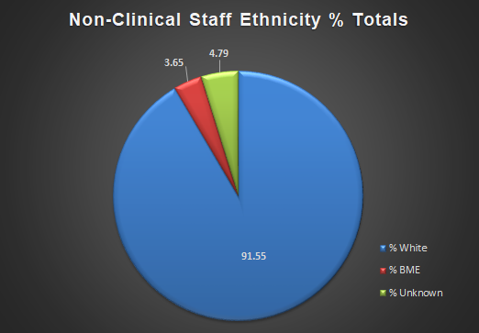
The figure below shows the breakdown by ethnicity of staff based on the clusters identified in WRES: A Model Employer (see Page 11). This clustered data allows us to look at small ethnicity figures while minimising the risk of data becoming person identifiable. As can be seen the numbers of Black, Asian, or minority ethnic staff reduces as you move up the pay scale to cluster 3.
Figure 2: Showing Non-Clinical Staff Ethnicity By Pay Band Cluster
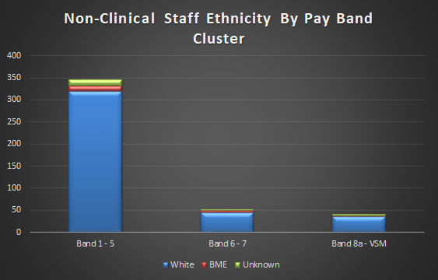
Clinical Staff:
Our clinical workforce (excluding our medical and dental staffing) is 2.5 times larger than our non-clinical workforce, and Black, Asian, or minority ethnic staff numbers are three times higher. However as for the non-clinical workforce, these staff are under-represented when compared with the overall workforce total of 5.4%, see Figure 3.
Figure 3: Percentage Ethnicity Breakdown For Clinical Staffing
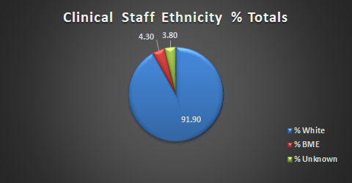
As with non-clinical staff we see the numbers of Black, Asian, or minority ethnic staff drop as we move up the pay bands, and for the same reason we have again clustered by pay band, as can be seen in Figure 4.
Figure 4: Showing Staff Ethnicity By Pay Band Cluster
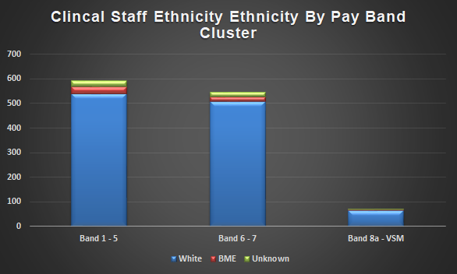

We have two Board members from Black, Asian, or minority ethnic backgrounds, one non-clinical and one clinical.

Medical and Dental Staff:
As for much of the NHS medical and dental staffing has a much higher percentage of Black, Asian, or minority ethnic staff and Bridgewater reflects this, as can be seen in Figure 5.
There are differing reasons for this, not least that the NHS has since its formation had a gap in the availability of UK born/trained staff to undertake these roles, and the contribution of our overseas born and trained workforce nationally and locally cannot be overstated.
Within our medical and dental workforce, the vast majority of staff are within the non-consultant career grade group, with less than ten staff in consultant roles.
Figure 5: Percentage Ethnicity Breakdown for Medical and Dental Staffing
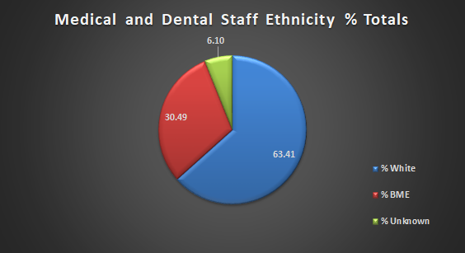
We have one Board member in the medical and dental workforce, they are included within the ‘unknown’ figure.
Black, Asian, or Minority Ethnicity Groups:
While the WRES submission looks at Black, Asian, or minority ethnic staff as a whole group we wanted to look at how representative our ‘BAME’ staffing was. This followed conversations with the Race Inclusion Network about the importance of seeing ‘someone like’ me at higher bands and in different roles; role models for different communities starting at a young age rather than an ethnic minority or BAME whole that doesn’t exist and/or feel inclusive.
Figure 6 to follow shows the percentage of different ethnic minority groups as a percentage of a whole BAME total. As can be seen there is significant under-representation in many ethnicities, and this equates in real numbers to just one or two staff from some identities/heritages.
When the figures are broken down further again into non-clinical and clinical staffing groups there are large gaps in representation for different ethnicities at higher bands, so while we may be able to be assured that our overall percentage figure is getting there, the picture for different groups is very different. For data protection reasons we are unable to show this information within the report as the data can be personally attributable to individual staff members.

Figure 6: Black, Asian, or Minority Ethnic Staff Groups As % Of Total ‘BAME’ Workforce
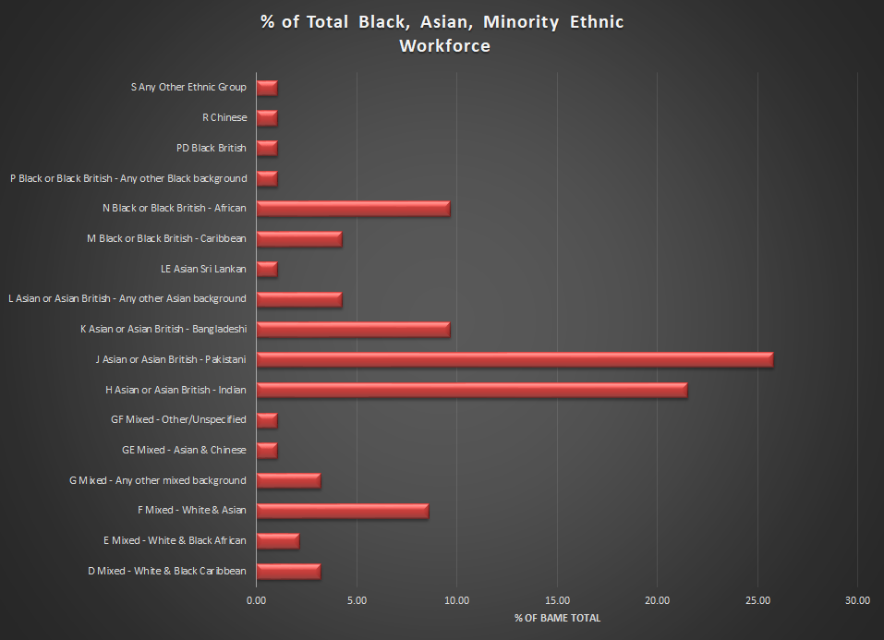
WRES: A Model Employer:
In early summer 2021 we have been analysing our workforce data and creating an action plan that covers two ‘asks’ from NHS England/Improvement.
The first ask was to produce an action plan that detailed how we would implement actions against six priority themes to improve race and other equality.
The second ask was to produce an action plan that would reduce the disparity ratio in career progression across the Agenda for Change and Very Senior Manager pay bands for Black, Asian, or minority ethnic staff when compared to white staff.
We undertook a lot of analysis of the data contained in and to inform this annual WRES Report and produced an overarching action plan and a WRES: A Model Employer Disparity Ratio Action Plan that was mapped to this.
The WRES: A Model Employer Disparity Ratio Action Plan can be viewed here:
https://bridgewater.nhs.uk/aboutus/equalitydiversity/equalityact2010/
WRES: A Model Employer provides our drivers and actions, that is the factors that we think, from our analysis, contribute to the career progression disparity, and the actions that we think will reduce this. This includes looking at under-representation in staff groups and at pay bands. Also, within the report is embedded the larger overall action plan for improving equality across the six priority themes.
We engage regularly with our Race Inclusion Network, and feedback and experiences shared by the members have informed our analysis and action plan development and will be a key part of monitoring and evaluation as we implement our plans.
Trust Analysis – Disparity Ratio
Note: The disparity ratio is the comparison between the progression ratios for white and BME staff. Progression ratios are the probability of white staff versus BME staff being promoted through the lower (band 5 and below), middle (band 6 & 7) and higher bands (8a and above).
Position as at 31 March 2020 (WRES 2020 Submission)
Trust Name | Lower to Middle | Middle to Upper | Lower to Upper
BRIDGEWATER COMMUNITY HEALTHCARE NHS FOUNDATION TRUST | 1.13 | 2.08 | 2.35

The 2020 data above shows that white staff at grades 6 & 7 (middle) are 2.08 times more likely to progress to 8a and above through the organisation compared to Black, Asian or minority ethnic staff; and white staff are 2.35 times more likely to progress through the organisation from the lowest to the highest bands compared to Black, Asian and minority ethnic staff.

Position as at 31 March 2021 (WRES 2021 Submission)
Trust Name | Lower to Middle | Middle to Upper | Lower to Upper
BRIDGEWATER COMMUNITY HEALTHCARE NHS FOUNDATION TRUST | 1.32 | 1.35 | 1.78

The 2021 data shows that white staff at grades 6 & 7 (middle) are 1.35 times more likely to progress to band 8a and above compared to Black, Asian or minority ethnic staff; and white staff are 1.78 times more likely to progress from lower to upper bands compared to Black, Asian or minority ethnic staff.
This data has excluded medical and dental staff in line with the national ask. Medical and dental staff will be considered nationally as part of the Medical WRES.

Year on Year Progress:
The tables to follow shows the numbers of Black, Asian, or minority ethnic non-clinical and clinical staff since 2015 when WRES reporting began.
Table 3: Black, Asian, or Minority Ethnic Non-Clinical Staff By Pay Band 2015 to 2021
Black, Asian, Or Minority Ethnic Non-Clinical Staff
 | 2015 | 2016 | 2017 | 2018 | 2019 | 2020 | 2021
All AfC Pay Bands | 18 | 18 | 16 | 20 | 19 | 15 | 15
Very Senior Manager | 0 | 0 | 0 | 0 | 0 | 0 | *
Where figures are below 10 an * is used to protect personal identities

Table 4: Black, Asian, or Minority Ethnic Clinical Staff By Pay Band 2015 - 2021
Black, Asian, Or Minority Ethnic Clinical Staff
 | 2015 | 2016 | 2017 | 2018 | 2019 | 2020 | 2021
All AfC Pay Bands | 42 | 39 | 44 | 31 | 52 | 49 | 51
Very Senior Manager | 0 | 0 | 0 | 0 | 0 | * | *
Where figures are below 10 an * is used to protect personal identities

The figures in the tables are interesting as whilst the Trust has reduced significantly in overall workforce since 2015, as explained earlier, the numbers of Black, Asian, or minority ethnic staff has stayed broadly the same. This explains the improved overall percentage figure if not necessarily the why this should be the case – staff role, borough, recruitment. Our work on the action plans may allow us to understand this data better.

Indicator 2: Recruitment
This indicator looks at recruitment, to see how more likely White applicants are to be successful and to be appointed when compared to Black, Asian, or minority ethnic staff.
(A likelihood figure above one would show that White applicants are more likely to be appointed than Black, Asian, or minority ethnic applicants).

Our likelihood figure for this year is 0.61. This means that white candidates are 0.61 times more likely to be recruited than Black, Asian, or minority ethnic staff. This is an improvement on our 2020 figure of 1.39 and shows that Black, Asian, or minority ethnic candidates are more likely to be appointed from shortlisting than white candidates – a figure below 1 is positive for minority ethnic staff. Table 5 details Trust results since 2015:
Table 5: Showing Recruitment Likelihood Figures and Numbers of Black, Asian, or Minority Ethnic, And White Staff Recruited 2015 - 2021
Recruitment 2015 - 2021
 | 2015 | 2016 | 2017 | 2018 | 2019 | 2020 | 2021
Likelihood | 1.85 | 1.72 | 1.30 | 1.24 | 1.28 | 1.39 | 0.61
Total Black, Asian, or minority ethnic Staff Recruited | 12 | 24 | 31 | 24 | 23 | 13 | 36
Total White Staff Recruited | 241 | 532 | 498 | 418 | 395 | 224 | 310
Total Not Stated Staff Recruited | * | 160 | 120 | 30 | 10 | 17 | *

The table above shows that ethnic diversity in recruitment overall has improved considerably with a greater number of Black, Asian, or minority ethnic staff being successfully appointed than at any time previously in WRES reporting.
Part of this success lies in the recruitment of a cohort of apprentices into Health Care Support Worker roles in 2020/21. In this process the Trust took a different approach to previous, traditional, recruitment, and as such was able to attract and appoint a much more diverse group than happens generally. We are reviewing this project in summer 2020 to look at lessons learned, what went well, what didn’t, and how we could use this approach again to recruit, particularly to harder to fill roles.
While the results this year are positive, we again we need to show caution. When we look at the likelihood for Black, Asian, or minority ethnic applicants moving from application to shortlisting the figure is 2.21, this means that white applicants are 2.21 times more likely to be shortlisted.
In addition, analysis shows us that not all ethnic minority groups faired as well through recruitment with some groups more successful than others.
There are likely different factors to explain these differences, for example we are not currently a sponsor Trust for overseas recruitment so a number of applicants will not be shortlisted as legally we can’t employ them. But this is an area to keep reviewing and evaluating in the future.
Figure 7: Black, Asian, or Minority Ethnic Recruitment Journey 2020 - 2021
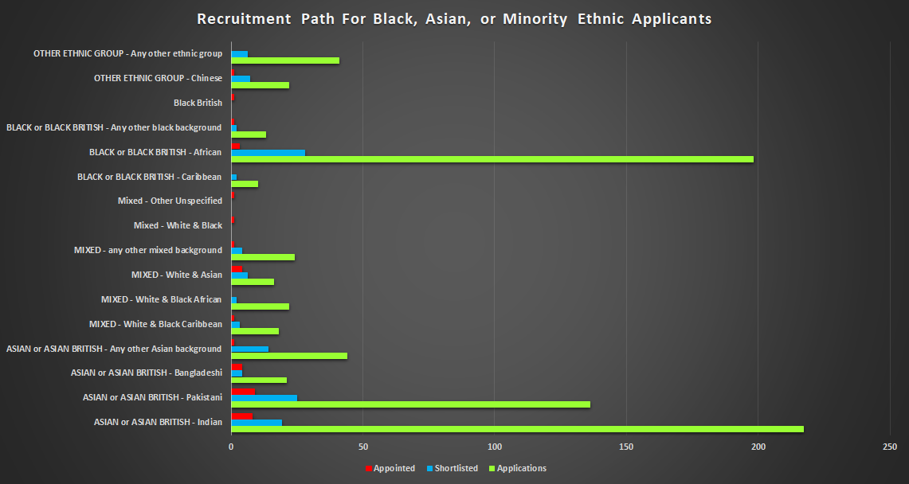

Analysis of recruitment in Agenda for Change roles shows that roles at band 5 are our biggest recruitment area and for both white and Black, Asian, or minority ethnic staff this was the biggest pool recruited.
However above band 7 there was no successful appointment of Black, Asian, or minority ethnic staff, either internal or external, except at Very Senior Manager level in the recruitment of new Non-Executive Directors.
This has been identified as a driver in WRES: A Model Employer and actions determined to understand and address this disparity.
Figure 8: Recruitment In Agenda for Change and Very Senior Manager Roles 2020 - 2021
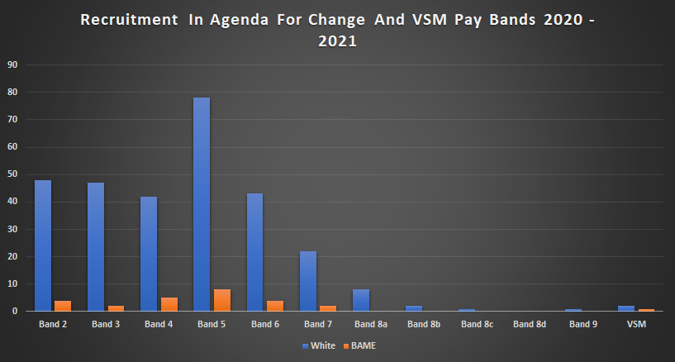
Finally, we analysed our recruitment based on staff group and determined that in most groups Black, Asian, or minority ethnic appointments were above the overall workforce percentage of 5.38%. Only in Allied Health Professionals (a very small recruitment pool in 2020 – 2021) and Additional Clinical Services were the figures below this overall.
Due to the Covid pandemic we didn’t recruit any students during the year, so this figure is nil for all.

Indicator 3: Disciplinary
This indicator looks at disciplinary processes in the Trust, at how more likely BME staff are to be involved in formal disciplinary processes when compared with White staff.
(A likelihood figure above one would show that BME staff are more likely to be in formal disciplinary processes than White staff).

Our result for this year is 0.0. There have been no Black, Asian, or minority ethnic staff enter new formal disciplinary processes during the reporting period, and only 10 staff overall.
Table 6: Showing Likelihood of Black, Asian, or Minority Ethnic Staff Entering Formal Disciplinary Processes
Black, Asian, Or Minority Ethnic Staff Formal Disciplinary 2015 - 2021
 | 2015 | 2016 | 2017 | 2018 | 2019 | 2020 | 2021
Likelihood | 6.46 | 4.93 | 3.83 | 1.99 | 2.72 | 2.40 | 0.00

Indicator 4: Non-Mandatory Training and Development
This indicator looks at non-mandatory training and development opportunities, and how more likely White staff are to take part in these opportunities compared to BME staff.
(A likelihood figure above one would show that White staff are more likely to take part in these opportunities than BME staff).

In 2021, 1311 staff in total undertook non-mandatory training and development opportunities. These equated to 6,328 individual accesses to more than 230 different options including verification of death, management of pressure ulcers, rainbow badges, clinical supervision training, Mary Seacole, vaccines, and various public health related courses.
Within both white, and Black, Asian, or minority ethnic staff groups there were variations in the numbers of opportunities accessed, with some staff accessing 1 or 2 courses during the year and others over 10. Covid related courses were well attended by staff who upskilled or re-trained to support services and the national swabbing and vaccination programmes; but other courses that had significant attendance focused on mental capacity, deprivation of liberty, and preventing radicalisation.
Many programmes, for example those provided through the Leadership Academy or NHS England were suspended. We have for example committed to supporting interested staff to apply for and complete the WRES Experts programme and we are awaiting reopening of the applications.
As a Trust we applied in 2020 to join the NHS Leadership Academy Reciprocal Mentoring Programme and are waiting to launch in autumn 2021. Our project board for the Programme has representation from the Race Inclusion Network, and many members of the network are interested in taking part in this 18-month programme.
Our result for this indicator in 2021 has deteriorated slightly, however we have had some challenges over the years in data reporting for this particular indicator so are now hopeful that moving forward and following 2020 and 2021 that we have a consistent and accurate way of downloading data to report.
Table7: Showing Likelihood Of Black, Asian, Or Minority Ethnic Staff Accessing Non-Mandatory Training and Development 2015 - 2021
Black, Asian, or Minority Ethnic Staff Undertaking Non-Mandatory Training and Development 2015 - 2021
 | 2015 | 2016 | 2017 | 2018 | 2019 | 2020 | 2021
Likelihood | 0.0 | 0.55 | 0.90 | 1.10 | 1.74 | 0.60 | 1.09
 | No data available

Indicator 9: Board
This indicator looks at our Board of Directors, and what the difference is, in percentage, compared with the workforce

The following table shows both the numbers of staff at Board level and the percentage difference between our Board membership and our overall workforce. A minus figure shows under-representation compared to workforce and a positive figure over-representation.
When viewing the figures, we need to recognise that our Board, which includes both Executive and Non-Executive members is small, and therefore while the percentage of Black, Asian, or minority ethnic staff appears over-representative we need to recognise this isn’t of all identities.
Table 8: Showing Board Ethnicity Representation Compared to Overall Workforce Representation
 | White | Black, Asian, or Minority Ethnic | Unknown
Board | 10 | 2 | 2
Difference (Total Board % – Overall Workforce %) | -19.0% | 8.9% | 10.1%

The Board is committed to race equality and equality for all protected and vulnerable groups. In 2020 the Board refreshed the Strategic Objectives of the Trust to include the addition of a specific equality objective:
Equality, Diversity, and Inclusion – to actively promote equality, diversity, and inclusion by creating the conditions that enable compassion and inclusivity to thrive.

In addition, the Board produced and published internally and, on the public, facing website an anti-racism statement setting out commitments to race equality and the elimination of racism and discrimination:
Bridgewater is committed to improving race equality for our staff and our communities, and to being actively anti-racist.
We are committed to improving awareness and understanding, from an individual to a Trust level, of the ways in which many of us have benefitted from privilege and systemic racial discrimination throughout our lives.
We will as a Trust demonstrate honesty and transparency; we will admit where we have gaps in knowledge, understanding, data, representation; we will be open and honest about where we believe we can do better; and we will actively facilitate and listen to the voices of our diverse workforce and communities, recognising that Black, Asian and minority ethnic groups are not a collective whole any more than ‘White British’ is a group with identical views, needs, aspirations and inequalities.
We will work in true partnership with our staff networks and with our wider communities to develop and deliver real and sustainable plans that address racism, discrimination, and inequality.
NHS Staff Survey 2020 Results
Indicator 5: Bullying, Harassment and Abuse – Patients, Relatives, and the Public
This indicator looks at the percentage of staff who have experienced harassment, bullying or abuse from patients, relatives, or other members of the public in the last year.
(NHS Staff Survey 2020)

The figure below shows Trust results for the years 2017 – 2020 against other community providers for Black, Asian, or minority ethnic and White staff:
Figure 9: Indicator 5 Community Trust Benchmarking 2017 - 2020
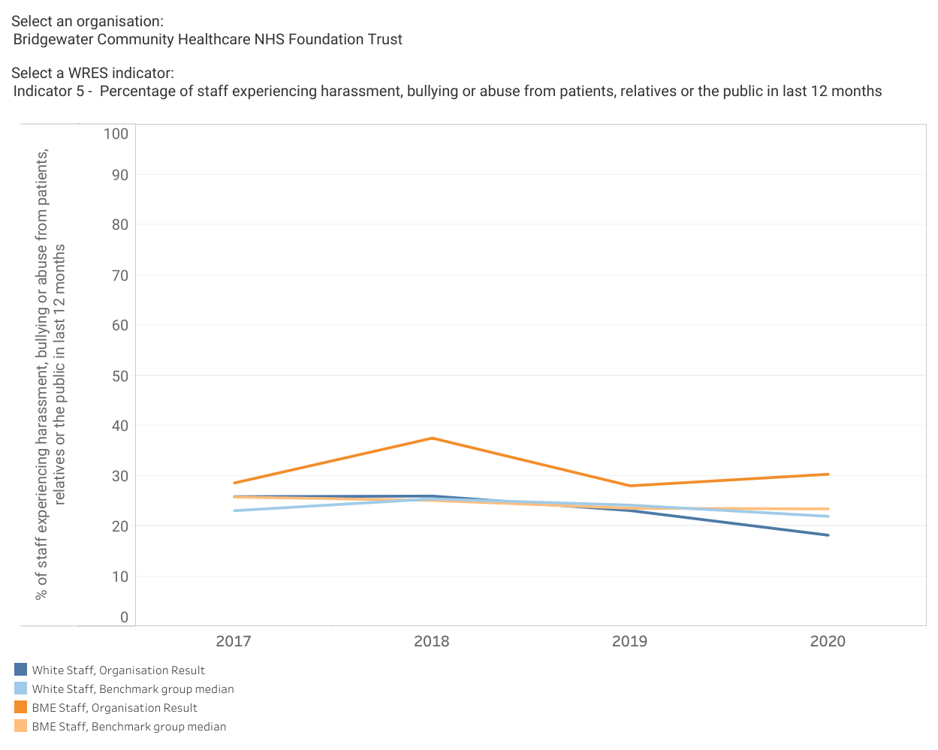
As can be seen the Trust has:
- A consistently higher figure for Black, Asian, or minority ethnic staff than comparator Trusts.
- A widening gap between the experiences of White and Black, Asian, or minority ethnic staff that isn’t reflected in the Community Trust average.
- A figure above 25% for Black, Asian, or minority ethnic staff since 2017 – a quarter of respondents.
The figure below looks at the trend for Bridgewater in this indicator from 2015 (when figures were too low to report so show as zero), to 2020:
Figure 10: Bullying, Harassment and Abuse from Patients/Relatives/Public from 2015 - 2020
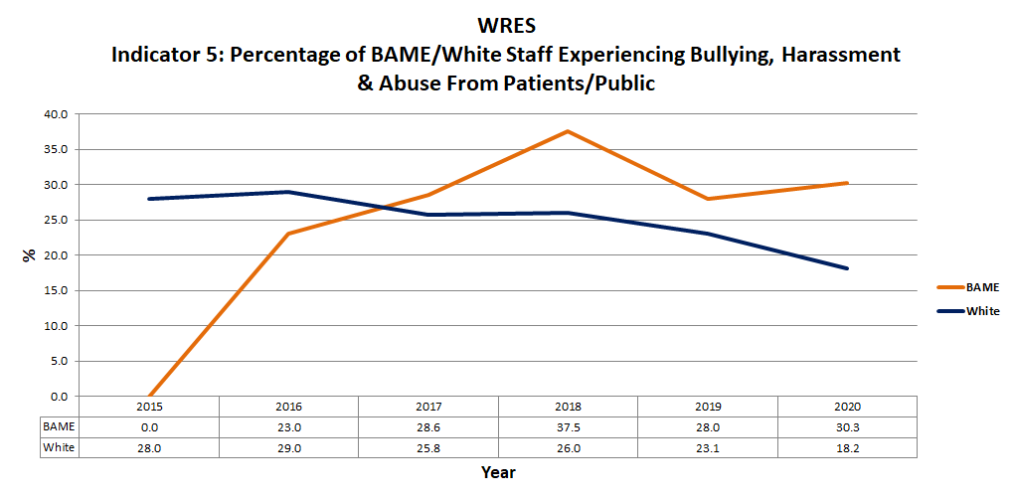
- Overall, the Trust’s result in this indicator was 18.8%, the best community Trust’s result is 17.0%.
- There were 33 responses from Black, Asian, or minority ethnic staff to this question an increase of 8 from 2019.
- As can be seen Black, Asian, or minority ethnic staff have since 2017 reported a higher rate of bullying, abuse and harassment from patients, relatives, and the public. There was a big rise in 2018 to 37.5% and again in 2020 we have seen an increase, back up to 30.3%.
- The figure for White staff, which includes staff from Europe and the rest of the World has seen a fairly steady decline.
- Trust reports of these incidents do not reflect the data in the staff survey and an important piece of work in 2021 is improvements in internal reporting through the Violence Prevention and Reduction Standard, and Zero Tolerance working groups.
- Our conversations with the Race Inclusion Network have also highlighted this issue and our action plan for equality references the work we have identified in partnership as necessary to start to address these behaviours. This includes training for staff and managers, zero tolerance resources, and a review of Trust policy.

Indicator 6: Bullying, Harassment and Abuse – Other Staff
This indicator looks at what percentage of staff have experienced harassment, bullying or abuse from other staff in the last year.
(NHS Staff Survey 2020)

The figure below shows Trust results for the years 2017 – 2020 against other community providers for Black, Asian, or minority ethnic and White staff:
Figure 11: Indicator 6 Community Trust Benchmarking 2017 - 2020
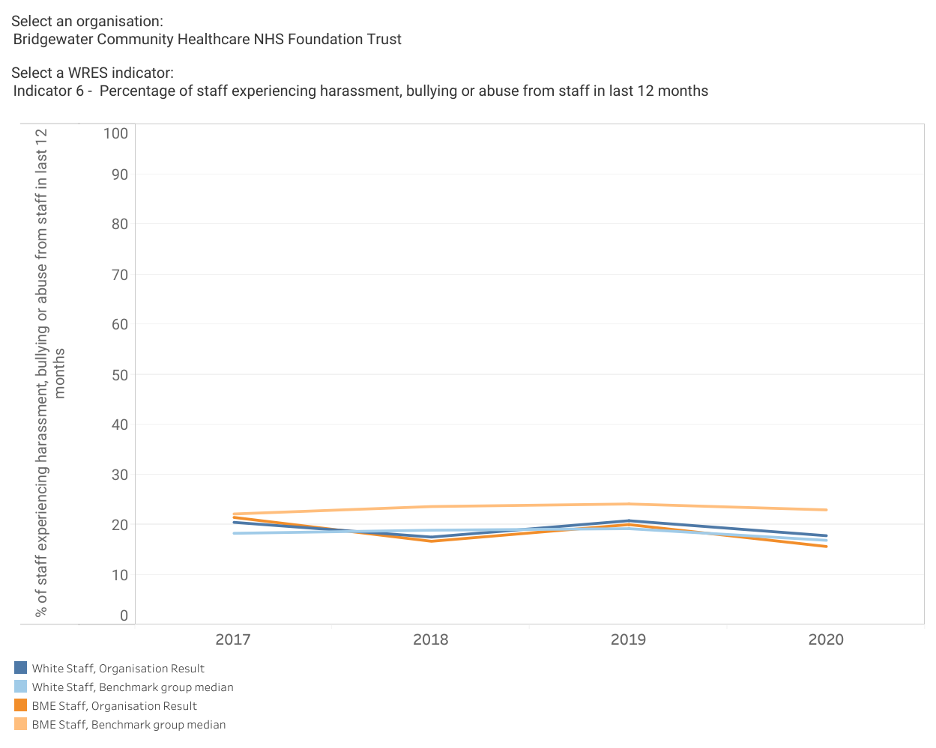
As can be seen:
- The Trust has a significantly lower result for Black, Asian, or minority ethnic staff compared to other community Trusts, 7.3% below the average result.
- White staff reports are slightly higher than the average.
- While the gap between White and Black, Asian, or minority ethnic staff experience is narrow it has widened in 2020 with Black, Asian, or minority ethnic staff reports falling faster than White staff.
The figure below looks at the trend for Bridgewater since 2015 for this indicator, (please note in 2015 as for above numbers responding were too low for reporting so a zero figure was returned).
Figure 12: Bullying, Harassment and Abuse from Staff from 2015 - 2020
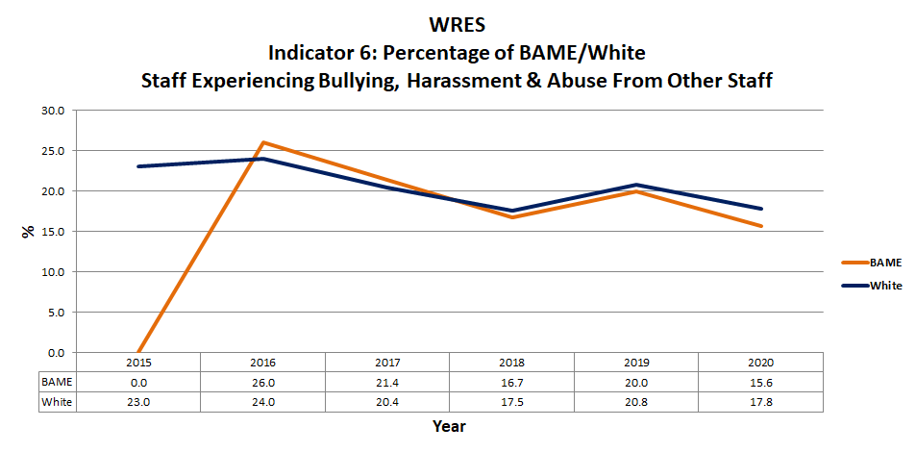
- Overall, the Trust’s result in this indicator was 12.4%, with the best community Trust’s result being 9.8%, so we still have work to do.
- There were 32 Black, Asian, or minority ethnic staff respondents to this indicator an increase of 7 from 2019.
- Results for White and Black, Asian, or minority ethnic staff have always been fairly similar but for both we have yet to see a sustained improvement.
- As for the previous indicator reporting internally does not reflect that seen in the Staff Survey, the Bridgewater Anti-Bullying and Harassment working group have an action plan for 2021 on how to encourage and improve reporting internally so that these issues can be understood and addressed.
Not reported in the WRES is bullying and harassment from managers. Bridgewater’s result was 8.4% overall, with the best community provider scoring 6.3%. In this indicator 9.7% of Black, Asian, or minority ethnic staff reported experiencing bullying, harassment or abuse from a manager compared to 8.3% of White staff. A better result than the above but reflective of conversations with the staff network and an area for us to address in 2021.
The NHS Staff Survey creates themes from the individual indicators, one of these looks at bullying and harassment generally. Please see further narrative on this theme on the following page
NHS Staff Survey Bullying & Harassment Theme:
This indicator brings together results for bullying, harassment and abuse from patients/public, managers, and staff.
The figure to follow looks at the bullying, harassment, and abuse theme overall, rather than by ethnicity, for the Trust since 2015:
Figure 13: Bullying and Harassment Overall 2015 - 2020
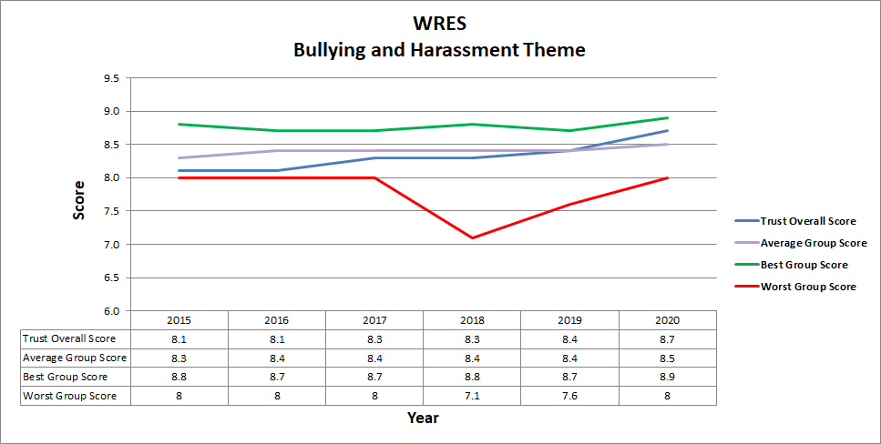
- As can be seen the Trust has slowly improved to now score higher than the average for its comparator group. 2020 shows the best result so far, bringing us closer to the figure for the best community Trust, but we know this theme still needs improvement, to achieve a figure above 9.5 would be our hope.
- This result looks at bullying and harassment overall rather than by specific protected characteristic group, we must not forget the impact that these behaviours have on certain groups when compared to those who don’t share a protected characteristic – comparing White and Black, Asian, or minority ethnic staff, disabled and non-disabled staff, LGBT+ staff and straight staff.
- We have also looked at the bullying and harassment theme by directorate and have identified areas where figures are lower – Corporate Estates, Dental, and Halton Adult’s and Children’s. Oldham has seen an improvement this year moving from a low score to a one that is higher than the Trust’s overall result.
As referenced for indicators 5 and 6 we have a number of working groups who, working together, are looking at addressing bullying, harassment, abuse and violence from patients/families, staff, and managers. These groups are reviewing current policy and practice and through engagement with staff and representation from our staff networks are leading improvements that should see us progress in this area in the future.
Indicator 7: Equal Opportunities
This indicator looks at the percentage of staff who believe the Trust provides equal opportunities for career progression or promotion.

(NHS Staff Survey 2020)

The figure below shows Trust results for the years 2017 – 2020 against other community providers comparing results for Black, Asian, or minority ethnic and White staff:
Figure 14: Indicator 7 Community Trust Benchmarking 2017 - 2020
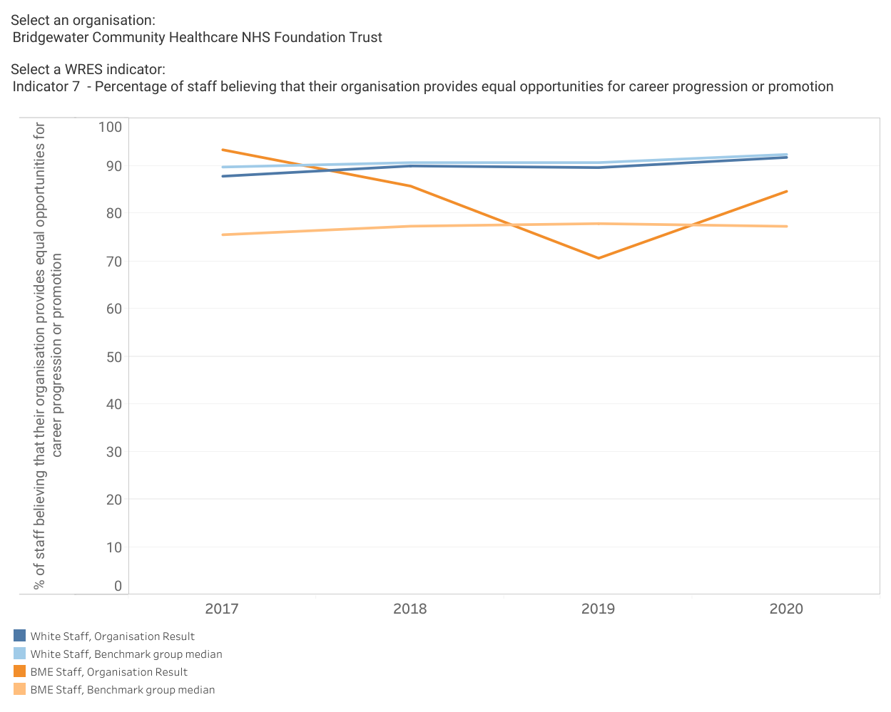
It can be seen in the figure above that this is an indicator where historically we have done well. 2018 and 2019 saw a significant deterioration in the result for Black, Asian, or minority ethnic staff, this followed three years where Black, Asian, or minority ethnic staff reported higher than White staff and always above 90%.
As an organisation we are above the average for our comparator group, but information from our conversations with the Race Inclusion Network tells us that we have work to do to improve equality of opportunity in career progression for our Black, Asian, or minority ethnic staff and this is reflected in our equality action plan.
The figure to follow shows our results for this indicator for staff from 2015, (when figures were too low to report so are recorded as zero) to 2020:
Figure 15: Equal Opportunities Results 2015 - 2020
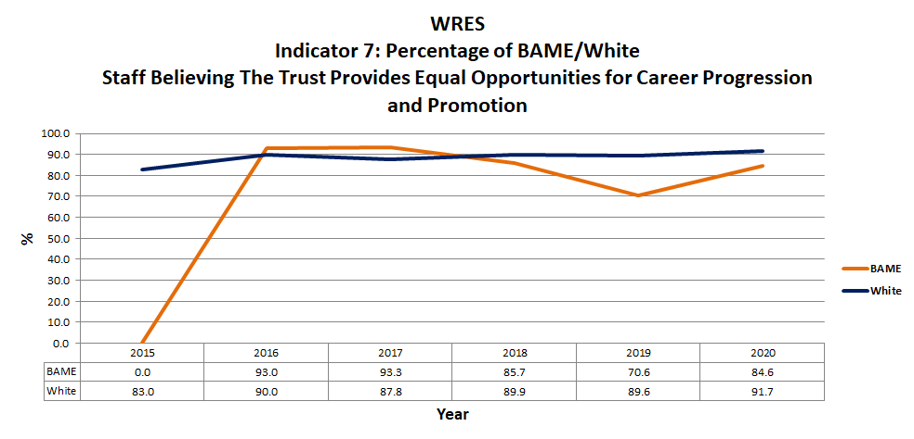
- Up to 2017 Black, Asian, or minority ethnic staff consistently reported a higher satisfaction rate than White staff, but this has decreased with a 15.1 percent decrease between 2018 and 2019 and a 14.0 percent increase to 2020. White staff meanwhile have remained rather more consistent in reported experience.
- It should be noted that the number of Black, Asian, or minority ethnic staff responding to this question is always significantly lower than the overall number completing the survey, 13 in 2020 compared to 33 for the other questions. Assumptions could be made on why this should be, but it is more effective and useful to listen to the voices of our Black, Asian, or minority ethnic staff through the Race Inclusion Network and other engagement methods and we will be doing this throughout 2021.
Overall, our result for this indicator is 92.5% with the best Trust in our comparator group scoring 93.3%. However, equality of opportunity is about creating equity between people from a protected characteristic group and people outside of this group and as the indicator above shows, and this is reflected in the Workforce Disability Equality Standard, staff from protected groups are not reporting as highly as their comparator staff.

Indicator 8: Discrimination
This indicator looks at what percentage of staff have personally experienced discrimination at work from their manager or team leader, or from another member of staff.

(NHS Staff Survey 2020)

The figure below shows Trust results for the years 2017 – 2020 against other community providers for Black, Asian, or minority ethnic and White staff:
Figure 16: Indicator 8 Community Trust Benchmarking 2017 - 2020
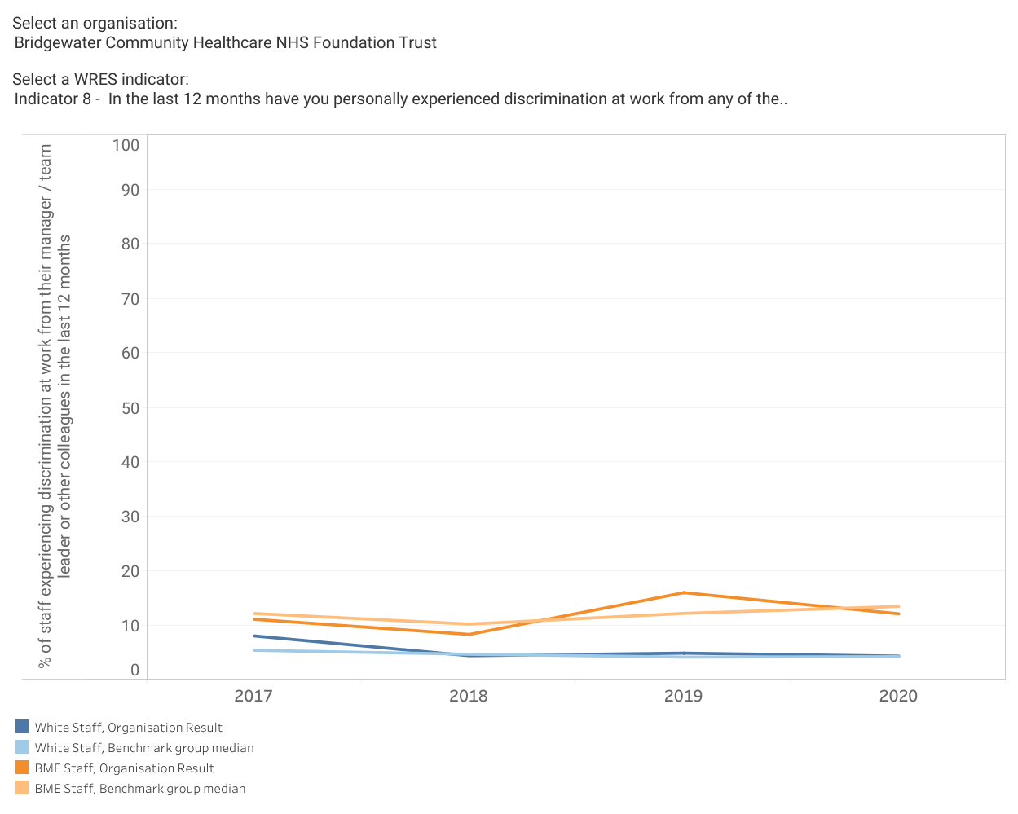
As can be seen in the above the experience of discrimination from other staff is significantly higher for our Black, Asian, or minority ethnic staff, and while we are below the average for other community providers this is still too high a figure at a 7.7% difference to White staff.
The number of Black, Asian, or minority ethnic staff responding to this question was 33, an increase of 8 from 2019.
Feedback from our Race Inclusion Network members tells us that this is an issue in the workplace and one we are looking to work together to understand and address.
The figure to follow shows our results for this indicator from 2015 to 2020, as for the other indicators results in 2015 have been recorded as zero to reflect low number of respondents rather than low results.
Figure 17: Discrimination Figures from 2015 to 2020
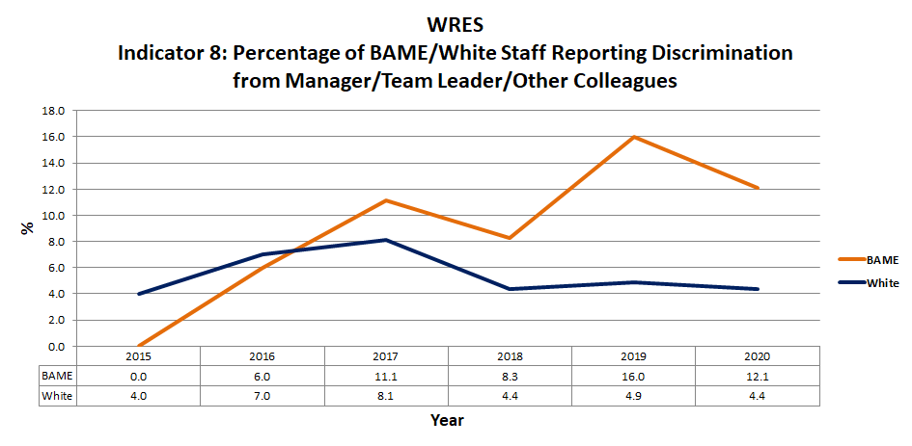

- As can be seen we are not, as yet, seeing a consistent improvement in this indicator with us never returning to the 2016 figure of 6%.
- There were 33 responses from Black, Asian, or minority ethnic staff to this Survey question.
Discrimination and harassment are both illegal acts under the Equality Act 2010 and the Human Rights Act 1998. Any staff member reporting these behaviours, including as a witness, is also protected in legislation from any treatment that victimises them as a result of this reporting.
Our conversations with members of the Race Inclusion Network, and also with team leaders and members of staff from within the Trust, have identified that we need to address these issues across the whole of Bridgewater. We have the policy and process to support staff, but we need to get better at acting when we hear of these issues and then communicating widely so that staff can feel safe and protected and that there is a worth in speaking up. Our action plans for equality and for the NHS People Plan address these priority areas.

Action Plan
As detailed on pages 11 - 12 we have been working to produce and publish an action plan for equality for all protected groups.
This uses engagement and feedback from the staff networks alongside analysis for WRES: A Model Employer, disparity ratio analysis, and review of NHS Staff Survey results to create an overarching plan.
The plan outlines the following action sets:
- Culture
- Modernising Recruitment
- Identifying and Developing Talent
- Developing EDI Awareness and Skills
This plan can be viewed on the Trust webpage - https://bridgewater.nhs.uk/aboutus/equalitydiversity/equalityact2010/
Thank you for taking the time to read our 2020 WRES report. Should you have any queries or questions or if you would like to request the contents of this report in another language or format, please contact our Equality & Inclusion Manager in the first instance, details below.

Contact Details
Paula Woods (Director of People and Organisational Development) paula.woods1@nhs.net
Ruth Besford (Equality & Inclusion Manager) ruth.besford@nhs.net

