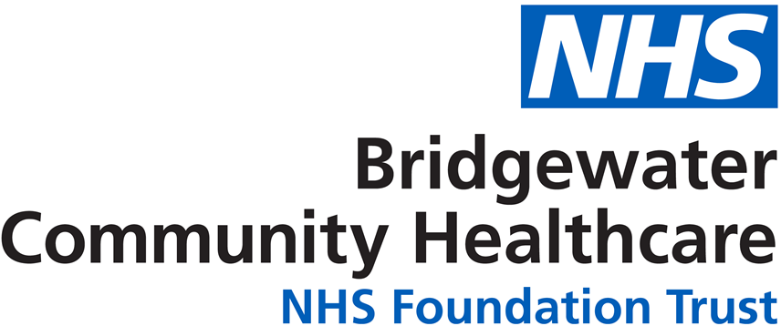

NHS Workforce Disability Equality Standard
For 31 March 2021


Contents
 | Page Number
Introduction | 2
Executive Summary | 3
Our Results - 31 March 2021 | 5
Metric 1: Staff Pay | 7
Metric 2: Recruitment | 11
Metric 3: Capability | 13
Metric 9b: Staff Engagement | 13
Metric 10: Board | 14
NHS Staff Survey 2020 Results  - Metric 4a: Bullying & Harassment  - Metric 4b: Bullying & Harassment Reporting  - Metric 5: Equal Opportunities  - Metric 6: Feeling Valued | 15  20  22  24
- Metric 7: Presenteeism | 27
- Metric 8: Reasonable Adjustments | 29
- Metric 9a: Staff Engagement | 30
Our Action Plan | 32
Contact Details | 32

Introduction
Welcome to our NHS Workforce Disability Equality Standard Report 2021.
The last year has been challenging for the NHS and for many in our workforce and communities. The Covid 19 pandemic has affected us all, but for some, including those with disabilities the impact has been disproportionate, and the effects may be felt for a long time to come.
As a community and specialist dental provider it has been a very different year. Our corporate services functions transitioned to agile and home working arrangements, many services were stepped down, resulting in a change to the way they delivered care to their patients. Some staff continued with ‘business as usual’ arrangements, but with higher volumes of patients through discharge to home and increased need from those recovering from Covid. Other staff were redeployed to support both these high priority services and the swabbing and vaccination teams. Others provided care to Covid positive patients alongside colleagues in social care.
As a Trust we have endeavoured to support all our staff and have put in place extra measures such as risk assessments to ensure we mitigate risks from the virus as much as we can. We have carried out home based working risk assessments to ensure staff have the necessary equipment, including reasonable adjustments, to enable them to work safely and in a way that supports their health and wellbeing and meets individual needs. And we have established our (Dis)Ability and Wellbeing Network (DAWN) and also consulted disabled staff via online surveys to get feedback on what is working, what isn’t, and what is satisfactory but could be improved.
We have engaged with our DAWN on the results published in this report and we thank them for the time they have taken to review the data and to feedback both their comments and their own experiences to enhance our understanding of workplace disability equality and inclusion.
Throughout this document we will use the abbreviations WDES for the Workforce Disability Equality Standard, ESR for Electronic Staff Record, EDI for Equality, Diversity and Inclusion, and AfC for Agenda for Change.
Should you have any queries or questions or if you would like to request the contents of this report in another language or format, please contact our Equality & Inclusion Manager in the first instance, details below.

Paula Woods (Director of People and Organisational Development) paula.woods1@nhs.net
Ruth Besford (Equality & Inclusion Manager) ruth.besford@nhs.net

Executive Summary
The Standard was mandated in 2018 as a result of extensive research into the experiences of staff with disabilities in the NHS. Research that showed consistent inequality and poor experience when compared to non-disabled colleagues.
As we look back at our third year of results for the WDES we can see areas of progress and equally areas where we are not progressing as we would like to.
Metrics 1 and 2 analyse career progression and recruitment and for these results we rely on the data provided in our Electronic Staff Record System (ESR). As with many NHS Trusts we have limitations with this data, both in the numbers of self-reported disability and also in the numbers of unknown records.
Many of our staff will become disabled during their working lives, often when they have worked for the Trust for a number of years; disability on ESR is a self-reported field and as such relies on staff accessing and updating, often something that isn’t at the top of a priority list. For other staff there can be issues in relation to this ‘disclosure’, such as a concern that a disability reported on ESR could lead to discrimination or bias from others. The Trust has undertaken work to both increase self-reporting and to also engage with staff and put in place supportive measures that will develop a culture of safety and inclusion that encourages self-reporting, and we will continue with this as we know how important this piece of work is to bettering our understanding of disability equality and inclusion.
Metrics 4 to 9a are taken from the NHS Staff Survey 2020. The definition of disability within the staff survey differs from that of the legal definition, providing a wider definition that includes ill health and long-term conditions that would maybe not meet the ‘substantial and long term’ test. This, along with the anonymity given by the Survey, means that our percentage of disabled staff in Survey respondents is much higher than that on ESR, 20.7% in the Survey compared to 2.72% in ESR, or 159 compared to 47 in ESR.
Due to low numbers for some metrics, we have throughout this report either kept confidential the real figures where they are below ten by using a *, or we have clustered staff together into bigger groups, particularly in relation to pay bands, so that analysis can be shown while maintaining protection of personal and sensitive data.
The results in full can be found in Table 1 on pages 5 and 6, and with additional narrative regarding analysis and results on pages 7 onwards, but to summarise our findings in 2021:
- Metric 1: Pay Progression. Analysis shows no change in relation to career progression. Disabled staff in the main are working in bands 5 – 6 with very small numbers above this and no known disabled staff in Very Senior Manager roles. Overall figures have dropped as a result in the reduction of the workforce as services have transferred with place-based commissioning.
- Metric 2: Recruitment. This metric has seen an improvement, with the likelihood figure for disabled applicants improving when compared to success for non-disabled applicants.
- Metric 3: Capability. There have been no formal capability procedures this year in relation to performance management.
- Metric 4a – 4b: Bullying, Harassment and Abuse. Some improvement in relation to these behaviours from patients/public, managers, and colleagues, but not yet a consistent and sustained improvement to bring experiences in line with non-disabled staff.
- Metric 5: Equal Opportunities. Slow, but consistent improvement, work still needed to level up experience with non-disabled staff.
- Metric 6: Presenteeism. Our best reported figure in three years and a big improvement for disabled staff bringing them in line with the non-disabled staff who felt pressured by managers to attend work while unwell.
- Metric 7: Feeling Valued. 8.1% improvement for disabled staff in 2020, but still reporting lower than non-disabled staff, and the Trust has work to do to match the best performing community provider.
- Metric 8: Reasonable Adjustments. Figure remains the same as 2019 with ¾ of responses agreeing that adequate adjustments had been made for them in work. A specific question for staff with disabilities so no comparator to other Trust staff, but 12.2% below the best performing Trust results.
- Metric 9a: Staff Engagement. A steadily improving result, though it remains below the figure for non-disabled staff.
- Metric 9b: Staff Engagement. A positive result due to the establishment of our staff network, the executive support for this agenda, and the engagement and actions that are developing as a result.
- Metric 10: Board. No change over three years. The Trust Board, including Executives and Non-Executives has no known disabled representation.
As can be seen we have made progress in some areas, others we remain challenged on; but as a Trust, from Board down we are committed to disability diversity, equality, and inclusion.
We have taken a number of steps in recent years to improve disability equality for staff, these are referenced throughout this document but include actions such as development of an Employee Adjustment Passport, and centralisation of the staff reasonable adjustment budget. We have also undertaken data analysis and engagement with staff to better inform our understanding. This has allowed us to develop an action plan for equality that addresses the issues raised by staff, highlighted by the results in this report, and aligned to the NHS People Plan and People Promise. Information on our action plan can be found on page 32.

Our Results – 31 March 2021
We have provided in Table1 a summary of our results against the ten metrics of the WDES.
Table 1: Showing WDES Results for 2021
Metric
- Percentage of staff in each AfC Band 1-9 or Medical and Dental pay grades, compared with the percentage of staff in the workforce overall. Disaggregated by non-clinical staff, clinical staff, and medical and dental staff. Note rounding up of numbers may mean a slightly higher figure than 100% is seen in the below.
 | Non-clinical |  |  |  |  | Clinical
 | Disabled | Non-Disabled | N/S |  |  | Disabled | Non-Disabled | N/S
AfC1 - 4 | 0.40 | 13.35 | 2.95 |  |  | 0.23 | 12.54 | 5.66
AfC5 - 7 | 0.17 | 4.22 | 1.45 |  |  | 1.50 | 37.80 | 8.03
AfC8a – 8b | 0.06 | 0.87 | 0.40 |  |  | 0.23 | 1.85 | 1.56
AfC8c - VSM | 0.06 | 0.66 | 0.75 |  |  | 0 | 0.40 | 0.17
 | Medical and Dental Grades:
Consultants | 0 | 0.29 | 0.16
Non-Consultant Career Grade | 0.06 | 3.06 | 1.16
Trainee Grades | 0 | 0 | 0
- Relative likelihood of being appointed from shortlisting across all posts |  |  |  | 1.53 times more likely to be appointed if you are Non-Disabled
- Relative likelihood of entering capability processes |  |  |  | 0.0 - no formal capability procedures in this period
- A) Percentage of staff experiencing bullying, harassment, and abuse from patients/relatives/public in last 12 months |  |  |  | 27.4% Disabled  16.6% Non-Disabled
Percentage of staff experiencing bullying, harassment, and abuse from managers in last 12 months |  |  |  | 14.4% Disabled  7.2% Non-Disabled
Percentage of staff experiencing bullying, harassment, and abuse from staff in last 12 months |  |  |  | 17.4% Disabled  11.6% Non-Disabled
- Percentage staff reporting bullying, harassment, and abuse in last 12 months |  |  |  | 60.3% Disabled  48.3% Non-Disabled
Continued….

Metric
- Percentage believing the Trust provides equal opportunities for career progression and promotion |  |  |  | 87.0% Disabled  92.8% Non-Disabled
- Percentage feeling pressure by manager to attend work even when feeling unwell |  |  |  | 19.6% Disabled  19.5% Non-Disabled
- Feeling valued by the Trust |  |  |  | 41.0% Disabled  49.1% Non-Disabled
- Satisfaction that reasonable adjustments made to support them in their work |  |  |  | 75.8% Disabled
- A) Staff engagement score (Disabled staff only) |  |  |  | 6.8 Disabled  7.2 Non-Disabled  7.2 Overall Trust Result
B) Have you taken action to facilitate the voices of Disabled staff |  |  |  | Yes
- Percentage difference between Board membership and overall workforce  Disaggregated by voting and non-voting members |  |  |  | Disabled -3%  Non-Disabled -4%  Not Stated 6%
Trust Overall Workforce:
Disabled 2.72%
Non-Disabled 75.03%
Unknown 22.25%
A * means that numbers are below 10 and therefore remain confidential in line with information governance and data protection requirements

Metric 1: Staff Pay
This metric looks at pay, what percentage (%) of Disabled staff are in each of the pay bands 1 to 9, in medical and dental posts, and very senior manager posts (including executive and non-executive board members).
These figures are compared with the overall workforce.

We have provided details below on the pay banding breakdowns of our non-clinical, clinical, and medical and dental workforces, giving information where we can about staff with disabilities.
It has not been possible to provide the same level of detail as that submitted to the NHS England team as a great deal of data has the potential to be personally identifiable, particularly when higher pay bands are analysed with their correspondingly low overall workforce.
Where we can we have aggregated information into larger clusters to allow reporting, and this has been managed in a way that should allow some understanding of issues such as career progression and representation at higher pay bands.
Non-Clinical Staff:
Our overall percentage and numerical totals for non-clinical staff can be seen in table 2, below.
As can be seen we have very low numbers of staff within this group who have a stated disability on ESR, and a high number of unknown records. As referenced in the Executive Summary this is an issue across the Trust, and across the NHS, and is something we have and continue to take action to improve.
Table 2: Showing Percentages and Totals of Disabled, Non-Disabled, and 'Unknown' Staff in Non-Clinical Roles As At 31 March 2021
Total Non-clinical Workforce = 438
 | Disabled | Non-Disabled | Unknown
% | 2.74 | 75.34 | 21.92
Total | 12 | 330 | 96

The figure to follow, figure 1, shows our non-clinical staff across the Agenda for Change and Very Senior Manager pay bands.
As the number of non-clinical staff with a disability stated on staff records is so small, (just 12 in total), we have had to further merge clusters to create just two, one for staff in pay bands 1 – 7 and the other for staff in pay band 8a and above. This still holds the risk of being personally identifiable, but the staff pool in question should be large enough that this would be difficult to ascertain.
Figure 1: Showing Non-Clinical Staff Pay Band Clusters By Disability Status on Staff Records As At 31st March 2021
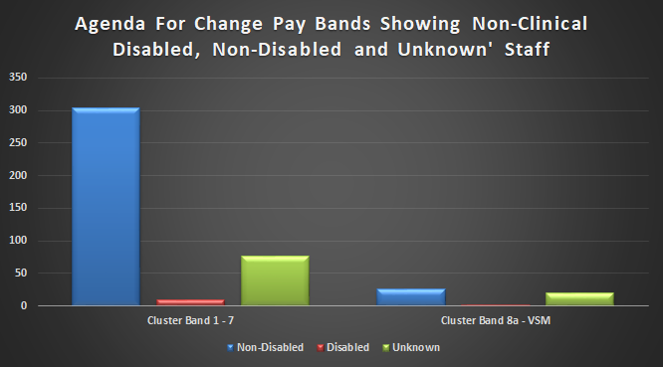

Clinical Staff:
Table 3 shows the percentage and numerical totals for staff in clinical roles, excluding those in the medical and dental staff group.
As can be seen percentage totals are broadly similar to those staff in non-clinical roles, and the numbers of staff with a disability are about 3 times as many as that group, similar to the increased size of this workforce. Once again there are a large number of unknown records.
Table 3: Showing Percentages and Totals of Disabled, Non-Disabled, and 'Unknown' Staff in Clinical Roles As At 31 March 2021
Total Clinical Workforce = 1201
 | Disabled | Non-Disabled | Unknown
% | 2.83 | 75.33 | 21.83
Total | 34 | 905 | 262

Figure 2 looks at disabled clinical staff in Agenda for Change and Very Senior Manager pay bands, again the clusters have been merged as numbers are very low, 34 in total this time with these staff mainly being in bands 1 – 7.

Figure 2: Showing Clinical Staff Pay Band Clusters by Disability Status on Staff Records As At 31st March 2021
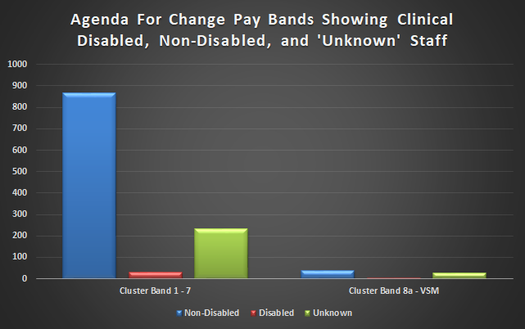
Career Progression:
We had hoped as part of our analysis to determine representation of staff with disabilities at higher pay bands, but the limitations at present of our data mean that no statistical significance can be seen in the figures we found. There does appear to be over-representation of disabled staff at pay bands 5 and 6, both groups have higher than the overall workforce percentage of staff with disabilities, but whether this is due to better self-reporting, manager ESR updates, new recruitment into these entry level roles, we simply don’t know, and until such time as we have more disability data we can’t accurately assess disability representation.
Medical and Dental Staff:
Medical and dental staff are reported separately to clinical staff in the WDES. Table 4 shows the details of staff in this group, in this instance the numbers of staff with disabilities have been kept confidential as they are below 10 in total.
Table 4: Showing Percentages and Totals of Disabled, Non-Disabled, and 'Unknown' Staff in Clinical Roles As At 31 March 2021
Total Medical and Dental Workforce = 91
 | Disabled | Non-Disabled | Unknown
% | 1.09 | 69.57 | 29.35
Total | * | 64 | 27

Year on Year Progress:
The table to follow shows the numbers of Disabled non-clinical and clinical staff since 2019 when WDES reporting began. Medical and dental staffing has not been shown as figures for disabled staff over the three years have remained below 10.
Table 5: Showing Disabled Non-Clinical and Clinical Staff by Pay Band 2019 to 2021
 | Disabled Non-Clinical Staff |  |  | Disabled Clinical Staff
 | 2019 | 2020 | 2021 | 2019 | 2020 | 2021
All AfC Pay Bands | 29 | 14 | 12 | 71 | 43 | 34
Very Senior Manager | 0 | 0 | 0 | 0 | 0 | 0
 | 2019 |  | 2020 |  | 2021
Percentage Disabled Staff Overall | 3.42 |  | 2.78 |  | 2.72
Overall Workforce Total | 3,016 |  | 2,048 |  | 1,730

It can be seen that the numbers of Disabled staff have fallen year on year, however this would be expected as the Trust’s overall workforce has also decreased every year, for this reason we have also included the overall workforce total and percentage Disabled staff. As can be seen our percentage of Disabled staff has also fallen in this time, this is a trend that we have and continue to take steps to reverse.

Metric 2: Recruitment
This metric looks at recruitment, to see how more likely non-disabled applicants are to be successful and to be appointed when compared to Disabled applicants.
(A likelihood figure above one would show that non-disabled applicants are more likely to be appointed than Disabled applicants).

Our likelihood figure for this year is 1.53. This means that non-disabled candidates are 1.53 times more likely to be recruited than disabled candidates.
The table below shows our likelihood figure for this metric since 2019 and as can be seen we have not made any positive, sustained progress in these results in the last three years. Disabled applicants that meet the person specification for the role applied for are guaranteed an interview.
Table 6: Showing Recruitment Likelihood Result and Totals Recruited 2019 - 2021
Recruitment 2019 - 2021
 | 2019 | 2020 | 2021
Likelihood | 1.45 | 3.03 | 1.5
Total Disabled Staff Recruited | 13 | * | *
Total Non-Disabled Staff Recruited | 352 | 210 | 174
Total Not Stated Staff Recruited | - | 40 | 55

The figure below, Figure 3, shows the journey from application to appointment, as can be seen the percentage of candidates with a disability increases at shortlisting, potentially reflective of our two ticks commitment, before falling below the applicants percentage at appointment.
In summer 2021 we have developed and published an action plan that sets out our commitment and plan to review and update the recruitment pathway from start to end to ensure fairness, effective training, challenge, and accountability. See more on page 32.
It can also be seen in figure 3 how the percentage of unknown disability records increases at appointment, from 1.5% of all candidates in application and shortlisting to 23.4% of all appointed. This is born out too in actual figures, 28 at shortlisting unknown disability up to 55 at appointment. Understanding and addressing the why of this is important to us in the next year as part of our action planning and staff engagement work. It should be noted here that just one candidate chose ‘prefer not to declare’ which shows a proactive wish to not state, rather than the potential omission through almost inactivity for the others.
Figure 3: Showing The Recruitment Pathway From Application To Appointment for Disabled, Non-Disabled, And 'Unknown' Candidates April 2020 - March 2021
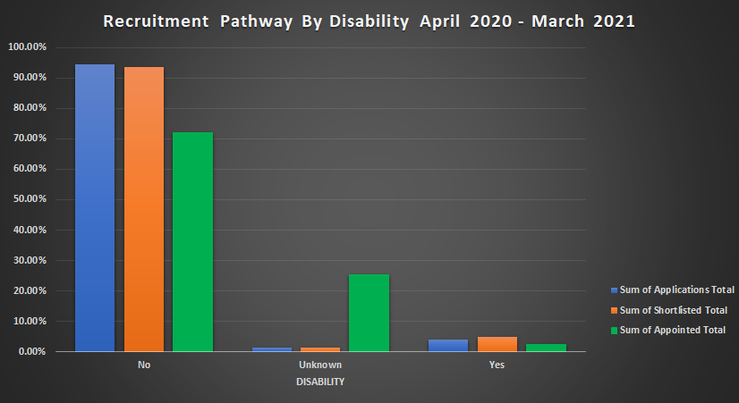
Our review of recruitment by staff group showed that our highest recruitment was in Nursing and Midwifery, nearly 40% of all recruitment. This was followed by admin/clerical posts and additional clinical posts, 26% and 20% respectively.
Our final figure looks at recruitment by Agenda for Change and Very Senior Manager pay bands, and no candidate who stated they had a disability was recruited above band 6.
Figure 4: Showing Appointments by Agenda For Change and Very Senior Manager Pay Bands April 2020 - March 2021
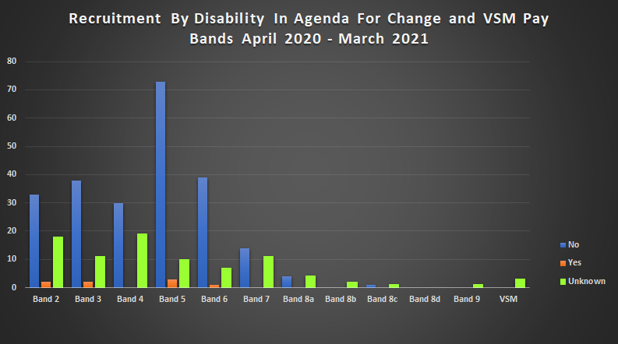

Metric 3: Capability
This metric looks at formal capability processes in the Trust, at how more likely Disabled staff are to be involved in formal processes when compared with non-disabled staff.
(A likelihood figure above one would show that Disabled staff are more likely to be in formal capability processes than non-disabled staff).

There have been no formal capability procedures during the period 1 April 2019 to 31 March 2021, as such we have no likelihood result to return.

Metric 9b: Staff Engagement
- Has your Trust taken action to facilitate the voices of Disabled staff in your organisation to be heard? (Yes) or (No)

Yes.
We established our (Dis)Ability and Wellbeing Network (DAWN) in summer 2020.
The Network meets monthly via Teams and the EDI lead for the Trust also works closely with Network members who wish to discuss issues or ideas outside of the Network meetings.
The first meeting of the Network looked at certain questions around staff experience before and during Covid, asking what the Trust could be better, and what members would like to see the Trust acting on. In addition, a Survey Monkey ran for a month asking the same questions. The responses were themed and shared with Board, they covered the following:
- Trust support
- Manager support and understanding
- Bullying, harassment, and discrimination
- Reasonable adjustments
- Inconsistency between employers
- HR processes and impact on mental and physical health
- Awareness and training
- Accountability
- Career progression
- Disability representation and role models
These themes have formed the basis for ongoing discussion with the Network members, and members have supported the development of the equality action plan for the Trust.
The Network has executive sponsorship through the Director of Finance who has already supported members to achieve one objective – the centralisation of reasonable adjustments for staff budget.
Other actions completed include representation on the Occupational Health procurement working group – a key area as a number of members and survey respondents have commented on the inaccessibility of the previous provider for staff with disabilities.
Further work is looking at the development of a reasonable adjustments policy and process, establishment of a peer support network, and support for the bullying and harassment and zero tolerance work streams. In addition, a Network member is part of the project board for our reciprocal mentoring programme due to start in autumn 2021.
Next steps in 2021 are to formalise the Network through agreed terms of reference and a work plan and objectives for the next three years. One key action the members have identified is working towards our application for Disability Confident Leader.
It is hoped that later in the year Network members may feel encouraged and supported enough to step forward and assume Network leadership roles, but for now the Trust’s EDI lead provides Chair and administration support.
The Network members have supported analysis and review of the WDES 2021 data and have provided comment and feedback that have been considered and have informed the development of our action plan.
Metric 10: Board
This metric looks at our Board of Directors, and what the difference is, in percentage, compared with the workforce.

The following table shows both the numbers of staff at Board level and the percentage difference between our Board membership and our overall workforce.
A minus figure shows under-representation compared to workforce and a positive figure over-representation.
Table 7: Showing Board Disability Representation Compared to Overall Workforce Representation
 | Disabled | Non-Disabled | Unknown
Board | 0 | 6 | 8
Difference (Total Board % – Overall Workforce %) | -3.0% | -4.0% | -6.0%

NHS Staff Survey 2020 Results
Metric 4a: Bullying, Harassment and Abuse – Patients, Relatives, and the Public
This metric compares the percentage of Disabled staff compared to non-disabled staff experiencing harassment, bullying or abuse from:
- Patients/their relatives/members of the public
- Managers
- Other colleagues
(NHS Staff Survey 2020)

The figure below is taken from the NHS Staff Survey results website and shows each of these three metrics comparing staff group and also Bridgewater against its comparator group of community providers. The results for all three years of the WDES are shown allowing us to start to look at overall trends for these metrics.
Figure 5: Showing Harassment, Bullying and Abuse Results 2018 - 2020
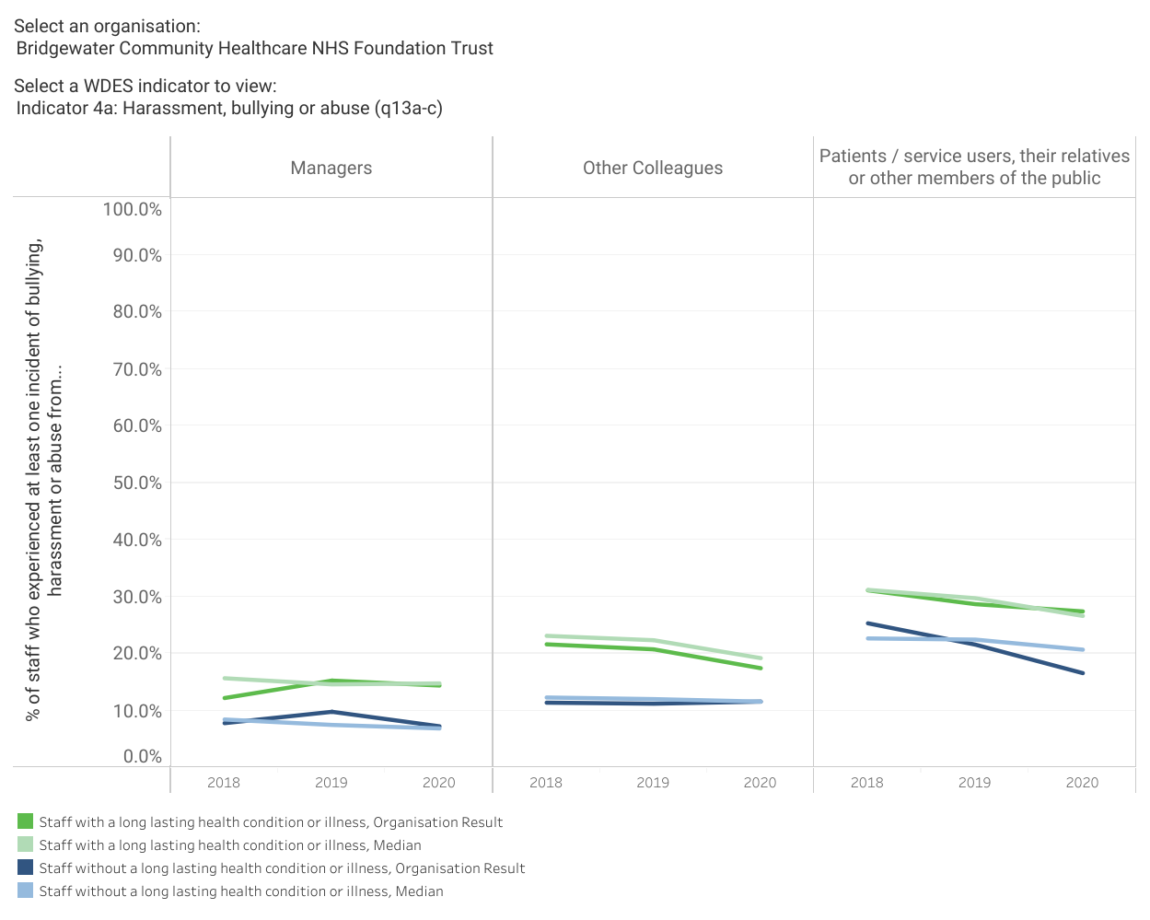
It can be seen that for harassment, bullying and abuse from patients/public and colleagues there are slow but continued improvements, from managers however for both groups there was a deterioration in 2019. The next figures break these down a little further by individual metric and compares them to the Trust’s overall result.
- Patients/service users, their relatives, or other members of the public:
The figure to follow shows the Trust results for the last three years for this metric.
Figure 6: Showing Bullying, Harassment and Abuse of Disabled Staff by Patients, Families, and the Public
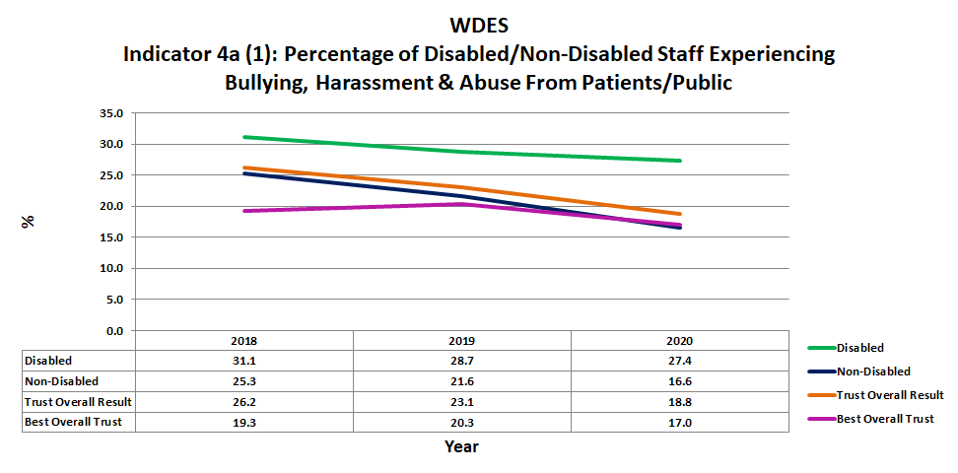
- Our results in the figure above show the responses of disabled and non-disabled staff groups, along with the overall Trust score for this metric and the score for the best community provider – our comparator group.
- Overall, our result (that is all staff responses and not disaggregated in any way) is improving annually with a 7.4% improvement over three years.
- As can be seen results for staff with disabilities and long-term conditions are consistently worse than the overall Trust result, jumping from a 5% difference in 2018 and 2019 to nearly 10% difference in 2020.
- Non-disabled staff have consistently reported better against the overall Trust figure.
- In both Disabled and non-disabled staff the figures are improving, but the gap is widening between the two groups.
- 157 staff with long term conditions responded to this question in 2020, this equates to 21% of all survey respondents a slightly lower response rate than that of 2019 (22%).

- Managers:
The figure to follow details the results for the last three years for this metric.
Figure 7: Showing Bullying, Harassment and Abuse of Disabled Staff by Managers
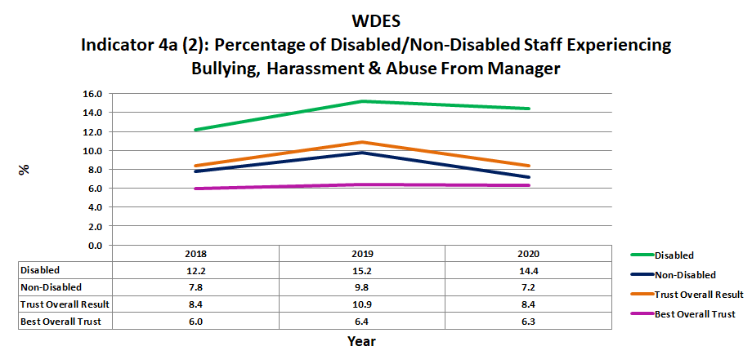
- Trust results for all staff (not disaggregated) are shown above along with the results of the best community provider and the disaggregated results for disabled and non-disabled staff.
- Trust results overall showed a spike in 2019 and have remained above the figures for the best community provider Trust. Results for non-disabled staff are below Trust overall figures.
- As can been seen results for staff with disabilities and long-term conditions remained around 4% above the overall Trust result in 2018 and 2019, however in 2020 this difference has risen to 6%.
- Both groups have improved this year, however the gap has widened between the two.
- 153 staff with long term conditions responded to this question this year, this was 20% of all survey respondents, a lower figure than the 22.5% who reported in 2019.

- Other colleagues:
The figure to follow looks at the results for the last three years for this metric focused on bullying, harassment, and abuse from other staff.
Figure 8: Showing Bullying, Harassment and Abuse of Disabled Staff by Colleagues
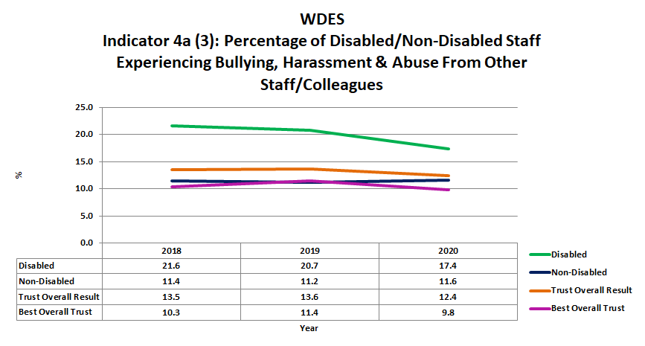
- As can be seen the overall Trust result for this metric has improved, though we have work to do to match the best overall community provider’s results.
- Results for non-disabled staff are consistently lower than the overall figure, though this group’s results did deteriorate slightly in 2020.
- Staff with disabilities or long-term conditions consistently score worse results; with the improvements in this metric for staff with disabilities the gap is slowly narrowing.
- 155 staff with long term conditions responded to this question this year, 21% of all respondents.
- For the three questions that make this WDES metric and also the reporting metric to follow there are a number of actions taking place to understand and address these issues:
  - (Dis)Ability and Wellbeing Network (DAWN) engagement
  - Bridgewater Anti-Bullying and Harassment Working Group
  - Zero Tolerance Working Group
  - Violence Prevention and Reduction Standard Working Group – tying into the above two
  - Just and Learning Culture – including Civility and Respect

The 2020 NHS Staff Survey also asked specific questions regarding Covid 19 including working area and shielding through the pandemic.
While we can’t break these metrics down by protected characteristic group, we can see the following yes and no responses by staff based on bullying and harassment metric and working area during the pandemic:
Table 7: Showing the Results for Bullying and Harassment of Staff Based on Area of Work during Pandemic
 | Covid Ward |  | Redeployed |  | Working From Home |  | Shielding
Numbers of staff (approx.) | 100 | 660 | 170 | 585 | 450 | 300 | 85 | 660
Harassment, Bullying and Abuse from…. | Yes % | No % | Yes % | No % | Yes % | No % | Yes % | No %
Patients/Public | 25.7 | 17.5 | 16.8 | 19.3 | 17.0 | 21.9 | 25.3 | 17.5
Manager | 11.3 | 8.2 | 10.1 | 8.1 | 8.9 | 8.7 | 10.3 | 8.4
Staff | 16.2 | 12.0 | 12.3 | 12.8 | 13.6 | 11.6 | 12.8 | 12.4

When compared with the figures reported for the Trust overall on the previous pages it is apparent that for most groups of staff stating they had been subjected to these behaviours there was an increased incidence, in some cases small and in some larger, through the pandemic.

Metric 4b: Bullying, Harassment and Abuse – Reporting
This metric compares the percentage of Disabled staff compared to non-disabled staff saying that the last time they experienced harassment, bullying or abuse at work, they or a colleague reported it.
(NHS Staff Survey 2020)

The figure below looks at the Trust’s results for the last three years comparing staff with and without long term conditions within Bridgewater.
Figure 9: Showing Harassment, Bullying and Abuse Reporting Results 2018 - 2020
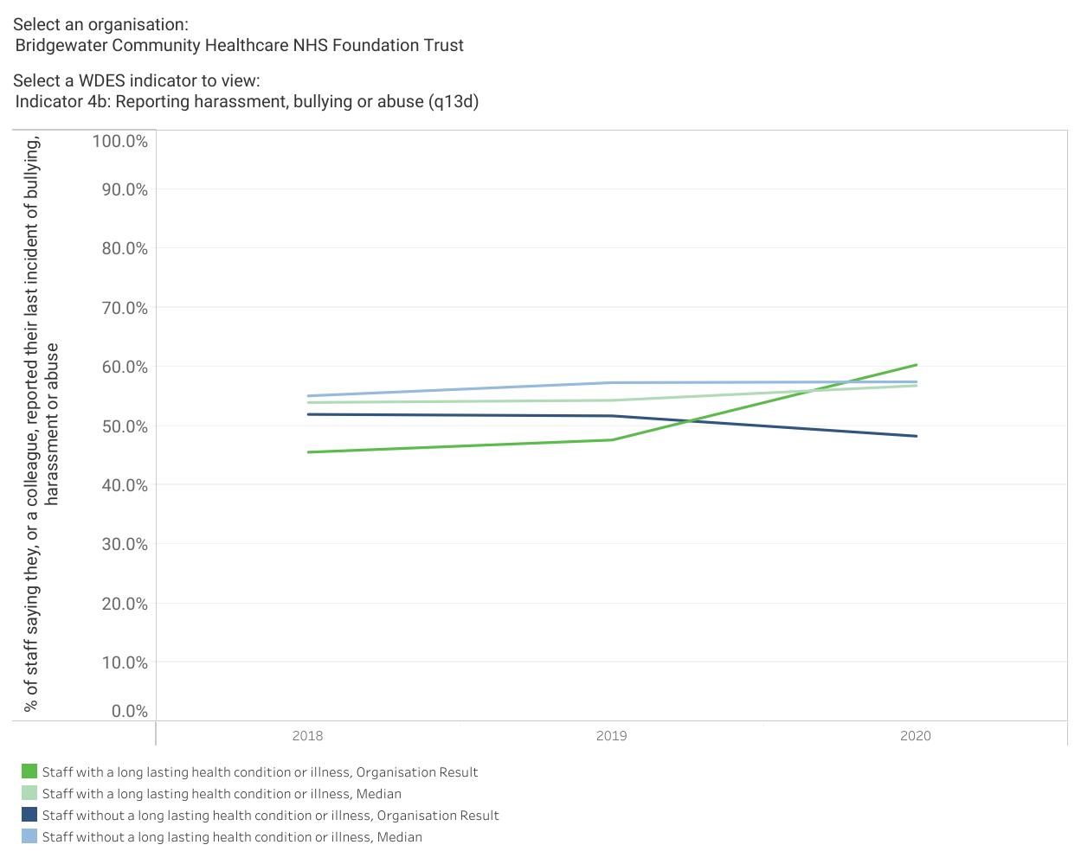
- The full question for this metric is ‘the last time you experienced harassment, bullying or abuse at work, did you or a colleague report it’. It is unclear in the staff survey results whether reporting of an incident was done by the individual concerned or a colleague supporting them as both responses are merged to give an overall result.

The next figure shows Trust results by staff group and also compares the results for Disabled and non-disabled staff against overall Trust results and the results of the best community provider.
Figure 10: Showing Reporting of Bullying, Harassment and Abuse of Staff
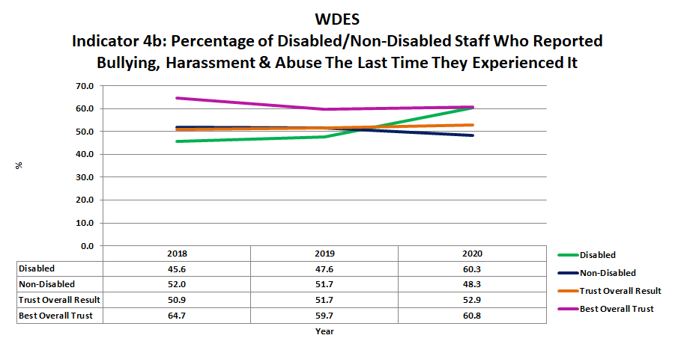
- As can be seen Trust overall, (all staff), results have remained fairly static over the three years of WDES reporting, and we remain below the best community provider results by several percentage points.
- Staff with long term conditions have seen a significant upward change in this metric.
- 63 staff with long term conditions responded to this question. This was 30% of all respondents, this metric traditionally having a lower response rate as it relates to yes responses to the previous three questions looking at these incidents. This equates to a year-on-year increase in the percentage of staff with disabilities or long-term conditions responding to the question.

Metric 5: Equal Opportunities
This metric looks at the percentage of staff believing that the trust provides equal opportunities for career progression or promotion.
(NHS Staff Survey 2020)

The figures to follow look at responses to the Survey question on whether staff felt the Trust provided equality of opportunity for career progression and promotion. The first looks at the three years WDES data for Bridgewater staff in disabled and non-disabled groups alongside the average for these groups in community provider trusts.
Figure 11: Showing Equal Opportunities Results for 2018 - 2020
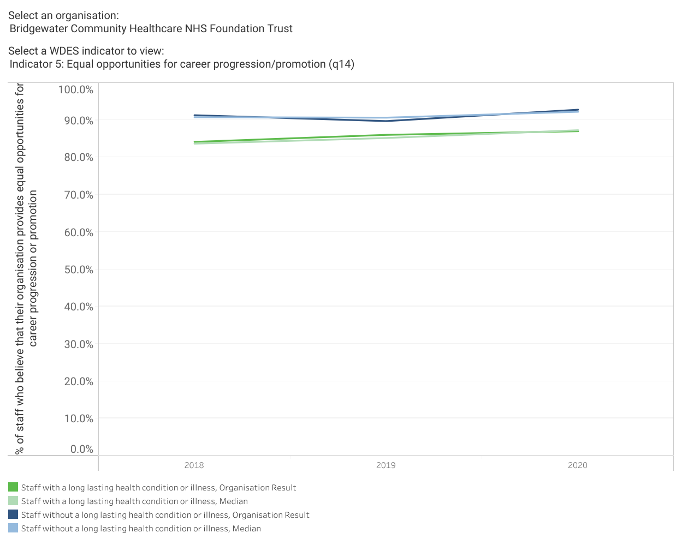
- What can be seen in the above is that staff with disabilities or long-term conditions report lower experiences of equal opportunities in Bridgewater mirroring the pattern seen in other community providers. For both, there has been very little change over three years.

Our second figure for this metric shows us more detailed Trust results, showing the results for disabled and non-disabled staff alongside the overall Trust score and the score for the best performing community provider.
Figure 12: Showing Equality of Opportunity Reporting for Disabled and Non-Disabled staff
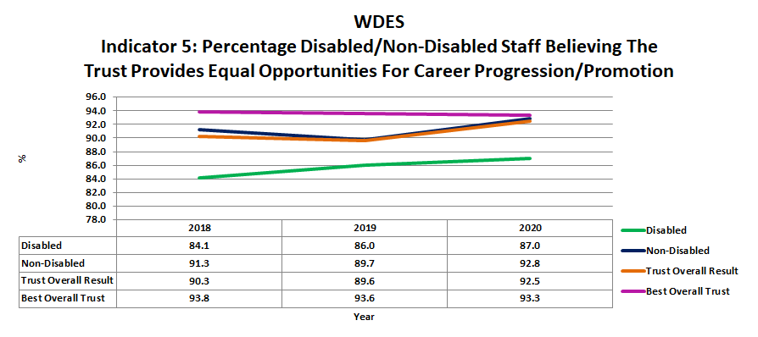
- It can be seen in the figure above that overall all staff results for this metric have improved this year – 2020 is the highest figure for five years. While we are pleased to see the improvements in this metric overall we recognise that there is work to do to close the gap between staff groups and to continue to improve overall.
- There has been an improvement in this score for staff with disabilities over each of the three years of the WDES. Results for non-disabled staff have been less consistent but have matched the inconsistent overall result for the last three years.
- In total 100 staff with disabilities or long-term conditions responded, 20.5% of all respondents and our biggest percentage response rate from this group of staff in the three years of the WDES.
- Our engagement with DAWN is developing our understanding of the experiences of staff with disabilities and long-term conditions; and members support will be invaluable in 2021-22 as we develop our action plan in relation to increasing diverse representation and improving career progression and career options for staff from all protected characteristic groups as per the NHS People Plan.

Metric 6: Presenteeism
This metric looks at the percentage of Disabled staff compared to non-disabled staff saying that they have felt pressure from their manager to come to work, despite not feeling well enough to perform their duties
(NHS Staff Survey 2020)

Our first figure for this metric shows the results for our disabled and non-disabled staff alongside the average figures for these groups in community provider Trusts.
Figure 13: Showing the Results for Pressure from Manager to Attend Work While Unwell 2018 - 2020
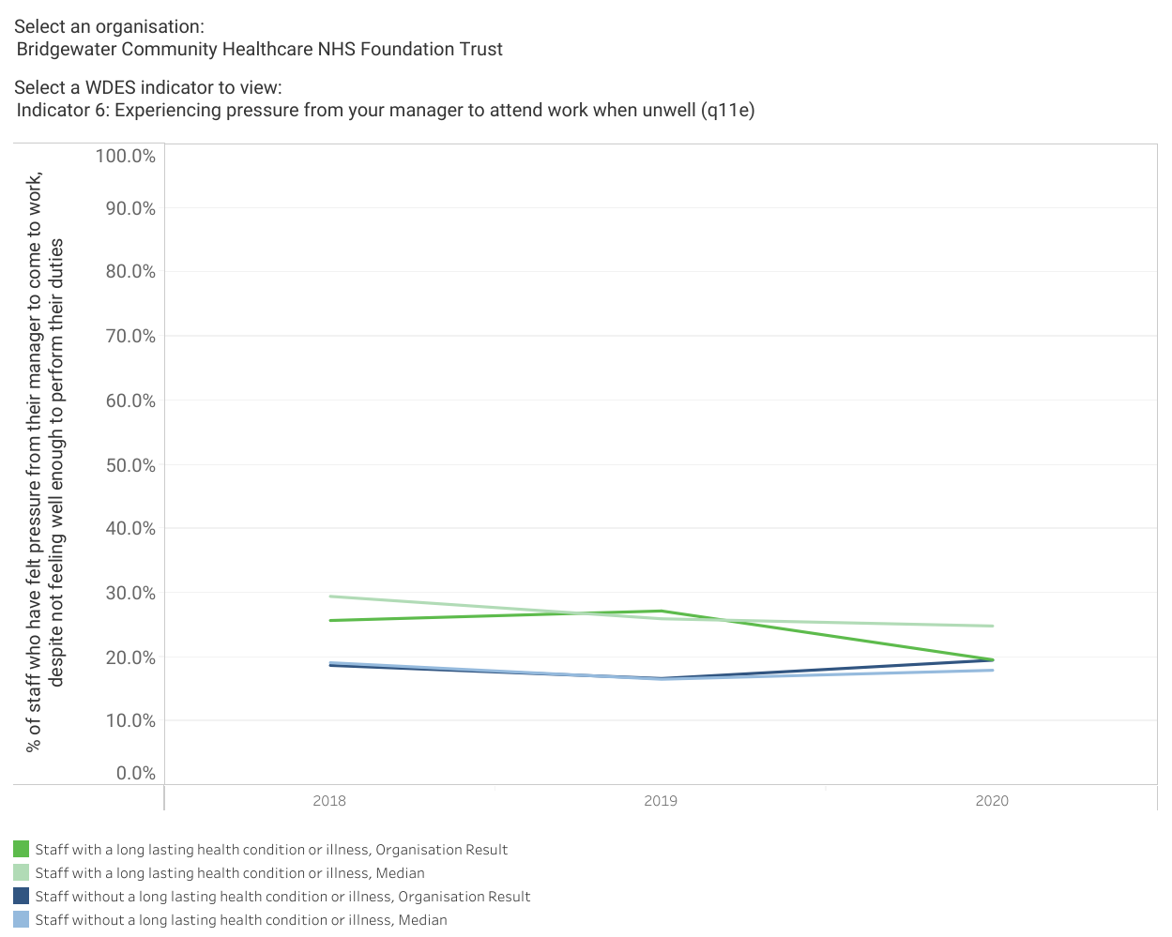
- It can be seen that other than a peak in 2019 we generally score better than our comparator Trusts for staff with disabilities or long-term conditions facing manager pressure to attend work when unwell.
- In 2020 just 0.1% separates the score between the two groups.

The next figure to follow shows the results for Disabled and non-disabled staff, and for Trust overall score and the best community Trust score.
Figure 14: Showing Staff Reporting Pressure to be in Work When Feeling Unwell Comparing Disabled and Non-Disabled Staff
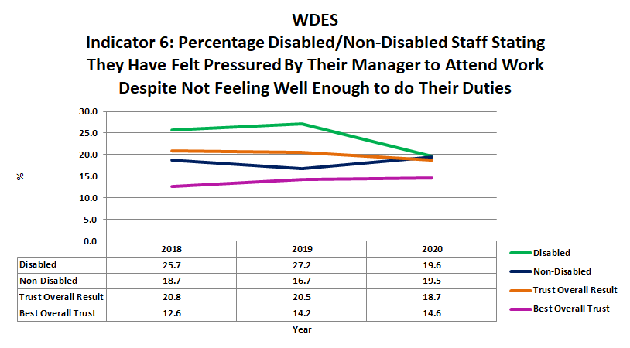
- It can be seen that the overall Trust figure for all staff is slowly improving, while the result for the best community Trust is going the other way albeit very slowly.
- Staff with disabilities and long-term conditions have reported a significantly improved figure in 2020 bringing them in line with non-disabled staff, however we need to continue to work to bring the results for both groups down and to improve the overall Trust result.
- 97 staff with disabilities responded, 28% of all respondents to this question.
- The 2020 Staff Survey Covid 19 breakdown shows us the following in relation to pressure from managers to attend:
  - Covid wards/areas – 30.8 % of relevant staff responded yes, 17.4% no
  - Redeployed staff – 25.3% of relevant staff said yes, 18.0% no
  - Working from home – 16.2% said yes, 24.0% no
  - Shielded staff – 15.7% yes, 19.9% no
- These figures while not good for staff responding ‘yes’ are maybe not surprising given the pressures the NHS has been under and the impact that staff absence, requirements to shield and/or isolate has had on service delivery. It could be assumed that the improved figure for disabled staff in 2020, as seen in the figure above, is due to these staff shielding and working from home and therefore both feeling better able to manage their health and wellbeing on a day to day basis, and facing less pressure to attend frontline services. These however are just suppositions, the 2021 survey results will tell us more about trends in this metric.
There is another element to presenteeism, and that is the pressure we put ourselves under to be in work when unwell.
Looking at the Survey question ‘in the last three months have you come to work despite not feeling well enough to perform your duties’ we can see the following results for Disabled and non-disabled staff:
Figure 15: Showing Staff Attending Work despite Feeling Unwell
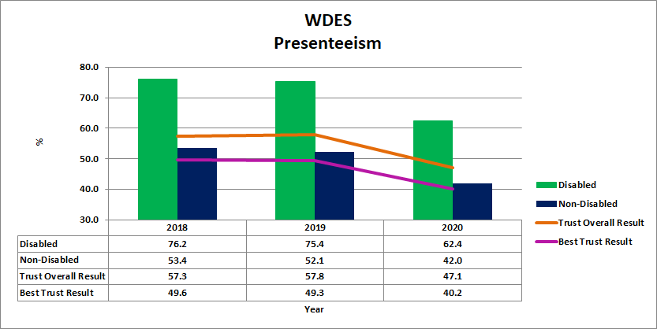
- As can be seen staff with disabilities or long-term conditions consistently state they have attended work despite feeling unwell or not well enough to undertake their duties. We are engaging with the (Dis)Ability and Wellbeing Network on understanding the reasons why this may be.
- Further work is planned for 2021 – 2022 looking at reasonable adjustments and other ways we can support our staff with disabilities and long-term conditions to feel safe, supported and valued, and enabled to manage their own health and wellbeing to their satisfaction.

Metric 7: Feeling Valued
This metric looks at the percentage of Disabled staff compared to non-disabled staff saying that they are satisfied with the extent to which their organisation values their work

(NHS Staff Survey 2020)

Our next figure looks at how staff feel they are valued for their input, looking at the differences for disabled and non-disabled staff, and also the average for these groups in community providers.
Figure 16: Showing the Results for Feeling Valued 2018 - 2020
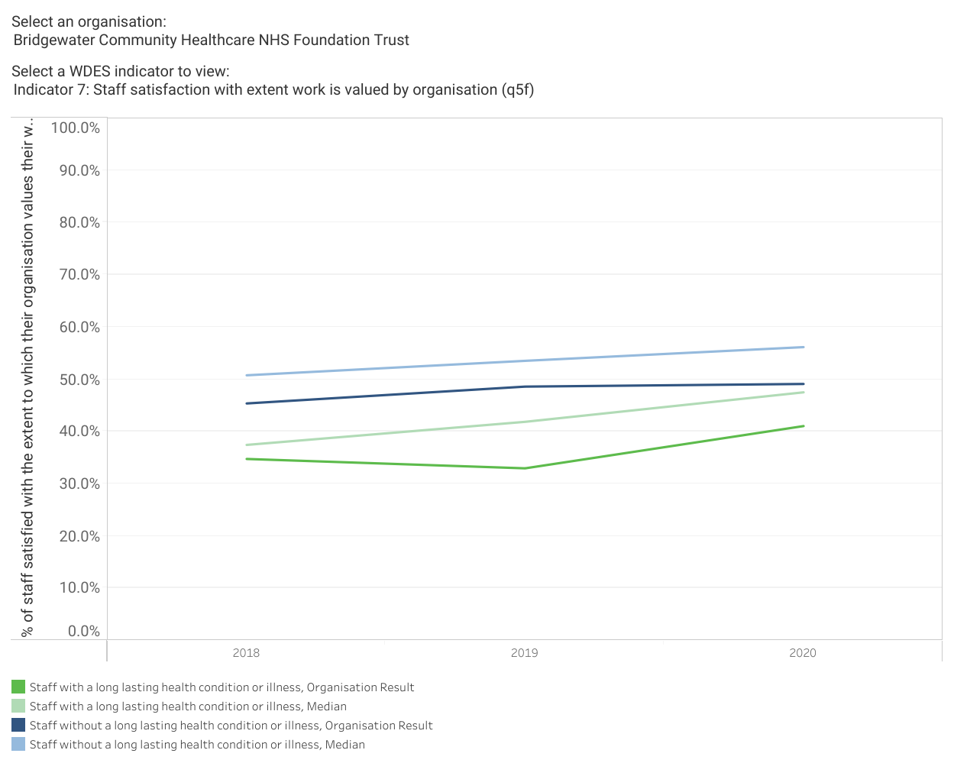
- These results tell us that both groups of staff are seeing a steady, but slow, improvement, for both however we are below the average for community Trusts, there is more therefore still to be done.

The image to follow shows the results for Disabled and non-disabled staff for the question ‘the extent to which the Trust values my work’ along with the overall Trust results and those for the best community Trust in this year’s survey.
Figure 17: Showing Extent to Which Disabled and Non-Disabled Staff Feel Valued by the Organisation
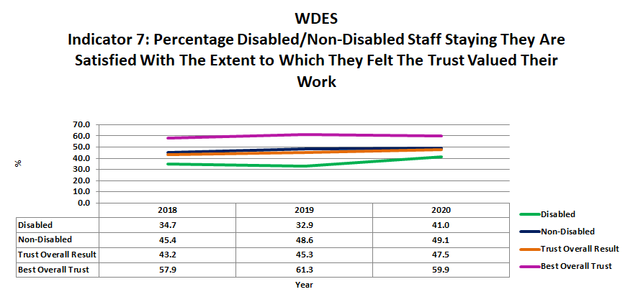
- As can be seen Disabled staff are less likely to report feeling valued by the Trust for the role they undertake, but this is improving.
- 156 staff with disabilities or long-term conditions responded, 20.5% of the total responses to this question, this is around the same percentage as in other years.
- Non-disabled staff have seen a steady improvement over the three years of reporting for the WDES.
- What needs to be noted however is that both of these groups score under 50%, that is less than half of respondents feeling valued by the organisation. The best community provider scores generally around 58 – 60%, still less than 2/3 of staff, but a 10% improvement that we will strive to make.

Metric 8: Reasonable Adjustments
This metric asked the percentage of Disabled staff saying that their employer has made adequate adjustment(s) to enable them to carry out their work. (Note: Only includes responses from staff who stated that they had a long-term condition or disability in the Survey questions.)

(NHS Staff Survey 2020)

The Duty to Make Reasonable Adjustments is set out in Section 20 of the Equality Act 2010. It requires us to anticipate and make adjustments that will eliminate or reduce disadvantage faced by people with disabilities arising from provision/criteria/practices of the Trust, barriers in the physical environment, or the need for provision of an auxiliary aid or information and communications in an accessible format.
The following image shows the results for this metric. Only those staff who stated they have a disability are questioned.
Figure 18: Results for Reasonable Adjustments 2018 - 2020
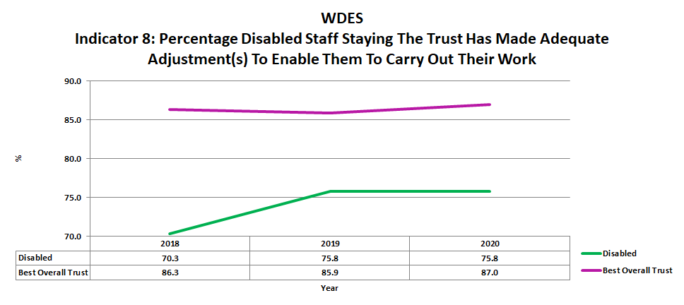
- As can be seen we saw an improvement in 2019 but the figure has remained the same in 2020. We remain significantly below the best community provider result.
- 95 members of staff with disabilities or long-term conditions responded, this is 5 less than the previous year and significantly less than in 2018, but 2018/19 year saw a large number of staff transfer out of the Trust for the Wigan integrated care system.
- With DAWN we have centralised the reasonable adjustments budget from 2021 and are developing a policy and process behind this budget to ensure provision of adjustments are understood, easy to access, and regularly reviewed for effectiveness.
- Our Employee Adjustment Passport was launched in 2020, during the pandemic.
Metric 9a: Staff Engagement
The staff engagement score for Disabled staff, compared to non-disabled staff and the overall engagement score for the organisation.

(NHS Staff Survey 2019)

Our final figures look at the staff engagement theme, this is made up of several questions that look at for example staff enthusiasm for work, ability to innovate and improve, patient priority, and recommendation as a place for work or treatment.
Figure 19: Showing Results for Staff Engagement 2018 - 2020
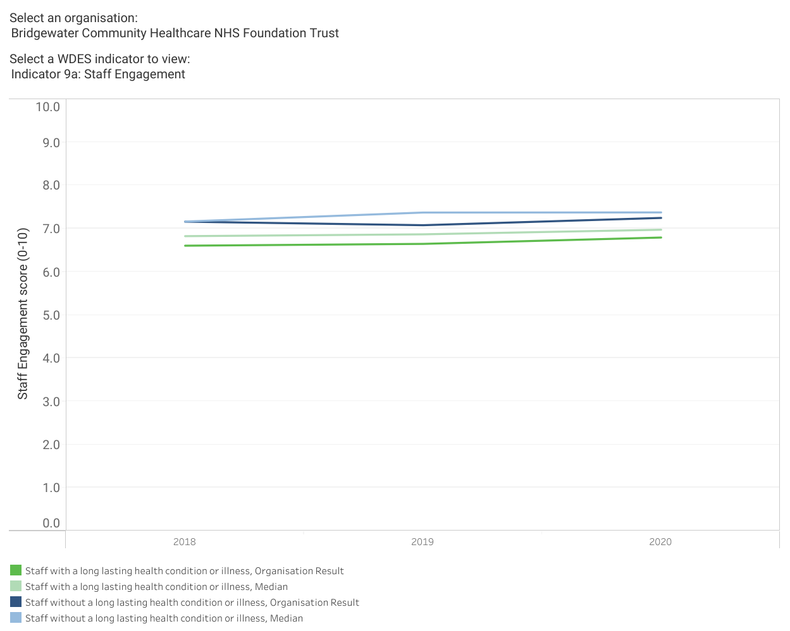
- It can be seen that staff with disabilities or long-term conditions score lower in this theme than non-disabled staff, and that both are below the average for community providers but improving.

The last image looks at staff engagement generally in the Trust, how engaged Disabled staff feel compared to non-disabled staff and the overall Trust score and best community Trust score.
Figure 20: Showing Staff Engagement. Comparing Disabled and Non-Disabled Staff to the Overall Trust Score
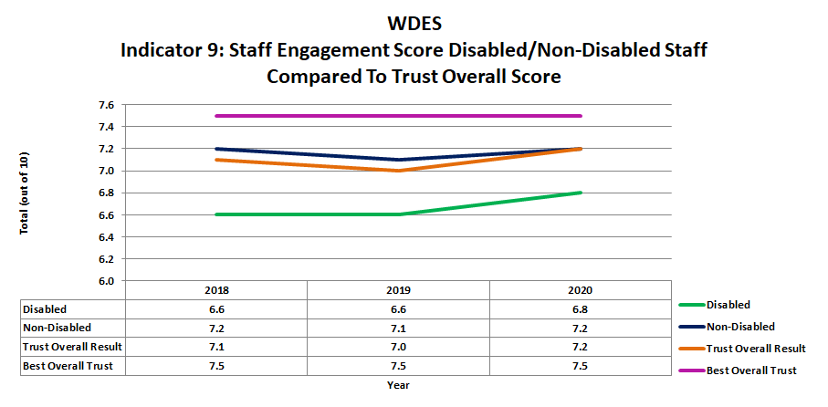
- As can be seen in 2020 there have been improvements for all Trust engagement results in this figure – staff with disabilities has improved by 0.2, non-disabled staff by 0.1 and the overall result by 0.2.
- We remain below the community best which has stayed the same at 7.5 for the last three years of reporting.
- 158 staff with disabilities or long-term conditions responded to the questions within this theme, this is 21% of all respondents but is below the 23% who responded in 2019.

Action Plan
During spring 2021 we have been working to produce and publish an action plan for equality for all protected groups. This uses engagement and feedback from the staff networks alongside analysis for WDES, WRES: A Model Employer, disparity ratio analysis, and review of NHS Staff Survey results to create an overarching plan.
The plan outlines the following action sets:
- Culture
- Modernising Recruitment
- Identifying and Developing Talent
- Developing EDI Awareness and Skills
This plan can be viewed on the Trust webpage - https://bridgewater.nhs.uk/aboutus/equalitydiversity/equalityact2010/
Thank you for taking the time to read our 2021 WDES report.

Contact Details
Paula Woods (Director of People and Organisational Development) paula.woods1@nhs.net
Ruth Besford (Equality & Inclusion Manager) ruth.besford@nhs.net

